The pupil premium: an update
This report provides an update on the progress schools have made in using their pupil premium funding to raise achievement for pupils eligible for free school meals. It is based on evidence from 151 inspections carried out between January and December 2013, text review of 1,600 school inspection reports published between September 2013 and March 2014, and national performance data for 2013.
Age group: 4–16
Published: July 2014
Reference no: 140088

Contents
Executive summary 4
Background 8
Part A: progress made by schools 9
Many schools are spending their pupil premium funding more effectively 10
Schools that are committed to ‘closing the gap’ and that have robust tracking systems are showing most improvement 10
Weak leadership and governance is an obstacle in too many schools 15
External reviews of a school’s use of the pupil premium 16
Part B: raising attainment and ‘closing the gap’ 17
Comparison of performance at the end of Key Stage 2 17
Comparison of performance at end of Key Stage 4 18
Notes 21
Annex A: Attainment of pupils at GCSE (2012 to 2013) by local authority area 22

Executive summary
The pupil premium is making a difference in many schools. Overall, school leaders are spending pupil premium funding more effectively, tracking the progress of eligible pupils more closely and reporting outcomes more precisely than before.
There are encouraging signs from inspection that the concerted efforts of good leaders and teachers are helping to increase outcomes for pupils eligible for the pupil premium. However, it will take time to establish whether this increased focus will lead to a narrowing in the attainment gap between those eligible for the pupil premium and other pupils.
The government is spending significant amounts of public money on this group of pupils. Schools will receive around £2.5 billion through pupil premium funding in the financial year 2014–15. This means that an average sized secondary school with average numbers of pupils eligible for free school meals will receive an additional amount of funding in the region of £200,000. This is the equivalent of five full-time teachers.
Ofsted’s increased focus on this issue in all inspections is making a difference. In each report, we now include a commentary on the attainment and progress of pupils who are eligible for the pupil premium and evaluate how this compares with other pupils. Headteachers know that their schools will not receive a positive judgement unless they demonstrate that they are focused on improving outcomes for pupils eligible for the pupil premium. For example, in a number of previously outstanding secondary schools that have declined to good or below, inspectors have judged that the pupil premium funding was not being effectively spent.
In 151 reports analysed between January and December 2013, there was an association noted between the overall effectiveness of the school and the impact of the pupil premium. Routinely, good and outstanding schools demonstrate unwavering commitment to closing the attainment gap. They target interventions forensically and have robust tracking systems in place to establish what is making a difference and what is not.
In these schools, governing bodies are more aware of their role in monitoring the use of their school’s pupil premium funding. The strongest governing bodies take strategic responsibility for ensuring that the funding improves teaching and support for eligible pupils in the school. They know how the funding is being spent, hold leaders to account for expenditure and assess how effectively the funded activities contribute to raising the attainment of eligible pupils.
Weak leadership and governance remain obstacles to narrowing the attainment gap. In schools judged to be inadequate, inspectors commonly report that leaders and governors do not ensure that pupil premium funding is used effectively. In these schools, the attainment of pupils eligible for funding is poor and attainment gaps are too wide.
Although inspectors have seen large improvements in the attitude of school leaders and governors, there is considerable variation across local authorities in the proportion of pupils achieving expected levels at Key Stages 2 and 4 and the rate of improvement from year to year. (See the annex on page 22 for the full list of attainment of pupils at GCSE by local authority area.) Figure 1 demonstrates this difference starkly. Pupils eligible for free school meals in Barnsley, Portsmouth, South Gloucestershire, North Lincolnshire and Northumberland were least likely to achieve five good GCSE passes including English and mathematics at the end of Key Stage 4. Around one in four eligible pupils achieved this benchmark in these areas in 2013. At the other end of the spectrum, Kensington and Chelsea, Westminster, Southwark, Tower Hamlets and Lambeth had the highest proportion of eligible pupils achieving five or more good GCSEs, including English and mathematics. In these areas, around three fifths of eligible pupils are attaining this benchmark. This is significantly above the national level of 37.9%.
Figure 1: Percentage of pupils eligible for free school meals attaining five or more GCSEs at grade A* to C including English and mathematics in 2013, by local authority

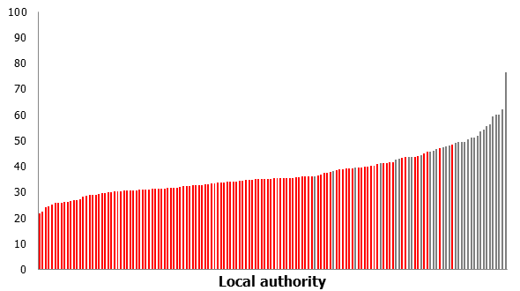
Source: Department for Education

Each line represents one of 150 individual local authorities in England. Local authorities on the left have the lowest proportion of pupils eligible for free school meals achieving five or more GCSEs grades A* to C including English and mathematics. Grey lines represent London boroughs. Data for City of London and the Isles of Scilly are not included owing to the small numbers of eligible students in these regions.
Figures based on outcomes for eligible free school meal students at the end of Key Stage 4 in the 2012/13 academic year. Figures for 2012/13 are based on revised data.

Twenty three of the top 25 local authority areas that attain this GCSE benchmark for eligible pupils are London boroughs. Schools in these areas were performing strongly in 2013 despite having high proportions of pupils coming from poorer backgrounds. This demonstrates powerfully that poverty is not always a predictor of failure.
If gaps are to be narrowed then school leaders must make sure that eligible pupils make faster progress than non-eligible pupils. Some are doing this – particularly in London. In five London boroughs, poor children are achieving above or in line with the national figure for all children at GCSE.
The change in proportion of eligible pupils who achieved at least five GCSEs grades A* to C between 2012 and 2013 varied considerably, ranging from a fall of 10 percentage points in Thurrock to an increase of 13 percentage points in Windsor and Maidenhead. Those local authority areas that have performed poorly over recent years arguably have greatest scope for most rapid improvement. It is, therefore, welcome to see that 12 of the local authorities identified as having the weakest GCSE performance for eligible pupils in Ofsted’s 2013 report ‘Unseen children’ have made impressive strides to improve. These areas have improved outcomes for eligible students by around six percentage points or more in the period between 2012 and 2013. Seven of them are in the 15 most improved local authorities. However, it is of significant concern that three of the worst performing areas highlighted in ‘Unseen children: access and achievement 20 years on’ are improving too slowly and in one case has declined further. In 2012, Barnsley had the third lowest proportion of eligible children attaining five or more GCSEs grades A* to C. Attainment further declined in 2013 and Barnsley is now the lowest attaining local authority at Key Stage 4. Poor children in Barnsley are getting an extremely raw deal.
Figure 2: Percentage point change in GCSE outcomes for pupils eligible for free school meals between 2012 and 2013, by local authority

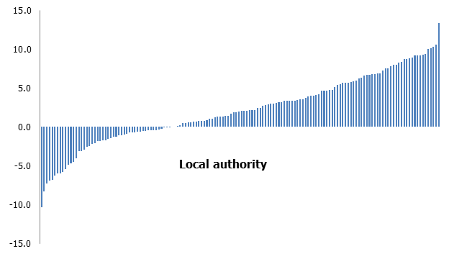
Source: Department for Education

Each line represents one of 150 individual local authorities. In those local authorities below the line, there has been a fall in the proportion of pupils eligible for free school meals achieving GCSEs grades A* to C including English and mathematics. Those above show an increase in the last year. Data for City of London and the Isles of Scilly are not included owing to the small numbers of eligible students in these regions.
Figures based on outcomes for eligible free school meal students at the end of Key Stage 4 in the 2012/13 academic year. 2012/13 figures are based on revised data.
It cannot be right that the likelihood of a child receiving a good education should depend on their postcode or economic circumstance. Government should focus its attention on those areas of the country that are letting poor children down. Ofsted will also focus its attention on these areas in subsequent reports to see if improvements have been made.

Background
- The pupil premium was introduced in April 2011. It is additional funding given to publicly funded schools in England to raise the attainment of disadvantaged pupils. Schools were allocated a total of £1.25 billion in the financial year 2012–13, increasing to £2.5 billion in 2014–15. In the financial year 2013–14, schools received £953 for each eligible primary-aged pupil and £900 for each eligible secondary-aged pupil.
- In September 2012, Ofsted published its first pupil premium report based on a survey involving 262 school leaders. At that time, only one in 10 of those leaders said that the funding had significantly changed the way that they supported pupils from disadvantaged backgrounds. Typically, funding was being used to maintain or enhance existing provision rather than introduce new initiatives, and its impact on eligible pupils was not being reviewed by governors.
- In February 2013, Ofsted published ‘The Pupil Premium: how schools are spending the funding successfully to maximise achievement’. This report found that more schools were using their funding well. In the best schools, carefully targeted spending of the pupil premium was starting to raise attainment for eligible pupils. Nevertheless, some schools were still spending the pupil premium on interventions that were having little meaningful impact on eligible pupils’ achievement.
- Since January 2013, Ofsted inspections have placed greater emphasis on how schools use their pupil premium funding. Inspectors have focused on its impact in raising achievement and closing attainment gaps for eligible pupils. Inspection reports now include a commentary on the attainment and progress of pupils who are eligible for the pupil premium and evaluate how this compares with other pupils. Since September 2013, inspectors have been able to recommend a review of pupil premium spending. Ofsted will report on the effectiveness of these external reviews in 2015.

Part A: progress made by schools
- The pupil premium is making a positive difference in many schools, especially where there is good or outstanding leadership and a school-wide commitment to raising achievement for pupils who are eligible for free school meals. Most schools are now using the pupil premium funding more successfully to raise attainment for eligible pupils. This is because most leaders and managers, including members of governing bodies, are routinely paying more attention to the needs of this particular group of pupils.
- Inspectors found an association between the overall effectiveness of the school and the impact of the pupil premium. In the sample of 151 reports, gaps in attainment for pupils eligible for free school meals were closing in all 86 of the schools judged to be good or outstanding for overall effectiveness. Gaps were closing rapidly in around a fifth of these schools. In 12 schools, there was virtually no difference between the attainment of eligible and non-eligible pupils; most of these schools were judged to be outstanding.
- In a small proportion of the good schools, typically those whose overall effectiveness had improved since their previous inspection, gaps in attainment were closing more slowly. The inspection reports for these schools commonly include a recommendation for further improvement that relates, at least in part, to those pupils eligible for the pupil premium funding.
- Gaps in attainment were also closing in around two thirds of the 50 schools that had been judged as requires improvement. However, the rate of improvement in these schools was often inconsistent across different year groups. In some cases, there had been more discernible recent increases in achievement after a period of stubborn poor performance. Often, this recent improvement was linked to changes at senior leadership level or in governance arrangements and the impact that these new leaders have on ensuring that the funding is used more effectively.
- In general, pupils eligible for the pupil premium were making poor progress in the 15 schools that were inadequate for overall effectiveness. Attainment gaps were typically wider than average or closing too slowly. However, in a few of these schools, the performance of pupils eligible for free school meals, although still too low, was better than their peers.

Many schools are spending their pupil premium funding more effectively
- Inspectors report that most schools spend their pupil premium funding effectively on a wide range of initiatives. Since September 2012, details of this spending and its impact must be published annually on schools’ websites.
- In the sample of 151 inspection reports, inspectors describe the most common uses of the pupil premium funding. Although its use is generally tailored to the age-specific needs of the pupils, there are no major differences in the types of spending seen in primary and secondary schools. As noted in Ofsted’s previous pupil premium publications, the most frequent use of the funding is to pay for additional staff, including teachers and teaching assistants, who deliver one-to-one support and small group tuition, typically focused on English and mathematics. In general, secondary schools in the sample were more likely to employ additional teachers, and primary schools were more likely to employ additional teaching assistants.
- Additional staffing is also used to enable schools to offer a range of interventions such as booster classes, reading support or ‘raising aspiration’ programmes, and to reduce the size of classes. In secondary schools, the funding is frequently used to employ ‘learning mentors’, who have specific roles in supporting pupils’ academic and personal development. In primary schools, the funding is sometimes used to provide specialist support for developing pupils’ language and communication skills.
- The funding is also commonly used to enable eligible pupils to participate fully in after-school clubs and activities and to provide financial support for educational visits. In secondary schools, the funding is often used to provide after-school, weekend and holiday sessions.
- There is very little difference in the types of spending reported on in the best schools compared with those that are judged as requires improvement or inadequate. However, the major differences are the extent to which leaders ensure that the funding is very carefully targeted at the types of activities that best meet the needs of their pupils, and the rigour with which these activities are monitored, evaluated and amended.

Schools that are committed to ‘closing the gap’ and that have robust tracking systems are showing most improvement
- Evidence from the 151 inspection reports shows that the most effective leaders identify their pupils’ specific needs accurately and promptly so that low attainment can be tackled at the very earliest stage. They then track the progress of pupils who are eligible for the pupil premium funding meticulously and make sensible amendments to the support they provide as a result of their monitoring and evaluation.
- The best leaders ensure that additional adult support is of high quality. Every effort is made to ensure that pupils eligible for the pupil premium have access to the best teachers and are supported by skilled and well-trained additional adults. These schools ensure that the work of additional adults is closely monitored and thoroughly evaluated.
- In the successful schools, there is a very strong commitment, shared by staff and governors, to doing everything possible to remove any barriers that might hinder a pupil’s development. These schools are highly ambitious, respond to what they know to be good practice and ensure that their vision for improvement is clear.
Setting a clear vision and high expectations
In this outstanding secondary school, the proportion of students known to be eligible for the pupil premium is high. In 2013, 83% of pupils eligible for free school meals achieved at least five GCSEs grades A* to C including English and mathematics compared with 88% of other pupils. Value-added and progress data for eligible pupils was significantly above average.
School website
‘Key principles for using pupil premium 2012–13:
1. The school carefully ring-fences the funding at the beginning of the academic year so that it was spent on a targeted group of students.
2. The school never confuses eligibility for the pupil premium with low ability, and focuses on supporting our disadvantaged pupils to achieve the highest levels.
3. The school thoroughly analyses which pupils are underachieving, particularly in English, mathematics and science, and why.
4. The school drew and draws upon evidence from our own and others’ experience to allocate the funding to the activities that were most likely to have an impact on improving achievement.
5. We allocate our best teachers to teach intervention groups to improve mathematics and English, or re-deploy support teachers who have a good track record in raising attainment in those subjects.
6. The school uses achievement data frequently to check whether interventions or techniques are working and make adjustments accordingly, rather than just using the data retrospectively to see if something had worked.
7. The school ensures that a designated senior leader, an Assistant Headteacher, plus the Headteacher have a clear overview of how the funding is being allocated and the difference it is making to the outcomes for pupils termly.
8. The school also ensures that class and subject teachers know which pupils are eligible for the pupil premium so that they can take responsibility for accelerating their progress.
9. The projects we have set up are to tackle a range of issues, e.g. attendance, behaviour, factors outside school, professional INSET on FSM pupils, effective teaching and learning, strong careers information, advice and guidance, literacy support, targeted support, good facilities for supported self-study, further enrichment.’
Inspection report
Students supported by the pupil premium do exceptionally well in all years because high quality teaching is well matched to their specific needs. They achieve better GCSE results than most students do nationally. The gap between their attainment and that of their peer group in the college is half a GCSE grade in English and less than half a grade in mathematics… The additional funding available through the pupil premium is very carefully targeted. Its impact is monitored to make sure that it is having the intended effect. As a result, these students make progress at a much faster rate than students nationally.
- Although schools often spend the funding on a common menu of activities, effective leaders make informed choices, on a yearly and flexible basis, that match the particular needs of their pupils. They continue with interventions that have been successful and amend their practice where it has been less successful.
- The most successful schools ensure that pupils catch up with the basics of literacy and numeracy and offer support, where necessary, to improve pupils’ attendance, behaviour, confidence and resilience. In the primary schools sampled, there was a very strong focus on improving reading. In the secondary schools, support for English and mathematics catch-up was often targeted at Year 7, but also continued across Key Stages 3 and 4.
- In the best schools, the overall package of support for eligible pupils is comprehensive, well-integrated and responsive to their changing needs. In these schools, leaders put in place a balanced programme of whole-school, targeted and specialist support that takes into account the needs of all pupils. Where schools encountered barriers to providing the support required, they found creative ways to achieve their aims.
A comprehensive package of support responds to a wide range of specific needs
This outstanding secondary school is larger than average. There are more boys than girls in the school. The proportion of students eligible for the pupil premium is well above average. Over 80% of pupils in the 2013 Key Stage 4 cohort were eligible for free school meals. Sixty two per cent of these pupils achieved at least five GCSEs grades A* to C including English and mathematics. Their value added was significantly above average.
School website
‘Students below national levels in English at KS3 will be allocated to Extended English (literacy) lessons on the timetable. The programme is designed to accelerate the children’s writing and reading skills. Extended English is taught in small sets by specialist teachers.
At Key Stage 4 students who have not made progress in line with national expectations and are at risk of falling short of a grade C in English language are targeted for two additional lessons of English a week. English booster tuition provides intensive coaching and guidance by very experienced GCSE teachers in English language in small groups averaging three students.
Mathematics booster tuition targets children in Years 7 to 11 to provide intensive coaching and guidance by qualified teachers and support staff in mathematics in small sets. This budget enables some smaller sets to be created so as to provide more personalised attention and guidance for the students.
The Success Ambassadors are a team of excellent role models who mentor targeted students and provide intervention support for children to improve their reading. The Success Lounge has been set up as an after-school base for children to do their homework and obtain additional assistance. Attendance for targeted students is compulsory; for others it is optional.
The Raising Achievement Team has been established to improve the attainment of students. The Team manages the Success Lounge and produces data for whole school use. They analyse performance and develop staff use of data and intervention methods to monitor and target support.

Inspection report
In 2012, a gap between the attainment and progress of students eligible for the pupil premium and other students was quickly identified. Action was taken that meant that the gap was halved in both English and mathematics in 2013 such that these students now achieve about half a grade less well than their peers in the school. The ‘Raising Achievement Team’ tracks the progress of these students… The school makes excellent use of its pupil premium funding to provide a summer school, after-school support in the ‘Success Lounge’ and booster sessions offered through subject teams to meet the needs of individuals.
- Strong governance is critical to schools’ successful use of the pupil premium funding to accelerate progress and narrow gaps in attainment. Effective governors are ambitious for their poorest pupils and hold leaders to account for their decisions and for the impact of initiatives funded by the pupil premium.
- Inspectors also report that strong governing bodies are fully involved in deciding how pupil premium funding is used. Finances are tightly controlled and decisions on spending are linked closely to priorities in the school improvement plan. They monitor its effectiveness in closing the attainment gap between different groups of pupils. They have a comprehensive knowledge of published data and are skilled in using this to check on the progress of the school and hold staff to account. They also take steps to collect first-hand evidence, for example by meeting with students and teachers.
Successful governors are very actively involved in holding leaders to account for the achievement of pupils eligible for the pupil premium
Good primary school
In 2013, all pupils eligible for free school meals in this good primary school achieved a Level 4 or above in reading, writing and mathematics. Their value added was significantly above average.
Inspection report
The governing body’s ‘Raising of Achievement Group’ checks the progress of all of the groups of pupils each month. Governors stringently hold senior leaders to account for all aspects of the school’s work. They have regular financial reports and make checks on the school’s budget.
Good secondary school
The proportion of pupils eligible for free school meals in this good secondary school is much higher than average. In 2013, 62% of pupils from low income backgrounds achieved five GCSEs grades A* to C including English and mathematics, which is one percentage point below other pupils. The value added for these pupils was significantly above average.
Inspection report
The governing body is well informed and holds school leaders strongly to account for raising standards. Detailed reports from the headteacher and presentations from faculty leaders ensure that they know how much progress individuals, groups and classes are making… They make regular visits and use assessment information to measure how students achieve compared with their peers in other schools. They effectively monitor the pupil premium and catch-up funding to make sure it is raising achievement for eligible students.

Weak leadership and governance is an obstacle in too many schools
- A common weakness in the schools where gaps in attainment are not closing quickly enough is insufficient analysis of the learning needs of pupils eligible for the pupil premium funding. In such schools, even where information about pupils’ progress was available, it was not always used well enough to ensure that funding was appropriately targeted.
Inspection report
Leaders do not analyse this information [about pupils’ progress] in enough detail to see how different groups of students are doing. This makes it difficult for them and for the interim executive board to check on how well the changing needs of different groups of students are being met. For example, the school was not clear until very recently about how many pupils who were eligible for the pupil premium were also at the early stages of speaking English and new to the school. This makes it hard for leaders to plan precisely what they need to do to accelerate the progress of these students.
- In some of the weaker schools, analysis of pupils’ progress had not been shared fully with teachers. Consequently, teachers were unable to plan work that met the needs of pupils.
Inspection report
The school has not used assessment information about how well these students are doing to provide them with appropriate work. Leaders do not check the progress of individuals and groups of students well enough or provide teachers with the necessary information to make sure that they set work at the right level for students.
- In the very weakest performing schools, inspection reports identified a worrying lack of focus on pupils eligible for the pupil premium. In these schools, a widespread failure in leadership and governance had normally been identified. Leaders had not prioritised raising the attainment of pupils eligible for free school meals and poorly informed or unskilled governors had not held leaders to account.
Inspection report
The headteacher is unaware of the impact that the spending of pupil premium funds has on the achievements of those pupils for whom it is intended. Information about the achievement of this group of pupils, published on the school’s website, is incorrect… The previous governing body did not provide appropriate challenge or support to the school’s senior leaders to improve the school’s performance… The interim executive board has started to take urgent action to address the key areas for improvement. A consultant headteacher has been appointed and is now beginning to work with the school and members of the executive board. However, it is too soon to judge the impact of their work.

Inspection report
Prior to the appointment of the current Associate Principal, there was no evidence of any accountability for use of the pupil premium or its impact. This is now being addressed and senior leaders are monitoring the effect this additional finance is having on the attainment and progress of those students for whom it is intended... Since the Executive and Associate Principals joined the staff and the new governance arrangements have been put in place, the life and work of the academy has been reinvigorated. The Associate Principal’s evaluation of the academy’s performance is accurate and he has galvanised his colleagues into action, putting in place systems to address the most pressing priorities. However, many of these strategies are so new it is too early to assess their impact on students’ outcomes.

External reviews of a school’s use of the pupil premium
- Since September 2013, inspectors have been able to recommend an external review of the school’s use of the pupil premium funding where the inspection identifies specific issues regarding the provision for eligible pupils. Even where leadership and management are judged to be good, inspectors may use their professional judgement to determine whether a recommendation for an external review of the school’s use of the pupil premium would benefit the school.
- A text review of around 1,600 inspection reports (where the school had been judged as requires improvement or inadequate) published between September 2013 and March 2014 identified that approximately 350 of these reports included a recommendation for a review of the schools’ use of the pupil premium.
- The most common reason for a review of the school’s use of the pupil premium funding was that gaps were not closing sufficiently well, especially in English and mathematics. The most common criticism in inspection reports was that the impact of spending was not being evaluated effectively by leaders and governors. Other examples of poor leadership and management include not ensuring that the funding is spent on the specific pupils for whom it is intended or having an underspend.
- At this stage it is too early to determine the effectiveness of external reviews of the pupil premium in bringing about improvement. We will report on this in early 2015.

Part B: raising attainment and ‘closing the gap’
- Attainment in England has been rising steadily over recent years for all types of pupils. However, as the attainment of pupils eligible for free school meals has improved at a similar rate to other pupils, the ‘attainment gap’ has closed only slightly. This is particularly the case at the end of Key Stage 4.
- Some of the complex reasons for the lower attainment of pupils from low income backgrounds, including differences in the performance of pupils from different ethnic backgrounds, were discussed in Ofsted’s recent report ‘Unseen Children: access and achievement 20 years on’.

Comparison of performance at the end of Key Stage 2
- In 2013, 60% of pupils eligible for free school meals achieved a Level 4 or better in reading, writing and mathematics in Key Stage 2 tests compared with 79% of non-eligible pupils. This is an increase of one percentage point on the 2012 figures for both groups. The attainment gap in 2013 remained at a difference of 19 percentage points.
- Small increases in the attainment of pupils eligible for free school meals were noted in most regions between 2012 and 2013 (see Figure 3). Nevertheless, gaps in attainment remained broadly the same across all regions.

Figure 3: Percentage of pupils eligible for free school meals attaining Level 4+ in reading, writing and mathematics at Key Stage 2, by region
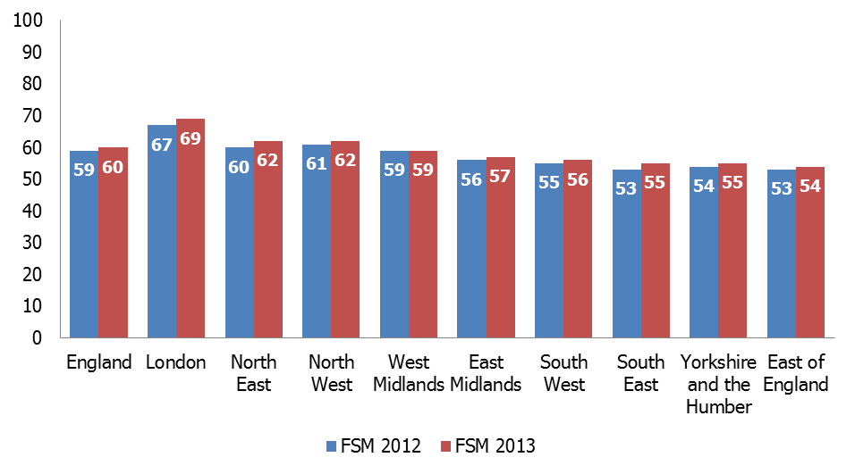Source: Department for Education
Figures for 2012 are based on final data; 2013 figures are based on revised data.

- Attainment for pupils eligible for free school meals was highest in London (69%) and lowest in the East of England (54%) in 2013.

Comparison of performance at end of Key Stage 4
- In 2013, 38% of pupils eligible for free school meals achieved five GCSEs or more at grades A* to C including English and mathematics compared with 65% of non-eligible pupils. This attainment gap – 27 percentage points – is unchanged from 2012.
- The 2013 figures follow a pattern of improvement evident since 2005 (see Figure 4). Although levels of attainment have gradually improved for all pupils, the ‘attainment gap’ has narrowed at a very slow rate. The fact that this is the case both before and after the introduction of the pupil premium is not surprising, given how recently the funding was introduced. It will take time before the full impact of this policy may be seen in national data.
Figure 4: Percentage of pupils at the end of Key Stage 4 attaining five or more GCSEs grades A* to C including English and mathematics, by free school meals eligibility,
2005–13

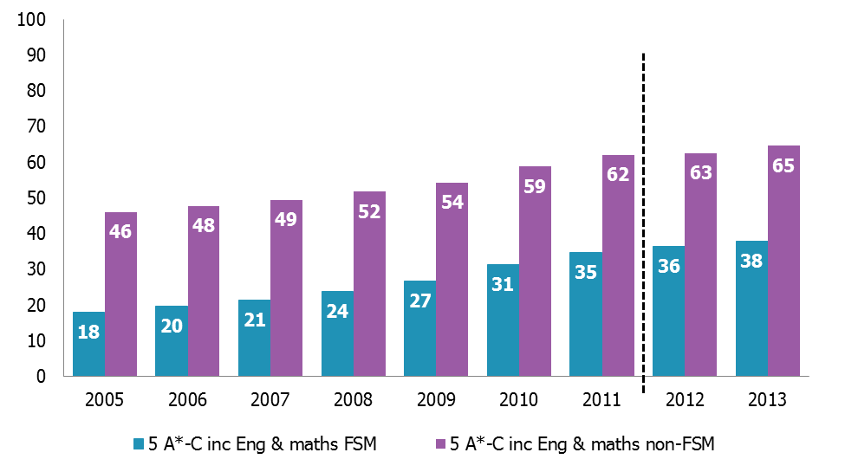
Source: Department for Education

The dotted line represents the point in time when the pupil premium was introduced (April 2011). It is very unlikely that this funding would have influenced the attainment of the 2011 cohort sitting GCSE examinations in summer 2011. Figures for academic years 2005-12 are based on final data. Figures for 2013 are based on revised data.
Figures are based on students in state-funded schools (including academies and city technology colleges) at the end of Key Stage 4 in each academic year.

- In 2013, the attainment of pupils eligible for free school meals increased in all regions at the end of Key Stage 4 (see Figure 5). Levels of attainment for pupils eligible for free school meals were highest in London (51%) and lowest in the South West and East of England (32%). The attainment of pupils eligible for free school meals at the end of Key Stage 4 rose most, from a low base, in the South East (three percentage points) and least in the East of England in 2013.
Figure 5: Percentage of pupils eligible for free school meals at the end of Key Stage 4 attaining five or more GCSEs grades A* to C including English and mathematics, by region, 2007–13

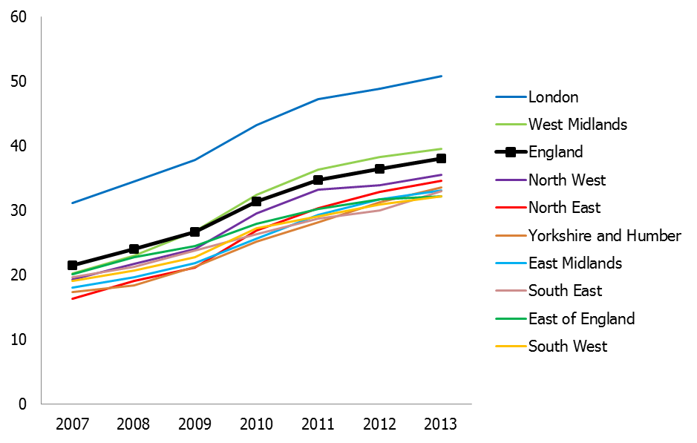
Source: Department for Education
Figures for academic years 2007–12 are based on final data. Figures for 2013 are based on revised data. Based on students in state-funded schools (including academies and city technology colleges) at the end of Key Stage 4 in each academic year.
- There is considerable variation across local authorities in the proportion of pupils achieving expected levels at Key Stages 2 and 4, and the rate of improvement from year to year. Pupils eligible for free school meals in Barnsley, Portsmouth, South Gloucestershire, North Lincolnshire and Northumberland were least likely to achieve five good GCSE passes including English and mathematics at the end of Key Stage 4 in 2013. Around one in four eligible pupils achieve this benchmark in these areas (see Annex A). At the other end of the spectrum Kensington and Chelsea, Westminster, Southwark, Tower Hamlets and Lambeth had the highest proportion of eligible pupils achieving five or more good GCSEs, including English and mathematics. In these areas, around three fifths of eligible pupils are attaining this benchmark. This is significantly above the national level of 37.9% of free school meal eligible pupils attaining this benchmark.
- Following the publication of Ofsted’s ‘Unseen children’ report, many of the lowest attaining local authorities for free school meal eligible pupils have improved their performance. Peterborough and West Berkshire are two of the most improved, increasing their attainment for this group by 10 and nine percentage points, respectively, in 2013. Herefordshire, Swindon, Shropshire, Dorset, Warrington and Hartlepool also improved their attainment outcomes by more than seven percentage points during this period.
- Similarly, some local authorities in the South East region have also improved their GCSE outcomes quite considerably for free school meal eligible pupils. From a position in 2012 where no authority in this region had attainment above the national figures for free school meal eligible pupils, Windsor and Maidenhead, Slough, Milton Keynes and Surrey are now all above the national figure for this group.
- However, some authorities with the lowest attainment for free school meal eligible pupils in 2012 have not improved their performance. GCSE attainment in Barnsley, for example, decreased for this group in 2013 and the authority is now the lowest performing.

Notes
This report is based on three main sources of evidence:
- analysis of national, regional and local authority level data published by the Department for Education in 2013
- analysis of the main strengths and weaknesses in schools’ use of the funding, based on a random selection of 151 inspection reports published between January 2013 and December 2013
- text review of 1,600 school reports, published between September 2013 and March 2014.
Report selection was stratified by the schools’ overall effectiveness judgement to provide useful case studies of stronger and weaker practice. The sample included 83 primary schools and 68 secondary schools. Special schools were not included in the selection process. Case studies also draw on information from the selected schools’ websites.

Annex A: Attainment of pupils eligible for free school meals at GCSE between 2012 and 2013, by local authority area
Local authority | Region | % of FSM eligible students attaining GCSE benchmark |  | Change between 2012 and 2013
Local authority | Region | 2012 | 2013 | Change between 2012 and 2013
Kensington and Chelsea | London | 76.8 | 76.7 | -0.1
Westminster | London | 65.3 | 62.2 | -3.1
Southwark | London | 51.7 | 60.1 | 8.4
Tower Hamlets | London | 59.4 | 60.0 | 0.6
Lambeth | London | 56.1 | 59.5 | 3.4
Islington | London | 45.7 | 56.3 | 10.6
Haringey | London | 46.4 | 55.6 | 9.2
Redbridge | London | 56.0 | 54.2 | -1.8
Barnet | London | 50.4 | 53.8 | 3.4
Hounslow | London | 50.8 | 51.9 | 1.1
Hammersmith and Fulham | London | 47.4 | 51.3 | 3.9
Greenwich | London | 48.9 | 51.3 | 2.4
Newham | London | 55.2 | 50.5 | -4.7
Hackney | London | 51.8 | 49.7 | -2.1
Croydon | London | 43.2 | 49.5 | 6.3
Harrow | London | 40.2 | 49.4 | 9.2
Barking and Dagenham | London | 49.5 | 49.1 | -0.4
Windsor and Maidenhead | South East | 35.0 | 48.4 | 13.4
Brent | London | 42.8 | 48.2 | 5.4
Bromley | London | 40.7 | 48.0 | 7.3
Ealing | London | 45.3 | 47.5 | 2.2
Birmingham | West Midlands | 47.4 | 47.3 | -0.1
Wandsworth | London | 45.9 | 46.8 | 0.9
Waltham Forest | London | 40.3 | 46.0 | 5.7
Hillingdon | London | 45.9 | 45.8 | -0.1
Slough | South East | 35.6 | 45.7 | 10.1
Luton | East of England | 40.2 | 45.0 | 4.8
Merton | London | 45.1 | 44.4 | -0.7
Halton | North West | 36.1 | 44.1 | 8.0
Wolverhampton | West Midlands | 37.0 | 43.9 | 6.9
Enfield | London | 40.4 | 43.8 | 3.4
Camden | London | 45.9 | 43.7 | -2.2
North Tyneside | North East, Yorkshire and Humber | 36.8 | 43.6 | 6.8
Kirklees | North East, Yorkshire and Humber | 39.3 | 43.3 | 4.0
Richmond upon Thames | London | 42.5 | 43.1 | 0.6
Sutton | London | 39.2 | 42.7 | 3.5
Darlington | North East, Yorkshire and Humber | 34.0 | 41.8 | 7.8
Trafford | North West | 43.6 | 41.8 | -1.8
Milton Keynes | South East | 31.3 | 41.3 | 10.0
Bexley | London | 42.4 | 41.3 | -1.1
Bury | North West | 42.8 | 41.3 | -1.5
Solihull | West Midlands | 39.0 | 41.1 | 2.1
Manchester | North West | 39.7 | 40.4 | 0.7
York | North East, Yorkshire and Humber | 36.2 | 40.2 | 4.0
Wakefield | North East, Yorkshire and Humber | 32.1 | 40.1 | 8.0
Bolton | North West | 36.8 | 39.9 | 3.1
Oldham | North West | 36.6 | 39.8 | 3.2
Rochdale | North West | 31.2 | 39.5 | 8.3
Lewisham | London | 45.5 | 39.5 | -6.0
Leicester | East Midlands | 37.3 | 39.4 | 2.1
Blackburn with Darwen | North West | 40.1 | 39.4 | -0.7
Surrey | South East | 32.5 | 39.3 | 6.8
South Tyneside | North East, Yorkshire and Humber | 33.3 | 39.0 | 5.7
Torbay | South West | 32.3 | 38.9 | 6.6
Tameside | North West | 31.8 | 38.7 | 6.9
Kingston upon Thames | London | 43.1 | 38.2 | -4.9
County Durham | North East, Yorkshire and Humber | 36.7 | 38.0 | 1.3
Wirral | North West | 40.7 | 37.6 | -3.1
Sandwell | West Midlands | 36.2 | 37.5 | 1.3
Sefton | North West | 30.1 | 36.8 | 6.7
East Riding of Yorkshire | North East, Yorkshire and Humber | 31.7 | 36.4 | 4.7
Bedford | East of England | 27.6 | 36.3 | 8.7
Havering | London | 43.1 | 36.3 | -6.8
Gateshead | North East, Yorkshire and Humber | 30.4 | 36.2 | 5.8
North Yorkshire | North East, Yorkshire and Humber | 33.9 | 36.1 | 2.2
Wigan | North West | 37.8 | 36.1 | -1.7
Medway | South East | 34.1 | 35.8 | 1.7
Coventry | West Midlands | 35.3 | 35.8 | 0.5
Salford | North West | 30.6 | 35.7 | 5.1
Southampton | South East | 32.4 | 35.6 | 3.2
Staffordshire | West Midlands | 32.8 | 35.6 | 2.8
Bradford | North East, Yorkshire and Humber | 34.8 | 35.6 | 0.8
Nottinghamshire | East Midlands | 32.5 | 35.5 | 3.0
Plymouth | South West | 34.1 | 35.5 | 1.4
Hartlepool | North East, Yorkshire and Humber | 26.0 | 35.3 | 9.3
Poole | South West | 39.8 | 35.3 | -4.5
Warwickshire | West Midlands | 30.5 | 35.2 | 4.7
Essex | East of England | 34.4 | 35.2 | 0.8
Hertfordshire | East of England | 35.7 | 35.2 | -0.5
Reading | South East | 35.4 | 35.1 | -0.3
Calderdale | North East, Yorkshire and Humber | 35.4 | 35.0 | -0.4
Rotherham | North East, Yorkshire and Humber | 33.4 | 34.8 | 1.4
Liverpool | North West | 35.1 | 34.7 | -0.4
Warrington | North West | 25.2 | 34.6 | 9.4
Walsall | West Midlands | 34.3 | 34.5 | 0.2
Buckinghamshire | South East | 29.6 | 34.3 | 4.7
Rutland | East Midlands | 35.7 | 34.3 | -1.4
Kingston Upon Hull, City of | North East, Yorkshire and Humber | 27.9 | 34.1 | 6.2
Dorset | South West | 25.2 | 34.0 | 8.8
Gloucestershire | South West | 32.0 | 33.9 | 1.9
Newcastle upon Tyne | North East, Yorkshire and Humber | 31.6 | 33.8 | 2.2
Devon | South West | 34.4 | 33.8 | -0.6
Cornwall | South West | 34.2 | 33.6 | -0.6
Stockport | North West | 36.1 | 33.6 | -2.5
Worcestershire | West Midlands | 29.7 | 33.3 | 3.6
Lincolnshire | East Midlands | 32.4 | 33.1 | 0.7
West Sussex | South East | 27.3 | 32.8 | 5.5
Kent | South East | 31.7 | 32.8 | 1.1
Middlesbrough | North East, Yorkshire and Humber | 35.4 | 32.8 | -2.6
Swindon | South West | 24.0 | 32.7 | 8.7
Sunderland | North East, Yorkshire and Humber | 39.5 | 32.6 | -6.9
North Somerset | South West | 30.5 | 32.5 | 2.0
Nottingham | East Midlands | 29.3 | 32.3 | 3.0
Derbyshire | East Midlands | 28.4 | 32.0 | 3.6
Shropshire | West Midlands | 24.4 | 31.9 | 7.5
North East Lincolnshire | North East, Yorkshire and Humber | 29.0 | 31.9 | 2.9
Herefordshire, County of | West Midlands | 22.8 | 31.7 | 8.9
Redcar and Cleveland | North East, Yorkshire and Humber | 29.3 | 31.7 | 2.4
Dudley | West Midlands | 27.5 | 31.6 | 4.1
St. Helens | North West | 28.1 | 31.5 | 3.4
Lancashire | North West | 30.2 | 31.4 | 1.2
East Sussex | South East | 30.9 | 31.4 | 0.5
Northamptonshire | East Midlands | 31.7 | 31.3 | -0.4
West Berkshire | South East | 21.9 | 31.1 | 9.2
Wokingham | South East | 26.2 | 31.0 | 4.8
Telford and Wrekin | West Midlands | 37.3 | 31.0 | -6.3
Thurrock | East of England | 41.3 | 31.0 | -10.3
Stockton-on-Tees | North East, Yorkshire and Humber | 24.2 | 30.9 | 6.7
Leeds | North East, Yorkshire and Humber | 26.7 | 30.9 | 4.2
Somerset | South West | 28.9 | 30.8 | 1.9
Cheshire West and Chester | North West | 24.6 | 30.6 | 6.0
Cambridgeshire | East of England | 24.7 | 30.6 | 5.9
Brighton and Hove | South East | 27.1 | 30.5 | 3.4
Bath and North East Somerset | South West | 30.5 | 30.5 | 0.0
Oxfordshire | South East | 29.5 | 30.3 | 0.8
Sheffield | North East, Yorkshire and Humber | 30.3 | 30.1 | -0.2
Bournemouth | South West | 31.1 | 30.1 | -1.0
Stoke-on-Trent | West Midlands | 29.5 | 29.6 | 0.1
Doncaster | North East, Yorkshire and Humber | 30.7 | 29.6 | -1.1
Bristol, City of | South West | 26.6 | 29.3 | 2.7
Bracknell Forest | South East | 27.9 | 29.2 | 1.3
Peterborough | East of England | 18.7 | 29.0 | 10.3
Isle of Wight | South East | 23.2 | 28.9 | 5.7
Leicestershire | East Midlands | 29.4 | 28.9 | -0.5
Derby | East Midlands | 32.6 | 28.6 | -4.0
Southend-on-Sea | East of England | 24.5 | 28.2 | 3.7
Hampshire | South East | 26.1 | 27.4 | 1.3
Suffolk | East of England | 27.1 | 27.1 | 0.0
Wiltshire | South West | 30.0 | 27.1 | -2.9
Norfolk | East of England | 32.5 | 26.7 | -5.8
Cheshire East | North West | 28.1 | 26.4 | -1.7
Central Bedfordshire | East of England | 27.5 | 26.2 | -1.3
Knowsley | North West | 27.3 | 26.0 | -1.3
Cumbria | North West | 23.8 | 25.9 | 2.1
Blackpool | North West | 31.8 | 25.8 | -6.0
Northumberland | North East, Yorkshire and Humber | 26.1 | 25.2 | -0.9
North Lincolnshire | North East, Yorkshire and Humber | 31.9 | 24.6 | -7.3
South Gloucestershire | South West | 32.7 | 24.4 | -8.3
Portsmouth | South East | 28.0 | 22.6 | -5.4
Barnsley | North East, Yorkshire and Humber | 22.5 | 21.8 | -0.7

Unseen children: access and achievement 20 years on (130155), June 2013, Ofsted; www.ofsted.gov.uk/resources/unseen-children-access-and-achievement-20-years.
Funding is paid, for the most part, to schools according to the number of pupils who have been registered as eligible for free school meals at any point in the last six years or have been in care for six months or longer.
Raising the achievement of disadvantaged children, Department for Education, The Rt Hon Michael Gove MP and The Rt Hon David Laws MP, March 2013; www.gov.uk/government/policies/raising-the-achievement-of-disadvantaged-children.
In 2014/15, this will rise to £1,300 per primary pupil and £935 per secondary pupil.
The pupil premium (120197), Ofsted, September 2012; www.ofsted.gov.uk/resources/pupil-premium.
The pupil premium: how schools are spending the funding successfully to maximise achievement (130016), Ofsted, February 2013; www.ofsted.gov.uk/resources/pupil-premium-how-schools-are-spending-funding-successfully-maximise-achievement.
Inspectors evaluate the extent to which gaps are narrowing between the performance of different groups of pupils (including those that are eligible for the pupil premium funding), both in the school and in comparison to those of all pupils nationally.
Inspectors have reported on schools’ use of the pupil premium funding and the impact that it has had on raising the attainment of pupils eligible for free school meals since September 2012. Where the numbers of eligible pupils are very small, inspectors may not be able to make a meaningful comparison between their performance and that of other pupils.
These principles are based on the good practice characteristics identified in The Pupil Premium: how schools are spending the funding successfully to maximise achievement (130016), Ofsted, February 2013; www.ofsted.gov.uk/resources/pupil-premium-how-schools-are-spending-funding-successfully-maximise-achievement.
Unseen children: access and achievement 20 years on (130155), June 2013, Ofsted; www.ofsted.gov.uk/resources/unseen-children-access-and-achievement-20-years.
The collection method applied by the Department for Education from English and mathematics as the key measurement up to 2011 was replaced by reading, writing and mathematics in 2012. This has implications on how we interpret the effect pupil premium might be having within primary schools nationally.
GCSE and equivalent attainment by pupil characteristics, Department for Education SFR05/2014, February 2014; www.gov.uk/government/publications/gcse-and-equivalent-attainment-by-pupil-characteristics-2012-to-2013. National curriculum assessments at key stage 2: 2012 to 2013, Department for Education SFR51/2013, December 2013; www.gov.uk/government/publications/national-curriculum-assessments-at-key-stage-2-2012-to-2013.
Twenty nine of the schools were outstanding, 57 were good, 50 were requires improvement and 15 were inadequate.

