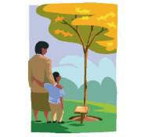

What this unit contains | This unit involves pupils in investigating beliefs about life and life after death and encouraging them to reflect on and express their  hopes for the future. In this unit pupils will have the opportunity to share their feelings of loss caused by separation, learn about how faith can provide believers with answers to life’s most challenging and ultimate questions, and also how faith challenges our attitudes, values and commitments in life. They will consider how important it is to celebrate the lives of those they have lost and how remembering can help the healing process. They will examine their attitudes, values and commitments in the light of this learning.  Key Concepts: AT1: Beliefs and Teachings; Practices; Forms of Expression. AT2: Belonging; Meaning and purpose.
Where the unit fits and how it builds upon previous learning | This unit should be taught in Upper KS2. It focuses on elements from the Southwark Diocesan scheme of work and local Agreed Syllabuses on Ultimate Questions. Some of the lessons in this unit have suggested cross-curricular links with ICT, art and design, and design and technology.  CAUTION: Some lessons could be upsetting to a pupil who has recently suffered bereavement. Care needs to be taken to check whether any pupils are in this situation.
Extension activities and further thinking |  Explore personal feelings about grief through: Michael Rosen’s Sad Book by Michael Rosen (Author), Quentin Blake (Illustrator), Walker Books   Find out about the work of a local hospice in caring for the families of those who are life limited. Contact St Christopher’s Hospice. 51-59 Lawrie Park Road, Sydenham, London SE26 6DZ Tel: 020 8768 4500   Visit a war memorial or graveyard   Investigate epitaphs
Vocabulary  Christian Buddhism God eulogy  Christianity Buddhist hope grave  loss community memorial gravestone  sadness Sikhism healing priest  remembering Sikh bereaved spirit religious reincarnation burial soul  Islam Heaven coffin Judaism  Muslim Karma commemorate Jew |  | SMSC/Citizenship   Personal hopes for the future   Beliefs about death   Ultimate questions about meaning and purpose in religion.   Remembering the lives of others.

Hinduism | bereavement | cremation
Hindus | grief | epitaph

Session 1. Key Question: How is life like a journey?

Learning objectives | A  T 1 | A  T 2 | Suggested teaching activities | Sensitivities, points to note, resources
Pupils should:  - realise there are  significant milestones of the journey of life;  - think about what they would like to happen for themselves and the world in the future;  - understand the importance of hope to human beings. |  | ✓  ✓  ✓  ✓ | Make a class map of a journey of life identifying significant milestones along the  way for an imaginary person. This could be drawn as a road with smooth and  rocky sections, crossroads, a river etc  Encourage pupils to share thoughts about key moments in their lives so far, e.g. taking their first steps, starting school, learning to read, moving from KS1 to  KS2, etc.  The teachers could share with pupils some of the significant milestones in his/her life, e.g. leaving school, first job … then a personal reflection on what the teacher still hopes to see or do in his/her lifetime. Invite pupils to share their hopes - it may be appropriate to make a list of these and for pupils to know that life can sometimes be difficult. Talk about how, during tough times, people hope for better times in the future. Decide on how one might show easy and hard times in life, on the diagram.  Pupils draw their own timelines, based on the idea of the one that has been  modelled. The timelines should branch off showing their probable and ideal  future. | Resources  Template of timeline for modelling  to the pupils  RE Today: Exploring the Journey of Life and Death
Notes for teachers:
This activity may lead to discussion about the end of the journey of a person’s life and may also lead to pupils sharing experiences of the ends of lives of members of their families.
These need to be dealt with very sensitively and a class code of
conduct where disclosures are
treated with respect would benefit
the atmosphere for starting this
unit.

 |  | ✓ | Plenary:  During this session the pupils can share their timelines with other members of the class. Encourage pupils to share what helps them to look forward to better times during times of difficulty.

Session 2. Key Question: How do we feel when people leave us?

Learning objectives | A  T 1 | A  T 2 | Suggested teaching activities | Sensitivities, points to note, resources
Pupils should:  - Consider human  responses to loss and bereavement;  - reflect on their own response to human experience of life and death. |  | ✓  ✓  ✓  ✓  ✓ | Start the lesson by reminding pupils how they shared and discussed their  timelines in session 1. Talk about the incidents in them and why they are  different e.g. starting school, illness, friends moving, so that pupils consider the  different experiences everyone of them has had and also that everyone has had some difficult times to cope with.  Read the storybook ‘Children Also Grieve’ with the pupils.  Talk about how the characters cope with their loss and grief and how they begin to feel less sad.  In groups think about questions you might like to ask the dog characters. Then pupils could, using the puppets, ’hot seat’ the characters asking their questions.  Plenary:  Discuss how people feel when people close to them die. How might the book  help the audience that it is intended for? | Resources  ‘Children Also Grieve’ – Talking  about death and healing’ by Linda  Goldman (Jessica Kingsley)  Dog puppets or toys can be the dogs in the story  SEAL Pack - Primary National Curriculum  Relationships Years 1 and 2 Pages  15, 29, 30 and 33  Relationships Years 3 and 4 Page 20  Relationships Years 5 and 6 Pages  22 and 23  Photographs of feelings and  emotions (SEN Pack)
Notes for Teachers:
These sessions may all involve
pupils sharing experiences of the
deaths of members of their families,
friends or pets. These need to be
dealt with very sensitively and it
will help to recall the class code of
conduct.

Session 3. Key Questions: What do Christians believe happens after we die?
How does the Christian community respond to bereavement?

Learning objectives | AT1 | AT2 | Suggested teaching activities | Sensitivities, points to note, resources
Pupils should:  - learn about ways in  which human experiences associated with death, loss and bereavement are  understood in Christianity;  - understand the term bereavement;  - be aware that people cope with  bereavement in different ways;  - understand how the Christian community supports the person  who is bereaved. | ✓  ✓ | ✓  ✓  ✓  ✓  ✓  ✓ | Recap work from last lesson.  Explore some of the different Christian viewpoints about death and the afterlife.  Explain to pupils that the vast majority of Christians believe in some kind of  Heaven, in which believers enjoy the presence of God and other believers and freedom from suffering. Views differ as to whether those of other faiths or none at all will be in Heaven, and concepts of what Heaven will be like differ as well.  Watch the short video extract on ‘Waterbugs and Dragonflies’ or read the book to the pupils and discuss the symbolism with them  Refer to the words of The Bible taken from 1 Corinthians 2:9:  “No eye has seen, no ear has heard, no mind has conceived what God has prepared for those who love him.”  Compare this to the dragonfly which is unable to return to tell the other waterbugs what he has discovered about life after the pond.  Introduce the term “bereavement” and talk about how different people cope with loss in different ways.  Think about how being part of the Christian community can help Christians who are bereaved in a variety of ways.  Record pupils’ views on Heaven – artistically on posters or in poetry/prose.  During the plenary the pupils can show their posters or read their responses to the class. | Resources
Good News Bibles for pairs or
small groups

‘Pathways of Belief’ Video/DVD: Christianity – Easter ‘Waterbugs and Dragonflies’
Or Rites of Passage
Religious Education (Whiteboard
Active BBC Active)
or the book on which this is based: ‘Waterbugs and Dragonflies: Explaining Death to Young Children’ by Doris Stickney

www.jtsma.org.uk/inspirations_wat erbugs.html

www.belovedhearts.com/stories/D oris-WaterbugsandDragonflies- 632617144169637500.aspx

Sessions 4 and 5. Key Questions: What do other religions believe happens after we die?
How do they respond to bereavement?

Learning objectives | A  T 1 | A  T 2 | Suggested teaching activities | Sensitivities, points to note, resources
Pupils should:  - understand the term  bereavement;  - learn about the ways in  which human experiences associated with death, loss, hope, and meaning in life are understood in Islam, Buddhism, Judaism, Hinduism and Sikhism;  - be aware that people  cope with bereavement in different ways;  - understand how each | ✓  ✓  ✓  ✓ | ✓  ✓  ✓ | Recap the areas covered in the unit so far. Explain that different religions have different  answers to the question ‘What happens when someone dies?’  Remember the term ‘bereavement’ and talk about how people cope with loss in different  ways. (You may be able to refer to topical local, national or international events or scenarios in  familiar television programmes to distance from pupils’ experiences.)  Explain that religious communities have certain beliefs about what happens after we die. Religious communities and individuals help people who are bereaved in different ways. In these 2 sessions the pupils are going to find out some of these. Divide the class into 5 groups, each group will be finding out about one religion and becoming the class experts on what that religion believes about death and what it does to mark the death of someone and to support their family. The group can use fact sheets, books, ICT and audio-visual resources etc. At the end of this double session, each group will feedback to the class on its findings.  Feedback session: Pupil groups report back their findings. Draw out from them how being part of a ‘faith community’ might help people who are bereaved in a range of ways. Talk about the support given by friends to all those who have suffered a loss, whether they  belong to a community or not. | Resources  Hodder/Wayland series – Life’s  End  Various websites  Espresso Faiths - Buddhism  (Worksheet on Pets)  Research Sheet  RE Today  Clearvision Buddhism for Key Stage 2’ Video/DVD – ‘The story of Kisa and the Mustard Seed’  Fact sheets for pupils on beliefs about death and bereavement  in each faith.  Music

community supports  the person who is bereaved. | ✓ | ✓ | Plenary:  Using a circle and a straight line explore the two ideas of reincarnation / rebirth and one earthly life. Sensitively compare and contrast the different beliefs about life after death. Play some peaceful music and ask pupils to think about the different helpful activities. If possible, record a personal response.

Session 6. Key Question: How do we remember people who have died?

Learning objectives | A  T 1 | A  T 2 | Suggested teaching activities | Sensitivities, points to note, resources
Pupils should:  - know some ways in  which human  experiences associated  with death, loss, hope,  and meaning in life are  expressed;  - reflect on their responses to human experience of death;  - understand how important it is to  celebrate a life and  how remembering  them can help their  friends to become less  sad. |  | ✓  ✓  ✓  ✓  ✓  ✓ | Recap the work done in previous lessons and in particular feelings about parting and  loss. Watch the video or read the book ‘The Fall of Freddie the Leaf’ with pupils. Give  pupils a leaf shaped piece of paper and encourage them to write their feelings about  the story on the leaf. These could be displayed in the classroom.  Read ‘Badger’s Parting Gifts’. Then give out text extract.  Highlight all the words that describe feelings. Discuss the parting gifts. Can pupils  suggest any ‘gifts’ that people have given them? Write a short account as one of the  animals, of an experience with Badger that they might recall to tell the others, and that includes positive feelings that will help them to remember him with less sadness. Play peaceful music while pupils share their writing with each other.  Talk about how important it is to celebrate the lives of people who have died and how remembering can help people to heal.  Plenary:  During the session, either have a candle lighting ceremony in which each child lights a  candle to remember somebody special.  or  Encourage the pupils to write down some sort of wish. During the plenary session the  pupils may consider various parting gifts that have been left to them by those who  have died. | Resources  Badger‘s Parting Gifts by Susan  Varley  (ISBN 0-00-664317-5)  The Fall of Freddie the Leaf: A  Story of Life for All Ages  by Leo F. Buscaglia Publisher:  Slack;  (Aug 2002) ISBN-10: 0-80507-  195-4  Notes for Teachers:  During this session pupils may  share personal experiences of loss. These need to be dealt with very sensitively within the  class code of conduct.

Death and Bereavement in Christianity
For Christians Good Friday is when they remember the death of Jesus on the Cross (his Crucifixion,) and Easter Day is when they remember Jesus rising, (his ‘astonishing’ Resurrection.) Christians believe that when Jesus had risen, it was a promise for a life after death, John 3:16, know as eternal life for those who believe in him.

Christians believe that although death is very sad, living a Christian life ensures that when they die, Christians will continue the next stage of their journey, sharing the promise of an eternal life with God in Heaven and with those Christians who have passed on before.

In many Christian traditions the priest or minister prays with a person who is dying and anoints them with Holy Oil to help them on their journey to eternal life.

Bereavement

Some Christians wear black after someone dies as an outward sign to sympathise and empathise with the sadness of the occasion. The period of wearing black may differ between culture to culture and denomination to denomination within the Christian faith.

Christians remember the life of the person who they have lost. Although Christians believe that their loved one has gone onto a better and everlasting life, they will still miss them and usually feel very sad.

Christians comfort each other at this time through strong community fellowship; visiting each other and talking with each other about their sense of loss. This experience can differ from church to church.

A special service is held for the burial or cremation usually within two weeks of the death. In addition a memorial service may be held as an opportunity for many people to remember and thank God for a person’s life. This may be held on the same day or several months later.

Before the service the Christian minister visits the bereaved family and helps them talk about their loved one and helps them choose readings and prayers for the service.

The funeral service is usually held within the church, chapel or crematorium. The Christian family are invited to celebrate the life of the person who has died and say ‘Goodbye’.

People often show their respect by sending flowers to adorn the coffin and grave, or they may donate money to a charity in the person’s memory.

The leader of the Christian family, priest, minister or bishop, leads the funeral service. Through prayer, reading, songs and a shared eulogy, Christians are supported to say goodbye to someone who has been part of their family. Christians can only be buried in consecrated ground. Christians may also be cremated and their ashes are either buried or scattered somewhere special to the person who has died and the family.

While earth is sprinkled over the grave, by a faith leader and sometimes by family members, or ashes are scattered, the faith leader will say, “Earth to Earth. Ashes to Ashes. Dust to Dust.”

This reminds Christians that a person’s body returns to dust, but the spirit or soul lives on with God. The period of time spent at a graveside can differ between culture to culture and denomination to denomination, e.g. most Pentecostal churches do not leave until

their Christian family have buried the Christian family member. While this is being carried out, the congregation continue to sing and
comfort each other until the coffin is completely buried.

After a funeral service it is customary for the bereaved family and friends to continue to share time, food and drink in order to comfort each other. Again the length of this time together can vary between denominations, from a few hours on the day of the funeral to nine nights.

Families may mark the site of the grave with a gravestone highlighting the life of the person who has died. As part of this an appropriate quote from the Bible with an epitaph about the person may be placed on the gravestone. Some people remember a person in another way such as by placing a plaque on a memorable site or by planting a tree to commemorate the person’s life.

The Christian minister will call or visit and offer to keep in contact and provide support for the family after the funeral.

People who are grieving often need to talk about their loved one and the personal loss they feel. Sometimes they need to be told they are allowed to be sad. They may feel lonely, guilty, fearful and even angry. The Christian Church offers friendship, practical support and prayers.

All Christians will share beliefs and rituals, but within the Christian faith there is also room for people to express their grief in different ways and to deal with their bereavement personally, but knowing that they have the support of their Christian community.

Helpful Bible Quotations
“Jesus said: ‘For God loved the world so much that He gave his only Son, so that everyone who believes in him may not die but have eternal life.’” – John 3:16 (Taken from The Good News Bible.)

“Jesus said: ‘Do not let your hearts be troubled. Trust in God, trust also in me. In my Father’s house are many rooms; if it were not so, I would have told you. I am going there to prepare a place for you. And if I go to prepare a place for you, I will come back and take you to be with me that you also may be where I am. You know the way to the place where I am going.’” – John 14:16 (Taken from The New International Version.)

“Now we see but a poor reflection as in a mirror; then we shall see face to face. Now I know in part; then I shall know fully, even as I am fully known.” – 1 Corinthians 13:12 (Taken from The New International Version.)

The ‘Committal’ from ‘Common Worship.’ (The Church of England Prayer Book) “We have entrusted our brother/sister….to God’s mercy,
And we now commit his/her body to be cremated/to the ground: Earth to Earth, Ashes to Ashes, Dust to Dust:
In sure and certain hope of the resurrection to eternal life Through our Lord Jesus Christ,
Who will transform our frail bodies
That they may be conformed to his glorious body, Who died, was buried, and rose again for us.

To him be glory for ever. Amen.”
Christian Glossary

Anoints | The sacrament of placing holy oil on the body of a person. This is done by a priest for a dying person to help them on their  journey to eternal life.
Bereavement | The period that follows when someone has lost someone/something, usually when someone/something has died.
Bishop | A name for the leader of the Christian community.
Burial | When a person who has died is buried in the earth.
Chapel | A Christian place of worship.
Christian | A follower of Christianity.
Church | A Christian place of worship.
Coffin | The container in which the body of the person who has died is placed for burial or cremation.
Commemorate | Remembering something.
Committal | The prayer that is said at a funeral when Christians pray over committing the body of the person who has died to be  cremated/to the ground in the sure and certain hope that the person will be raised to eternal life.
Consecrated | Blessed by a priest, bishop or other faith leader.

Cremation | When the body of a person who has died is cremated (burned.)
Crematorium | The place where a cremation takes place.

Crucifixion | Being put to death by being placed on a cross and left to die.
Easter Day | The greatest festival of Christianity, when Christians celebrate the resurrection of Jesus.
Epitaph | A sentiment or statement about the person who has died which is placed on their gravestone.
Eternal life | Everlasting life which Christians have been promised by God that they will have after death.
Eulogy | A review of the life of the person who has died. This is shared at the funeral service and may be given either by the Priest or  a family member/one of the friends of the person who has died.
Good Friday | The Friday before Easter Day when Christians commemorate the crucifixion of Jesus.
Grave | The place where a person who has died is buried.
Gravestone | A stone that is laid to mark the place where a person who has died is buried. Details about the person’s life are written on  the gravestone.
Grief | A feeling of something missing and emptiness that a person can experience when someone / something close to them has  died.
Grieving | Enduring the pain that someone can feel when someone/something close to them has died.

Holy Oil Oil that has been blessed by a priest or bishop and may be used by them in the sacrament of anointing a person who is dying.

Memorial Service | A religious service that may be held some time after a person has died for their family and friends to celebrate the life of  their loved one and in which to remember them.
Minister | A name for the leader of the local Christian community.
Priest | A name for the leader of the local Christian community.
Resurrection | The rising of Jesus from the dead, which forms the basis of Christianity.
Spirit | The inner nature of a being, the soul.

Loss
A feeling of something missing and the emptiness that a person can experience when someone / something close to them has
died.

Soul | The inner nature of a being, the spirit.

Death and Dying in Buddhism
Traditional Buddhists believe that when people die they are reborn as another being - and not always as a human being. The English word for this is rebirth (bhavana or jati in Sanskrit, the language in which many Buddhist sacred texts are written).

When beings die, Buddhists believe that they are reborn in one of the six realms of existence.

Rebirth and the Six Realms
Buddhists believe that there are many kinds of beings in the universe. Some live very long lives. Some others live only for a few hours. Some beings live happy lives full of pleasure. Some others have lives full of suffering and unhappiness.

The Buddha taught that all things change and pass away, including everyone and everything we like and love; and whatever kind of being we are now - for example a human or an animal - we won’t stay like that forever. Buddha taught that lives may be short or long, happy or unhappy, but the one thing humans all have in common is that we will die at some point, and when that happens we will be reborn as another being, maybe a completely different kind of being. This is why Buddhists teach that we should always try to be kindly to other living things because we are all connected together, like members of one great family.

In traditional Buddhism there are said to be six kinds of beings who live in the six realms of existence:
- First there are humans.
- Then there are animals (which includes all the different kinds of insects).
- Then there are the devas (gods) who live for a very long time in a kind of heaven, filled with light and many pleasant things.
- Next are the asuras (jealous gods) who are powerful warriors, always fighting a war against the devas.
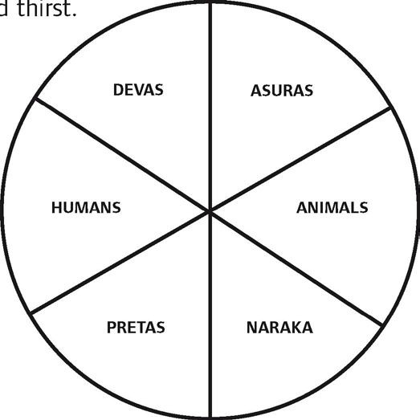
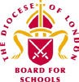
- In the past people everywhere believed in other kinds of non-human beings, like ghosts and fairies, who hang around the edges of our human world. In Buddhism the name for the
place where these beings live is called the preta (spirit) realm. Pretas often live lonely lives and suffer from hunger and thirst.
- The last kind of beings live in naraka (hell) which is a horrible nightmarish place full of pain and suffering.

The endless cycle of the birth and death of beings through the six realms is called samsara, which means something like ‘continually moving on’. All beings are trapped in samsara.

The deva, asura and human states are called the higher realms. The animal, preta and hell states are the lower realms. It’s only in the higher realms that we can do good actions and become wise enough to get free

from samsara.

Karma and Rebirth
Buddhists believe that the things people do and the way we think is important in this life and also affects the kind of rebirth we will have. This is the idea of karma, which means ‘action’. In Buddhism it matters how we behave. The way we act now shapes our present life. But our actions also have a powerful influence on the kind of being we become after we die and are reborn.
For example, when our minds are filled with angry thoughts towards other people, we always want to fight and other people become frightened of us. We may have very few friends and make lots of enemies. Always being angry causes a negative kind of karma and makes us very unhappy and lonely in this life. Buddhists believe that after someone like that dies, because of the habit of being angry, they are more likely to be born somewhere where they are surrounded by lots of fighting. On the other hand, if we are kind, generous and work for the happiness of others, this creates good karma, and we will probably be reborn in one of the higher realms.

Things Buddhists do for dying people
Buddhists think that it is important for people to die in a peaceful place, cared for by those they know and trust.
Sometimes the dying person will be visited by their Buddhist teachers who chant special verses. They might also re- take some of their Buddhist vows. Dying people are encouraged to let go of the attachment

to this life by giving away their wealth for the benefit of others - maybe to help support a monastery or print Buddhist texts, but also to help relieve suffering and poverty in the world.

After Death
Immediately after death, it is common for Buddhist scriptures to be chanted around the body, and for people who were close to the dead person to say farewell and make wishes for them to have a happy rebirth. Buddhist ceremonies are performed, and the benefit of doing the ceremony is dedicated to the person who has died, to make sure they are born as another human being.

In Buddhism the body is usually cremated, following the example of the Buddha. The destruction of the body through fire is thought to be a very powerful teaching on impermanence and helps the family and friends to realise that the person has left this life and cannot return.

Rebirth
In South East Asian countries the person who dies is thought to be reborn immediately after dying. In Tibetan and Chinese Buddhism there is said to be a period of seven weeks between one life and the next.

In Tibetan Buddhism, a picture of the dead person is sometimes placed on the shrine for seven weeks. Special words are chanted regularly during this period. On the 49th day, the picture is burned, and special prayers are

made.

In many East Asian Buddhist countries special prayers are made for the dead person to be reborn in a Pure Land, a happy place where they can learn much more about the Buddha’s teachings and train in ways to help free other beings from suffering.

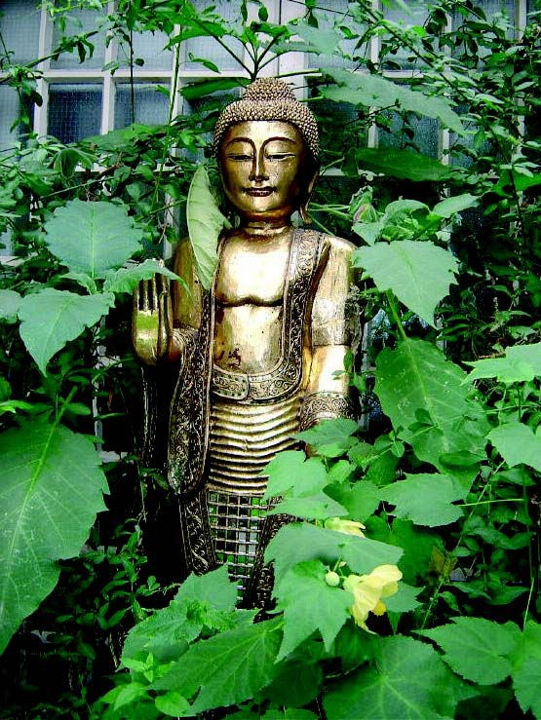
Buddhist Glossary

Asura | ‘Jealous God’ – one of the six realms
Being | Every kind of living thing, apart from plants.
Deva | ‘God’ – one of the six realms. A bit like Heaven, but doesn’t last.
Karma | Actions with a strong intention that influence not only the current life,  but also future rebirths.
Naraka | ‘Hell’ – one of the six realms. Like hell, but doesn’t last.
Preta | ‘Spirit’ or ‘Hungry Ghost’ – one of the six realms.
Pure Land | ‘Buddha Realm’. A kind of temporary heaven presided over by a Buddha,  where people can go further on the Buddhist path.
Rebirth | The process by which beings are endlessly born into one of the six realms.  The traditional Sanskrit words for this are Bhavana which means ‘becoming’ or Jati which is ‘birth’.
Samsara | The endless cycle or wheel of birth and death, driven by the actions of  beings (karma).
Six Realms | The six realms cover all the possible kinds of beings that exist in the  universe. None of these realms are permanent.

Rituals Related to Death in the Hindu Family
Hindus believe in reincarnation. They believe that death is the start of a long sleep for the soul, before it sets out on a new life. Hindus believe that death is part of the cycle of life and is what happens before you set out on a new life.

Each life teaches new lessons and brings a soul closer to God. Good deeds will bring you nearer to God and bad deeds will push you away from him so that you will just stay in the cycle of life and death and not move towards freedom.

What happens when a Hindu dies?

Where possible, relatives gather around a dying person, dip a leaf of sweet basil in water from the Ganges or milk, and place this on the lips of the dying person while they sing holy songs and read holy texts. If available, a special funeral priest is called. A light is lit in the home which is kept alight for twelve days. The “chief mourner” leads the rites. This person is either the eldest son in the case of the father’s death or the youngest son in the case of the mother. If there are no sons the work will be done by the nearest male relative.

After death, the chief mourner performs arati, passing an oil lamp over the remains, and then offering flowers. The body is prepared for cremation. Sesame oil is applied to the dead person’s head. The body is bathed with water, anointed with salve of sandalwood, kum kum powder and vibuthi from the nine kumbhas, dressed in best clothes and placed in a coffin. The women then walk around the body and offer puffed rice into the mouth to nourish the deceased for the journey ahead. A widow will place her Mangalsutra around her husband’s neck, signifying her enduring tie to him. The coffin is then closed. The ritual homa fire can be made at home or kindled at the crematorium.

The Funeral
How a Hindu funeral is organised differs in India and in the UK

The Journey of Life and Death

In India
These days, in most families the body is laid in a coffin and covered with flowers before it is driven to the crematorium. In the crematorium, a small candle or oil lamp (Diwali lamp) is lit, which the main mourner holds in his hand while carrying a container of water on his shoulder. He circles the dead person
three times, and a hole is made in the container each time he goes around. The coffin is then moved to the cremation room (Shamshan ghat). Only men go to the cremation site, led by the chief mourner.
When there is a funeral pyre, the body is carried three times counter-clockwise around the pyre, and then placed upon it. At each turn around the pyre, a
relative knocks a hole in the water container with a knife, letting water out, signifying life is leaving its vessel.
In the UK
The body is laid in a coffin and covered with flowers before it is driven to the crematorium. In the crematorium, a small candle or oil lamp (Diwali lamp) is lit.

At a gas-fuelled crematorium, sacred wood and ghee are placed inside the coffin with the body. Where permitted, the body is carried around the chamber, and a small fire is lit in the coffin before it is consigned to the flames. The cremation switch then is engaged by the chief mourner.

Returning home, everyone bathes and shares in cleaning the house. A lamp and water pot is set where the body lay in state. The

water is changed daily, the picture of the deceased is placed in a room and a garland is placed on it. A lamp is lit next to it and is kept lit for twelve days.

The family shrine room is closed, with white cloth draping all images. During these days of ritual impurity, family and close relatives do not visit other homes, though neighbours and relatives bring daily meals to relieve the burdens during mourning. The mourners do not attend festivals, temples, visit swamis, nor take part in marriage arrangements. Some families observe this period for up to one year.

About twelve hours after the cremation, men from the family return to collect the remains. Water is sprinkled on the ash; the remains are collected on a large tray. At crematoriums the family can arrange to personally gather the remains: ashes and small pieces of white bone called “flowers.” In crematoriums these are ground to dust, and arrangements must be made to preserve them. Ashes are carried or sent to India for depositing in the Ganges or are placed in an auspicious river or the ocean, along with garlands and flowers.

Helping the family
After the cremation, friends visit the bereaved family for the next two weeks, to pay their respects and provide support. Devotional songs are sung and scriptures are read from the Ramayana. This period may be longer if it is a young person who has died or it is an unexpected death. The friends and family talk together about the dead person, share happy memories about their lives with that person and help around the home. Hindus believe that by sharing their grief with each other, the amount of grief will be halved. They believe that although everyone will miss the deceased, death is not sad. The dead person has learned the lessons he or she was meant to learn in life and will move on nearer to God.

The Final Farewell

Each month during the first year after the death, a pinda rice-ball and bowl of water are offered in memory of the dead person. A widow will erase her sindoo and wear white clothes for the first year after her husband’s death. Sons will hold a memorial service each year on the day of their father’s death as long as they are alive.

At the yearly anniversary of the death (according to the moon calendar), a priest conducts the shraddha rites in the home, offering pinda to the ancestors. This ceremony is done yearly as long as the sons of the deceased are alive (or for a specified period). It is now common in India to observe shraddha for ancestors just prior to the yearly Navaratri festival. This time is also appropriate for cases where the day of death is unknown.

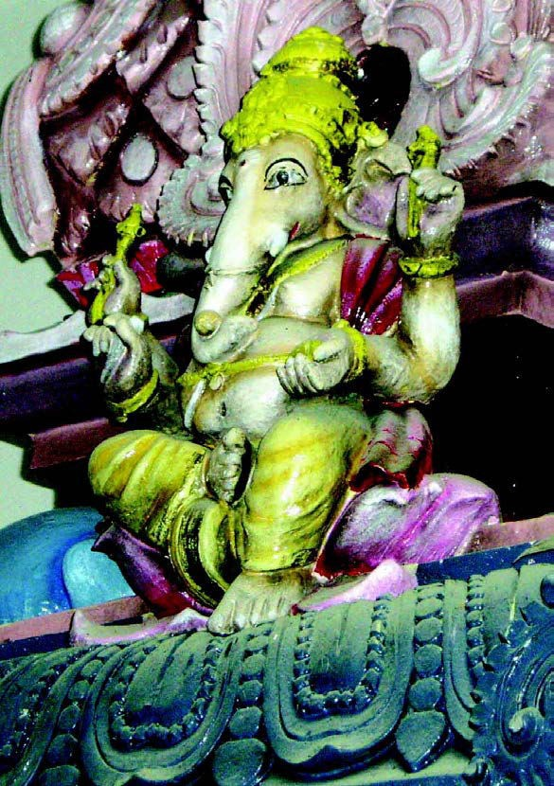
Hindu Glossary

Auspicious | Lucky
Chief mourner | Either the eldest or the youngest son or the nearest male relative
Cremation | Burning
Homa | Fire used in worship
Kumbhas | Brass water pots
Mangalsutra | Wedding pendant
Pinda | Rice-ball
Reincarnation | Rebirth into a new body for another life
Shraddha | Hindu ritual of treating people to feasts in the name of the deceased
Sindoor | Marriage mark

Notes about Death and Bereavement in Judaism
As death approaches an observant Jew would read, or have read for them, a Prayer of Confession followed by the Shema, a prayer said twice a day. The Shema declares that there is one G-d, which is the main belief of Judaism.

There are no services at the Synagogue concerning a funeral. All prayers are said in the ‘House of Mourning’ (usually the home of the deceased, or a close relative) or at the cemetery.

At the ‘House of Mourning’ (Bet Avel), all shiny surfaces such as mirrors and TV’s are covered. This is so that the mourners are not tempted to look at themselves, but think of their departed loved one. Great respect is shown to a person after death - as in life.

Jews believe that the soul of the departed goes to Heaven.

Jewish people believe that all their good deeds are ‘weighed up’ against their bad deeds, with one angel speaking for their ‘good deeds’ and another angel speaking about their ‘bad deeds’. When the good deeds outweigh the bad deeds, the soul can enter Paradise, or Gan Eden, the Garden of Eden.

Eternal Life is a cornerstone of Jewish belief. Jewish people believe that this life, life on earth, is a ‘preparation’ for the ‘Heavenly World’. Jewish people also believe that their souls (but not their bodies) are destined for Eternal Life.

Jewish people believe all their deeds on earth are weighed in this way. They believe that their souls return to G-d in this way. After a person has died, the same respect is shown for them as when they were alive. With this in mind, the body is not left alone at any time. A ‘watch’ is kept from the time of death until the funeral. Funerals in the Jewish tradition are held very quickly, sometimes on

the day of death, but usually on the next day. It is very unusual for there to be a delay, except for Shabbath. A funeral would break the laws of Shabbath (the Jewish Day of Rest), as Shabbath is a day of joy.

Jewish people are always buried in a Shroud. Men are buried in their Tallit (Prayer Shawl) over the Shroud. Coffins are always plain, with no decoration or adornments, and made of unpolished wood. It is not usual to have flowers at a Jewish funeral. These are all signs of the equality of all, in death.

The Mourners (Aveylim) at a funeral would be parents, siblings, children and spouse of the deceased.

One of the main customs to take place before the funeral, either at the Mourners’ house before leaving for the funeral, or at the cemetery, is to ‘Make Kriah’. A piece of clothing of each Mourner would be cut by a friend, relative or by the Rabbi. Kriah is always cut on an actual piece of clothing, such as a shirt or cardigan, but not a tie or scarf, etc. Kriah is cut on the left side of the clothing for a parent, (over the broken heart), and on the right for other relatives. This signifies the more intense grief for a parent. After the cutting, the garment is then torn further by the Mourner.

Each Mourner will wear their torn clothing for the week of intense mourning known as the Shiva.

At every Jewish Cemetery there is a Prayer Hall. Prayers are said in the Prayer Hall both before and after the burial. A tribute may be paid before the burial by a friend or relatives or read by the Rabbi.

The service is aimed at honouring the deceased, and not at comforting the mourners. The service mostly consists of chanting of Psalms. While walking to the graveside, Psalm 91 is chanted.

After the coffin is lowered into the ground, first the Aveylim, and then all those present who wish to, are invited to throw three spades full of earth into the grave. This is done until the entire coffin is covered, showing continuing concern for the deceased. The spade is not passed from hand to hand, but each person returns the spade to the mound of earth, for the next person to take. This signifies that death is not ‘catching’, and will not pass from one person to another. The sound of the earth on the coffin is an act of finality. It helps all concerned to accept the death of the relative or friend. There are two parts of the final goodbye: respect for the deceased, and comfort for the mourners.

Before re-entering the Prayer Hall it is customary for all those who have been on the ‘grounds’ of the cemetery to wash their hands. This represents washing their hands clean of pre-occupation with death. Water is a symbol of life and a source of life in Judaism, no life survives without water. Washing of hands also shows faith that death is not the end, and that life, for the living, must go on. If there are ten men (boys aged over 13 years and one day and men) present, the service in the Cemetery will conclude with the Aveylim reciting the Mourners Prayer, or Kaddish. This prayer declares the greatness of G-d, and the acceptance of his will. If there are not ten men (a Minyan or quorum) present, this prayer cannot be said.

On taking their leave of the Aveylim, both from the cemetery, and later from the House of Mourning, visitors wish each Mourner a ‘Long Life’. This is one of the ways Jewish people tell each other to ‘move on’, and not let grief take over their lives. This is a very important concept in Judaism. Concern is for the living, while showing respect for the deceased.

It is considered to be an exceptional ‘good deed’, (Mitzvah), to ‘accompany the dead’ to their final resting place. This is because this is one Mitzvah for which no reward from the recipient can possibly be expected or given. It is not necessary to have known the deceased to ‘accompany the dead’. It is still considered to be a very important Mitzvah.

There are two parts of the final ‘goodbye’: - respect for the deceased and comfort for the mourners.

On return from the Cemetery, the Aveylim eat a special ‘meal’, consisting of a hard boiled egg, a baigel, and a piece of salt herring. This is called the ‘Meal of Consolation’. The significance of these foods is as follows: The egg, for fertility, and for continuity, an egg has no beginning or end, as mankind has no beginning or end. The baigel, also for continuity, and, as bread, is the staff of life, the sentiment that life must go on. The salt herring signifies the sad time brought by the death of a relative or friend, and reminds us of tears.

After the funeral, seven days of intense mourning are observed by the Aveylim. This period is called ‘Shiva’ meaning seven (days). A memorial candle is kept alight for all of the seven days. During this time, the Aveylim do not work, or beautify themselves, they do not cook or clean, and they sit on low chairs, and wear slippers, not leather shoes, all signs of mourning. Friends and relatives come to the house to speak to them and comfort them.

The Aveylim only leave the house to attend the Synagogue on Shabbath. Friends and family bring ready prepared food for the Aveylim. The three daily prayers (Morning, Afternoon and Evening) are held at the Shiva House for the week of mourning, except for on the Shabbath, as they are then said in the Synagogue. Kaddish is said by the Aveylim at each of these services, as long as there is the required Minyan.

From the day of the funeral, thirty days of mourning are observed, referred to as ‘Shloshim’, meaning ‘Thirty’ (days). During this time, the Aveylim do not go to parties, listen to music, watch TV, cut their hair, or shave their beards. After the first week of Shiva, the Aveylim continue to say Kaddish in the Synagogue, at all daily services. If an Aveylim is mourning the loss of a parent, these restrictions and prayers will continue for one year.

On the anniversary of the death of a relative according to the Jewish calendar, (counting from creation), the Aveylim lights a candle in their home. The candle lasts for 24 hours, and is a reminder of the deceased. On this day, the Aveylim again does not listen to music or attend parties etc. The Aveylim would also say Kaddish in the Synagogue, as before.

Although it is acceptable to dedicate a memorial stone to mark the grave of a loved one after the Shloshim have elapsed, it is more customary to do so at the end of a year.

Note: G-d has been used because it is Jewish practice not to write the Lord’s name as this makes a document or paper holy.

Jewish Glossary
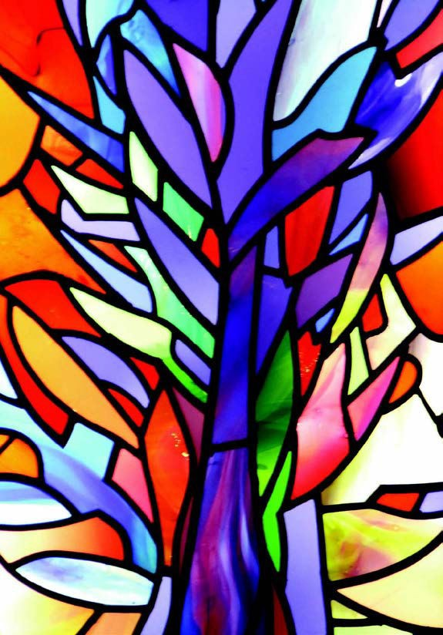
Aveylim | Mourner
Bet aveyl | House of mourning
Kaddish | Mourners prayer or memorial prayer
Kriah | Cutting of mourners clothes
Minyan | Quorum of ten men (over 13 yrs and one day)
Mitzvah | Good deed
Shiva | Seven days of intense mourning
Shloshim | Thirty days of mourning
Tallit | Prayer shawl
References
The Jewish Book of Mourners, Why? By Albert Kolach

www.mazornet.com/deathandmourning Jewish Perspective of Death and Mourning.

Notes about Death and Bereavement in the Muslim Faith

Death
For Muslims, the purpose of life and death and of the afterlife in Islam is explained in the Qur’an. For a Muslim, death is the return of the soul to their Creator, Allah, and so the inevitability of death and the hereafter is never far from the Muslim’s mind.

When a Muslim is dying
Family members of the dying person and their good Muslim friends should be informed and should support him or her in reminding them of Allah. They encourage the dying person very gently to be sorry for all that he or she has done wrong, remind him or her about all the good things that he or she has done, about Allah’s mercy, and of Allah’s forgiveness. Prophet Muhammad (pbuh) said: “Let no Muslim die except expecting and hoping the best from Allah.”

What should be done when someone dies?
Muslims are recommended to do the following when someone dies:
- Advise the dying person to say: “La ilaha illa-Allah.”
- To lay the dying person so that the Qibla is on his right side.
- When the person has died, close their eyes and cover them.
- Prepare the body for burial without delay, as soon as death is confirmed by a doctor.

- Settle any debts of the dead person.
Informing Family and Friends
Muslims tell the family, friends, and other good people when someone dies so that they can attend the funeral. It is a Muslim’s duty to offer condolences, comfort, and sympathy to the family and the relatives of the deceased.

Grieving for the Deceased
Muslims are agreed that crying and grieving for the dead is good, but it is not acceptable to be angry with Allah for the person’s death. It is allowed and acceptable for a Muslim to be sad and grieve for as long as they want to and as long as they need. However people are encouraged to restrict loud and outward mourning.

Preparation of the Deceased
Wherever someone dies, it is very important that the body is taken to the mosque as soon as possible, with all the necessary papers. Muslims have been taught to treat the dead body with gentleness and respect. Cremation is forbidden. Rather, the body is cleaned “washed or bathed”, scented, and covered with a clean cloth for burial. There are certain steps in the preparation of a Muslim’s body for burial, these are:-

Ghusul - This involves a ritual washing like wudu and then there is a complete washing of the whole body. Male bodies are washed by a man and female bodies are washed by a woman, these will normally be close relations.

Kafan - This is the shroud that is used to wrap the body of the person who has died. The kafan must be wrapped around the body at least three times overlapped. These could be the Muslim’s Hajj robes.

The Funeral
Praying for the person who has died and having funeral prayers in the mosque Salat-ul-Janazah, are essential in Islam. The Muslim starts his or her life with a call to prayer and life is concluded with a prayer, so all of life is seen as an act of worship. The congregation pray to ask Allah to forgive the dead person’s sins, have mercy on him or her and to grant them a place in Jannah.

Burial
The body should be buried by Muslims as soon as possible in a Muslim cemetery and the body should be turned towards the Qibla. Generally graves should be simple. People may visit them afterwards to pray for the person who has died and to remember that there is an end to earthly life but also to reflect on the life after death.

Bereavement
The initial bereavement period lasts for three days, during which prayers in the home are recited almost continuously. Shoes are taken off before entering the house of the bereaved, and it is customary to cover one’s head when talking about the person who has died. People often sit on the carpet to pass on their condolences. Traditionally, black clothes or veils are not worn during bereavement - most people wear plain simple clothes with

no make-up or jewellery.

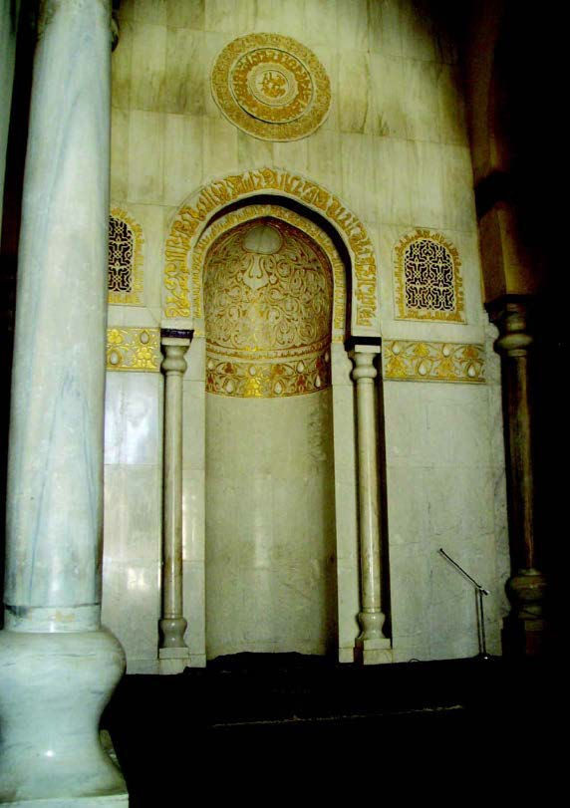
“Allah has created life and death as a test to see who is the better in conduct.”
From The Qur’an, Sura 67:2

Muslim Glossary

Allah | God, in Arabic.
Ghusul | Washing of the dead body.
Hajj | Pilgrimage to Makkah. Hajj Robes are the robes worn by men during the Hajj. Women do not wear Hajj robes.
Jannah | This is paradise; a place that Muslims believe has been prepared as a reward for those who have lived a good life. ‘A good life’ means one that Allah considers good.
Kafan | Shroud used for wrapping the dead body.
“La ilaha illa-Allah” | “There is no god but Allah.”
Qibla | Towards Makkah.

Qur’an | The final revealed message from God.
Salah-ul-Janazah | The funeral prayers.
Wudu | Ritual washing before prayer.

Notes about Death and Bereavement in the Sikh Faith
Sacred Text

This text tells Sikhs to behave well in this life, so that when they die they will be able to stay with God and escape reincarnation.

‘Strive to seek that for which you have come into the world, find through the grace of the Guru, God will dwell in your heart. You will abide in His presence, in comfort and in peace and not return ever to be born and to die once more.’
Guru Arjan

The Long Sleep

Many Sikhs believe in reincarnation. They believe that death is the start of a long sleep for the soul, before it sets out on a new life. Sikhs believe that death is part of the cycle of life and is what happens before you set out on a new life.

Each life teaches new lessons and brings a soul closer to God. Good deeds will bring you nearer to God and bad deeds will push you

away from him and that you will just stay in the cycle of life and death and not towards freedom.

Sikhs believe that souls are rewarded for good deeds and that when all lessons are learned God will free them from the need to experience another life. Then they will be able to join God and be liberated (mukti) from the cycle of birth and death.

The Sikh holy book, the Guru Granth Sahib, says that mukti can only be achieved by living a God-conscious life, where everything you do is guided by the word of God. Sikhs believe that the only thing that you carry with you when you die is good deeds. (See Guru Nahak’s story of the Rich Man and the Needle.)

What happens when a Sikh dies?

When a Sikh dies the evening prayer is said and everyone remembers God by saying ‘Waheguru!’ meaning ‘Wonderful Lord’.

Everyone is treated equally in Sikhism because Sikhs believe that everyone is of equal importance and was created by one and the same God, so no matter how wealthy or powerful a Sikh may be in this life, his or her funeral will be the same as the poorest Sikh’s. Sikhs believe in cremation, not burial, as the body that is left is just a shell for which the soul has no more use. The cremation should take place as soon as possible, and in India it usually happens on the same day as the death, or the next day.

Before the cremation, the body is washed; traditionally yoghurt and water are used. It is then dressed in new clothes, including the Five Ks – the symbols of the Sikh faith: shorts, uncut hair, sword, bracelet and a comb. The body is then placed on a bier or in a coffin and covered with a plain cloth. It is brought home on the way to the funeral so that friends and relations can pay their respects to the dead person one last time.

When a death occurs, the family and friends make arrangements to read the Guru Granth Sahib. This can either be read whenever the bereaved wish or continuously (Akhand Path). The continuous reading takes approximately 48 hours to complete. Sometimes

the Guru Granth Sahib is read over a week or more.

The Funeral

On the way to the place where the cremation takes place, the body is taken to the Gurudwara for prayers. It is not usually taken inside the building; the prayers are said outside the building. Then a procession takes the body to the funeral ground where it will be cremated.

Once they arrive, the friends and relations say a general prayer over the coffin. This is the concluding prayer (Keertan Sohila), and this is the same prayer which is said every night when the Guru Granth Sahib is placed in its resting place in the Gurudwara. At the cremation site the funeral pyre is lit. This is usually done by the eldest son. If the cremation takes place in a crematorium, the nearest relative will indicate when the cremation should begin. After the cremation, everyone returns to the Gurudwara for the Bhog service, in which Shabads (hymns) from the Guru Granth Sahib are recited and sung.

Everyone shares Karah parshad, a sweet which symbolizes equality of all humans, and they have a meal in the community kitchen, or langar. Both of these rituals symbolize equality to Sikhs. They also remind everyone that life must go on for those left behind. Sikhs often give money to charity at this time.
Helping the Family

After the cremation, friends visit the bereaved family for the next two weeks, to pay their respects and provide support. This may be longer if it is a young person who has died or it is an unexpected death. They talk together about the dead person, share happy memories about their lives with that person and help around the home. Sikhs believing that by sharing their grief with each other, the amount of grief will be halved. This will help bring the community together and may heal any family conflicts that existed before the person died.

Sikhs believe that although everyone will miss the deceased, death should not be sad. The dead person has learned the lessons he or she was meant to learn in life and will move on nearer to God.

The Final Farewell

In Sikhism it is forbidden to erect a tomb of memorial to a dead person because Sikhs do not believe that the body is of any use after the soul has left it. In India, therefore, after a cremation many families arrange for the dead person’s ashes to be taken to Kiratpur near Anandpur Sahib. There they are sprinkled onto the waters of a river. Sikhs living outside India who cannot arrange to travel there for this purpose will still arrange for the ashes to be scattered onto flowing water in the local river or sea.

Sikh Glossary

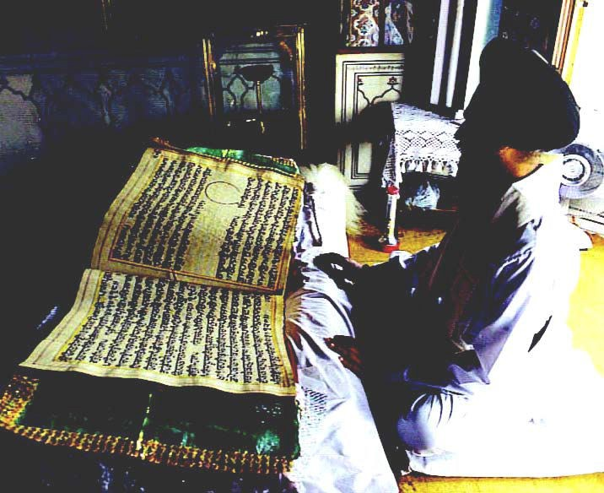
Akhand Path | The 48 hour continuous reading of the Guru Granth Sahib
Bhog | Food offering
Guru Granth Sahib | Last and everlasting Guru, Sikh holy book
Karah parshad | A sweet pudding which symbolizes equality of all humans
Keentan Sohila | Concluding prayer of the day for Sikhs
Langar | Food prepared and shared in the community kitchen
Mukti | Liberation
Shabads | Hymns
Waheguru | Wonderful Lord

Learning Together Through Faiths

The Journey of Life and Death

Make some notes for your feedback under the name of the religion.

- Which religion are you studying?

- Where do people of this faith believe they go after death?

- What can you find out about that place?

- In this faith what does it teach about how this life influences what happens to believers after death?

- What rituals or traditions are used by members of this faith when a believer has died?

- Are there any special ways that this religion has helped people to remember someone who has die?

The Journey of Life and Death

From “Badger’s Parting Gifts”

“Although Badger was no longer with his friends, he had given each of them a special memory of him.”

“He wanted them to help each other using these gifts.”

“Even though Mole and his friends felt lost, alone and unhappy, in time their sadness melted like the winter snow.”

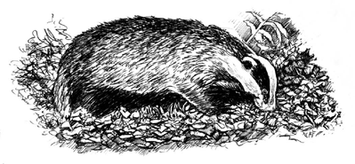
“They remembered the joyful moments they had shared with Badger and all that he had taught them, and they felt thankful that they had known him. As he had left them he had felt free and happy, not afraid.”
By Susan Varley

