Year group: Reception

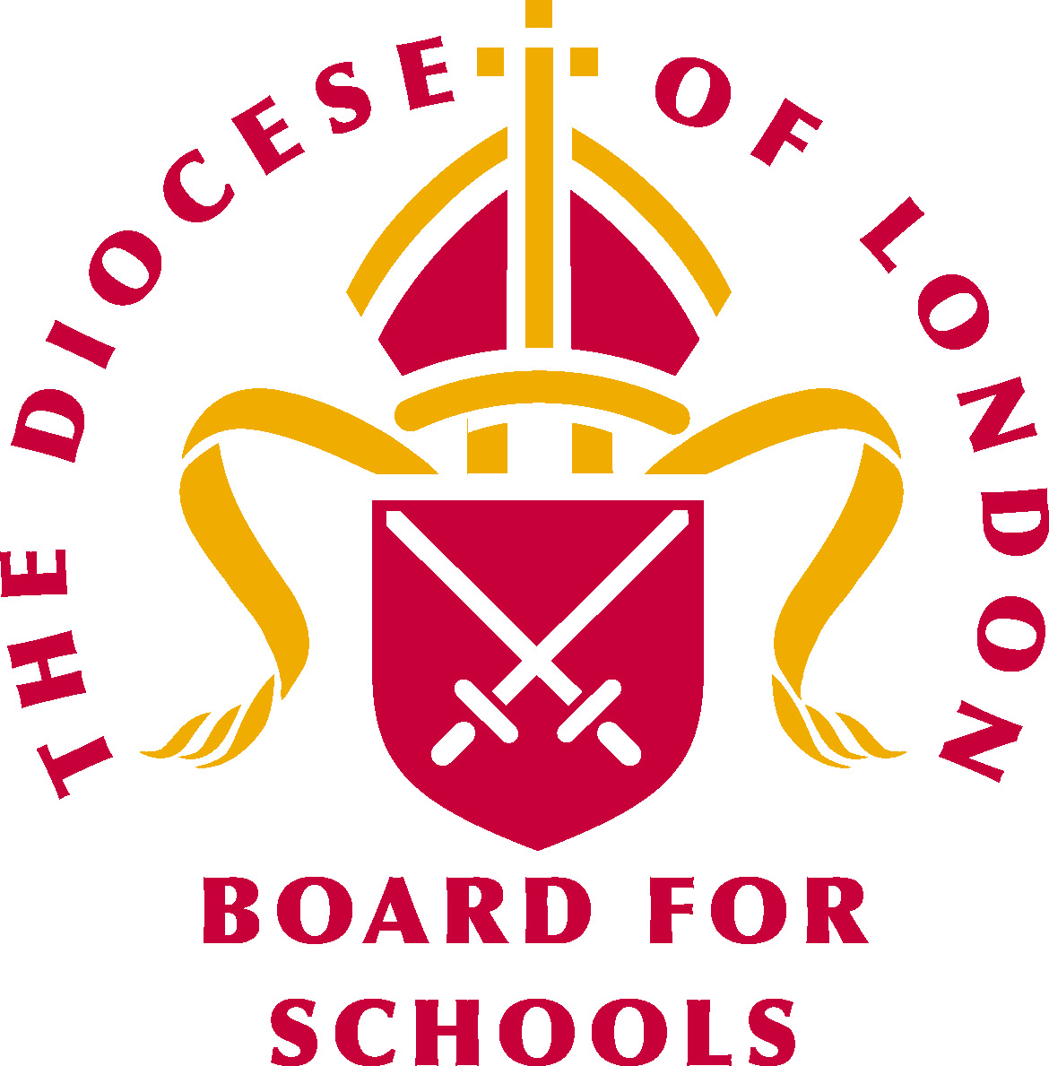Big question: Why is Christmas special for Christians?
Points for discussion throughout the unit:

Sensitivities:
- Be mindful of pupils’ cultural backgrounds and beliefs.
- Jealousy with birth of sibling, pupils with no siblings, adoption / fostered pupils, single parent families.
- Personal unforeseen circumstances such as death of a baby.
- Disparities between pupils’ experiences of Christmas and Christmas presents.
- The Nativity story is told in the Quran but is significantly different.

Religious vocabulary:
- Incarnation: See background knowledge for teachers.
- Christmas: Christian festival that marks the birth of Jesus Christ.
- Good News: News of salvation - being saved.
- Bible: Holy Book for Christianity.
- Announcement: The announcing (telling) from Archangel Gabriel to Mary that she would conceive God’s son.
- Archangel Gabriel: See background knowledge for teachers.
- Mary: See background knowledge for teachers.
- Joseph: See background knowledge for teachers.
- Shepherds: See background knowledge for teachers.
- King Herod: See background knowledge for teachers.
- Wisemen: See background knowledge for teachers.
- Love: Our relationship with God and with each other.

At the end of this unit children will have explored….
- The Nativity story and what it means to Christians.
- How Mary knew she was having a baby through the visitation of the Archangel Gabriel.
- How Christians prepare for Christmas.
- Why Christmas is special to Christians.
- The special gift of Christ at Christmas.
Weekly questions:
Week 1: How do people prepare for the birth of a baby?
Week 2: How did Mary know she was going to have a baby?
Week 3: How did Mary and Joseph feel about having a baby?
Week 4: How do Christians prepare for the special day of Christmas?
Week 5: What story do Christians remember at Christmas and why?
Week 6: Why is Christmas special for Christians?

Core concept: Incarnation
Background knowledge for teachers:

Core concept: Incarnation

The meaning of incarnation: God comes to live amongst His creation in the form of Jesus. Jesus is both human and devine. Incarnation means that Jesus is God in the flesh.

To note: Jesus has always existed as God. He is part of the Trinity that has been present from the very beginning of time. Misconception: Jesus appeared at Christmas and was not in existence before then.

Key things to note:

Christmas:
What is the meaning of Christmas in Christianity? Christmas is about the birth of God's Son – Jesus. It is about how he came to give love, hope and joy. The Archangel Gabriel appeared to Mary and explained that she was the chosen one to carry God’s Son Jesus.
A special baby At Christmas time once, a man named Joseph and a woman named Mary were going to have a very special baby. An angel told Mary the baby was God’s own son! His name was Jesus.
No room at the inn
Joseph and Mary had to go to Bethlehem, a city far away. But when they got there, there was no room for them at the inn.
Born in a Stable
The inn keeper told them they could stay in the stable. That night, baby Jesus was born among the animals in the stable!
Shepherds in the field
Nearby, there were some shepherds taking care of their sheep. Suddenly, the sky was filled with angels! they told the shepherds that Jesus had been born that night. The shepherds hurried away to find him.
The wise men
Even some wise men from far away heard of Jesus. God put a special star in the sky to lead them to where Jesus was! They travelled a long time. Finally, they found Baby Jesus.
Gifts to Baby Jesus
The wise men gave gifts to baby Jesus of Frankincense, Gold and Myrrh. They knew he was God’s own son because God had told them.

Archangel Gabriel:
- Gabriel is known as an archangel – meaning chief angel.
- The word Gabriel means God is strong/powerful/mighty.
- Gabriel is God’s messenger.
- Gabriel appears in both the Old and New Testament.
- Gabriel appears to Daniel in the Old Testament.
- In the New Testament, Gabriel first appears to Zachariah, father of John the Baptist, to let him know that Elizabeth shall bear a son who shall be called John.
- Gabriel then appears again to Mary to announce that she will conceive God’s son.
- After the annunciation of Mary, Gabriel is not spoken of again.
- Misconception: Angels have wings. In the Bible, angels are not depicted as having wings.
Mary:
- Prominent female figure in the New Testament.
- Mary is fully human but has a very important and intimate place in the story of Jesus. She is the God bearer.
- Mary is often described as the role model for motherhood.
- Mary was a young Jewish girl probably around the age of 13.
- Mary, like many Jewish girls of her time, would have spent most of her days working.
- Mary was betrothed to be married. This would often happen about a year before she would move to live with her husband and his family. It would be at this point that she would have been considered married.
- Mary though afraid said ‘yes’ to God.
- Mary accepted the will of God. She gave birth to His son and stood by Jesus throughout his whole ministry. John’s Gospel recalls her being at the foot of the cross when Jesus was crucified.
- Mary was an ordinary Jewish girl who accepted the most extraordinary task, to be the God bearer of His one and only son Jesus Christ.

Importance: Without Mary, Jesus could not have been born. Mary is therefore essential to the Nativity story.

Joseph: From the Gospel of Matthew
- Joseph was a righteous man.
- His actions towards Mary were kind and sensitive.
- Joseph could have broken off the engagement and he did consider this. To be with a pregnant woman would not have been accepted and would have brought significant shame on the family. However, Joseph was reassured in a dream, of God’s plan, which he accepted in spite of the public humiliation he would face.
- We are told little about what he was like as a father. We are given indications that he acted with integrity and righteousness.
- God honoured Joseph’s integrity by entrusting him with His son.
- Joseph took his job seriously. He protected Jesus right from the beginning – the escape to Egypt when he was told in a dream to go there to get away from King Herod.
- Joseph ensured that Jesus learnt at the synagogue from an early age, in preparation for his ministry.
- Joseph did not know all the details of what was to happen to Jesus, but he responded in faith to what God was asking of him.

Importance: God chose Joseph. Joseph was righteous, loyal, committed and kind. He took his role seriously and acted with integrity.

Lesson 1: How do people prepare for the birth of a baby?
Intentions:  To give pupils opportunities to: | - Be able to talk about how people prepare for a new baby.  Be able to discuss different emotions about the birth of a baby.  Religious Vocabulary: Baby shower, Jesus, God, baby, hope, gift.
Implementation:  Outlining how to introduce the religious content in the classroom and create learning opportunities from it. | Main teaching input:  Concept: Incarnation  Teacher explains that the pupils are going to be learning about a very special baby called Jesus who is an important person in the Christian faith. Teacher role play: Displays a giant invitation to a baby shower. Explains that we are all invited but we have to bring things that the new baby will need.  Introduce the big question for the unit: Why is Christmas special for Christians?  Introduce this week’s question: How do people prepare for the birth of a baby?  Key questions:  - What will we need to bring and why?  - What will a new baby need?  - Why do some people have baby showers?  - Why are babies special?  - How would you feel about a new baby?  Suggested whole class activities:  - Mind map on whiteboard to share ideas.  - Counting how many sets of clothes a baby would need during a day.  - Compare and contrast – sorting things a baby would need compared to things they would need / want.  Talk about how a long time ago people were getting ready for a new baby to be born, which was baby Jesus.  Explain how at that time the world was not a very nice place and this baby was going to help the world be a better place. The baby was a sign of hope. Explain how this baby was God’s son and God had sent messages to tell people that the baby would be born.  *The telling of the Nativity story is not to be explored at this point.  Explain continuous provision activities. Send pupils off to explore and discover.  Come back together at end of session and role play giving the doll the things they’ve made. Focus on feelings giving the gifts to the baby.  Key questions/adult Interaction (C&L, PSED):  - How would you feel about a new baby?  - What would you hope for the new baby?  - What can we give the new baby?  - What can we make the new baby?  - I wonder why the birth of baby Jesus is so important to Christians.  - I wonder what kind of baby equipment baby Jesus would have had.
Continuous provision: | Areas of learning:  Understanding of the world:  - Tuff spot Baby dolls, clothes and baby equipment.  - Why do babies need certain items? What are they used for?  Expressive arts and design:  - Making a baby mobile.  - Drawing picture of them welcoming baby with focus on their face.  - Making a gift for a baby out of junk e.g bottle with rice in as a rattle.  Literacy:  - Writing names for the baby.  - Writing “Welcome baby” banners.  Maths:  - Count how many baby grows, bibs, soothers, baby bottles you can find in box. Write the numbers on a whiteboard using a number line to support.
Resources: | - Baby doll.  - Baby clothes, baby bottle, soother, bib etc.  - Baby Shower invitation.
Sensitivities: | - Jealousy with birth of sibling, pupils with no siblings, adoption / fostered pupils, single parent families.  - Personal unforeseen circumstances such as death of a baby.
Impact:  What do you notice as a teacher?  What do pupils say? | In this box, note down anything that you heard a pupil say that would provide evidence towards their progress in RE.  Note down anything significant an additional adult has noticed.  Note down anything significant that happened in the lesson that will have an impact on the next lesson.
Lesson 2: How did Mary know she was going to have a baby?
Intentions:  To give pupils opportunities to: | - Be able to retell the story of the Angel Gabriel visiting Mary.  - Be able to talk about things that are puzzling.  Religious vocabulary: Angel Gabriel, Mary, Son of God, Bible Jesus, Christian, baby.
Implementation:  Outlining how to introduce the religious content in the classroom and create learning opportunities from it. | Teaching input: As session starts, play show, calm choral music, e.g. https://www.youtube.com/watch?v=hOVdjxtnsH8  Concept: Incarnation  Read the story of Angel Gabriel visiting Mary, explaining that it comes from the Holy book for Christians - the Bible - e.g.  “The Angel’s Secret” from The Beginners Bible (Zonderkidz 1997) / watch a video clip of it.  Suggested whole class activities:  While the story is being read, second adult reveals an angel, a figure of Mary and a figure of the baby from a story bag.  Talk about the story with “I wonder...” questions, e.g.  Key questions:  - I wonder what you liked about the story.  - I wonder what the angel meant when he said that Mary’s baby would be called the Son of God.  - I wonder how Mary felt when the angel first appeared.  - I wonder how Mary felt about the news the angel had given her.  Key questions/adult interaction (C&L, PSED):  - Why did the Angel Gabriel appear to Mary?  - I wonder why the Angel Gabriel appeared to Mary when she was alone.  - I wonder why God chose Mary to have baby Jesus.  - Why do you think angels are so special to many Christians.
Continuous provision: | Areas of learning:  Understanding of the world:  - Role- play using costumes or using figures from story bag.  Expressive arts and design:  - Making angels - e.g. paper cone or hand prints (painted or sand) could be problem solving activity.  Literacy:  - Writing in speech bubbles to show communication between Angel Gabriel and Mary.  - Retell the story using a writing frame.  Maths:  (Laminate Angel cut outs)  - Counting angels, adding or subtracting angels. Writing sums on whiteboards.
Resources: | - Bible, angelic music clip, story bag (e.g. angel from top of the tree, PlayMobil / Lego / knitted woman figure for Mary / art and design materials, drawing/ writing computing programme, clothes for role play.
Sensitivities: | - Jealousy with birth of sibling, pupils with no siblings, adoption / fostered pupils, single parent families.  - Personal unforeseen circumstances such as death of a baby.
Impact:  What do you notice as a teacher?  What do pupils say? | In this box, note down anything that you heard a pupil say that would provide evidence towards their progress in RE.  Note down anything significant an additional adult has noticed.  Note down anything significant that happened in the lesson that will have an impact on the next lesson.
Lesson 3: How did Mary and Joseph feel about having a baby?
Intentions:  To give pupils opportunities to: | - Be able to talk about the feelings of Mary and Joseph.  - Be able to talk about their own feelings.  Religious vocabulary: Mary, Joseph, Jesus, special baby, Bible, present, gift, Christmas, expectation, trust.
Implementation:  Outlining how to introduce the religious content in the classroom and create learning opportunities from it. | Teaching input:  Concept: Incarnation  Begin by producing a big cardboard present box and role play excitement about guessing what’s in the box. Open box to discover small birthday card. Emphasis that it’s lovely to get a gift but discuss feeling of disappointment when the pupils saw that it was just a card.  Introduce this week’s question: How did Mary and Joseph feel about having a baby?  Read Matthew chapter 1: 18 and 21 and discuss how Mary and Joseph might have been feeling when they realised that something had changed in their lives.  Emphasise that plans can change for the better, but it still feels unsettling if something happens that you aren’t expecting.  Suggested whole class activities.  Key questions:  Questions about changes in plans:  - How would you feel if you were expecting your trusted adult to pick you up and then it was someone different you knew instead?  - How would you feel if you were going to have a treat and then it got cancelled?  - How would Mary and Joseph have felt about being chosen for this special job, but not knowing exactly what was going to happen?  *Bring in the idea of trust and express sometimes our plans can change for the better.  Key questions/adult interaction(C&L, PSED):  - I wonder how Mary and Joseph felt.  - How do you feel when your plans get changed?  - What emotions can we use to show how we feel?  - What is your favourite emotion and why?  - I wonder which emotions Mary and Joseph showed when they heard the good news.
Continuous provision: | Areas of learning:  Adult led discussion group using traffic light emotion faces. How might Mary have been feeling? How might Joseph have been feeling? What ‘emotion’ face would you give each person? Can you say why?  Understanding of the world:  - Use puppets in pairs to practice conversation between Mary and Joseph.  Expressive arts and design:  - Adult led - group making up nursery rhyme about Joseph and Mary’s feelings.  - Making puppet faces on sticks to show Mary and Joseph’s emotions.  Literacy:  - Writing activity – diary entry on how Mary and Joseph may have felt.  - Use 3 images, one of Angel Gabriel with Mary, one of Angel Gabriel with Joseph and one of Mary and Joseph talking together. Sequence the pictures. Pupils then write in the speech bubble what each person might be saying.
Resources: | - Children’s Bible  - Wrapped present with card inside  - Emotion cards  - 3 images: Angel Gabriel with Mary. Angel Gabriel with Joseph. Joseph and Mary.
Sensitivities: | - Jealousy with birth of sibling, pupils with no siblings, adoption / fostered pupils, single parent families.  - Personal unforeseen circumstances such as death of a baby.
Impact:  What do you notice as a teacher?  What do pupils say? | In this box, note down anything that you heard a pupil say that would provide evidence towards their progress in RE.  Note down anything significant an additional adult has noticed.  Note down anything significant that happened in the lesson that will have an impact on the next lesson.
Lesson 4: How do Christians prepare for the special day of Christmas?
Intentions:  To give pupils opportunities to: | - Be able to recognise and talk about Advent.  - Be able to discuss why preparation is important to them and others.  Religious Vocabulary: Advent, wreath, candle, Jesus, altar cloth, preparation, Christians, Christmas, Advent calendar.
Implementation:  Outlining how to introduce the religious content in the classroom and create learning opportunities from it. | Teaching input:  Concept: Incarnation  Introduce this week’s question: How do Christians prepare for the special day of Christmas?  The teacher uses a box or bag with special advent objects in it: purple cloth, Advent wreath, Advent calendar, Advent candle.  Key questions:  - Ask what the objects are for / about. Why do we get ready for special times?  - Why do Christians spend time counting down to Christmas? Explain that this countdown time is called Advent and is a special time of waiting and preparing for Christmas.  - How do / are some of the pupils and their families preparing for Christmas?  Suggested whole class activities key questions:  - How long does a minute last? Play music and when the music stops, children freeze for a whole minute.  - Discuss how much longer than a minute Mary and Joseph had to wait for their baby to come. How might they have been preparing for the birth of Jesus?  - If appropriate, visit the local church to learn how the church is decorated for Advent and preparing for Christmas.  - Invite a practicing Christian to the class to share with how they are preparing for Christmas and to share what Advent means to them.  Key questions/adult interaction(C&L, PSED):  - Why is Advent a special time for Christians?  - Can you think of a time where you have counted time e.g. Birthday or a special event? How did it make you feel?  - I wonder why advent calendars end on 25.  - I wonder why advent wreaths have candles.
Continuous provision: | Areas of learning:  Understanding of the world:  - Making an Advent wreath from leaves and sticks (collect from outside/forest school).  Expressive arts and design:  - Make own Advent wreath using a variety of media.  - Make an advent wreath hat.  Literacy:  - Candle shaped writing frames - choose to write about what people might do to prepare for Christmas.  Maths:  - Make a class Advent calendar with each child making a picture for a different door/pocket representing different characters/scenes from the nativity and number doors.
Resources: | - Purple altar cloth, Advent wreath, Advent calendar, Advent candle, art and design materials, natural materials including leaves and twigs, stopwatch.
Sensitivities: | - Jealousy with birth of sibling, pupils with no siblings, adoption / fostered pupils, single parent families.  - Personal unforeseen circumstances such as death of a baby.
Impact:  What do you notice as a teacher?  What do pupils say? | In this box, note down anything that you heard a pupil say that would provide evidence towards their progress in RE.  Note down anything significant an additional adult has noticed.  Note down anything significant that happened in the lesson that will have an impact on the next lesson.
Lesson 5: What story do Christians remember at Christmas and why?
Intentions:  To give pupils opportunities to: | - Be able to retell the Nativity Story.  - Be able to talk about what they find interesting and puzzling.  Religious vocabulary: Christmas, special baby, God, Jesus, innkeeper, Mary, Joseph, manger, baby, human, Incarnation, nativity.
Implementation:  Outlining how to introduce the religious content in the classroom and create learning opportunities from it. | Teaching input:  Concept: Incarnation  Introduce this week’s question: What story do Christians remember at Christmas and why?  Tell the story of the first Christmas as a reflective story using toy figurines. Alternatively watch the Christmas story e.g. https://www.youtube.com/watch?v=FrTFAZPQxpE or read it from the Bible (Luke 2:1-7.)  Introduce the special word ‘Incarnation’. Talk about how it means God becoming human. Discuss the idea of Incarnation: Christians believe that they can’t see God so God made Jesus so that they could see him / Jesus is God as a human, in a body.  Suggested whole class activities:  Key questions:  - Sing a Christmas song e.g. The Virgin Mary Had a Baby Boy https://www.youtube.com/watch?v=IqDVq-L269c or Away in a manger.  - Question: Which part of the story do you think is the most important? Why?  - Why do you think Christians remember this story at Christmas?  Key questions/adult interaction (C&L, PSED):  - Who are the main people in the nativity story?  - Who do you think is the most important person in the nativity story?  - Why do you think the nativity important to Christians?
Continuous provision: | Areas of learning:  Adult led activity looking at role of innkeepers, discussion about being kind, caring and sharing, difference between right and wrong.  Understanding of the world:  - Reflective storytelling to retell Christmas story – Tuff spot Nativity scene.  - Role play with props / costumes/puppets.  Expressive arts and design:  - Use modelling clay to make class nativity scene.  - Paint nativity scene.  - Make nativity puppets.  Literacy:  - Writing baby announcement cards for Mary and Joseph to send - “It is a boy!” Also add a comment from Mary and Joseph about how they are feeling as the parents of baby Jesus.  Maths:  - Count how many nativity characters there are, write number on whiteboard using number line to support.  - How many would you have if we took ‘x’ amount away or added ‘x’ amount. Can you write the sum on the whiteboard.
Resources: | - Figures for reflective storytelling, props and costumes for role play, templates for “It’s a Boy!” cards, modelling clay.
Sensitivities: | - Jealousy with birth of sibling, pupils with no siblings, adoption / fostered pupils, single parent families.  - Personal unforeseen circumstances such as death of a baby.
Impact:  What do you notice as a teacher?  What do pupils say? | In this box, note down anything that you heard a pupil say that would provide evidence towards their progress in RE.  Note down anything significant an additional adult has noticed.  Note down anything significant that happened in the lesson that will have an impact on the next lesson.
Lesson 6: Why is Christmas special for Christians?
Intentions:  To give pupils opportunities to: | - Be able to talk about religious symbols (peace) and words (joy, good news) and significant people.  - Be able to talk about why these words, symbols and people are important.  Religious vocabulary: shepherds, angel, joy, peace, good news, Christian, Christmas, gift.
Implementation:  Outlining how to introduce the religious content in the classroom and create learning opportunities from it. | Teaching input:  Concept: Incarnation  Introduce this week’s question: Why is Christmas special for Christians?  Read the story of the shepherds (Luke 2:8-20) or watch video clip e.g. https://www.youtube.com/watch?v=TaeBx6bPlv4  The angel said he had “good news”. What was the good news? Discuss message of Jesus’ birth: joy, peace and good news What do joy / peace / good news mean?  Key questions:  - Talk about joy as a bigger version of happy.  - What do joy / peace / good news feel like?  - What good news have the pupils had in their lives?  - When have the pupils felt joy / peace?  - Why do you think God sent the Angel Gabriel to appear to shepherds?  *Emphasise the idea of shepherds being ordinary people because Jesus was here for everyone, not just important kings.  Suggested whole class activities:  Key questions:  Reinforce idea that Christmas is special to Christians because they remember when Jesus was born. This meant good news, peace and joy for the world. Give out a range of ‘gits’ to children that are free – eg – the gift of love, the gift of friendship, the gift of peace, the gift of kindness, the gift of a smile. Have Christmas reflective music playing in the background while pupils read their gift to the class and to all. Talk to children about how this gift makes them feel? Emphasise that these gifts are precious and lasting.  Key questions/Adult interaction(C&L, PSED):  - I wonder if you can remember a time when you felt joy?  - Why do you think Jesus’ birth is so important to Christians?  - Why were the shepherds important in the nativity story?
Continuous provision: | Areas of learning:  Understanding of the world:  - Using magnifying glasses to find shepherds / other important characters in Christmas card pictures.  - Adult led discussion - Jesus came to bring peace to people. How can we bring peace in the classroom?  Expressive arts and design:  - Creating paper peace doves (either with handprints for a whole class dove) or individual ones.  - Shepherd and angel role play.  Literacy:  - “I feel joy when...” drawing / writing activity.  - Free gifts - writing free gifts they could give to others (e.g. a hug, peace, friendship) and putting them in present boxes.  Maths:  (Laminate dove cut outs)  - Counting doves, adding or subtracting angels. Writing sums on whiteboards.
Resources: | - Video clip, role play costumes / props, Christmas cards, art / design materials, present boxes, “I feel joy . . .” templates, magnifying glass.
Sensitivities: | - Jealousy with birth of sibling, pupils with no siblings, adoption / fostered pupils, single parent families.  - Personal unforeseen circumstances such as death of a baby.
Impact:  What do you notice as a teacher?  What do pupils say? | In this box, note down anything that you heard a pupil say that would provide evidence towards their progress in RE.  Note down anything significant an additional adult has noticed.  Note down anything significant that happened in the lesson that will have an impact on the next lesson.

