Name of Unit: Why is it good to listen to and remember the stories Jesus told? | Faith:  Christianity
Key Stage in which this unit should be taught: Key Stage 1 | Recommended Year Group: Year 1 or 2
Previous Learning: Christianity units across the Foundation Stage. Ensure appropriate activities are set according to ability and age range.
AT1 Learning About Religion  Focus:  Beliefs, teaching, sources of wisdom and authority | AT2 Learning From Religion  Focus:  Questions of meaning, purpose and truth
What This Unit Teaches:
Key concept being explored: Gospel
Key ideas being explored: Meanings behind the parables. The teachings of Jesus
Big questions being explored:
- Why did Jesus tell stories?
- Who helps you when you are lost?
- Can God help you when you are lost?
- Why is it important to listen?
- Why is it important to believers to listen to God?
- Are you a good listener?
- What makes someone a good friend?
- What is Jesus’ understanding of friendship?
- What is your understanding of the parables?
Key RE Vocabulary:  Bible  Parable  Christian message  The nature of God | Cross-Curricular Links:  English  Art and Design  Personal, Social and Health Education  Collective Worship
Spiritual, Moral, Social and Cultural Development:  Things to be considered:  - What do the parables teach Christians about how to live their lives?  - What do the parables tell us about the nature of God from a Christian perspective?  - How should we live together as the human family?  - The importance of listening, friendship, making the right choices.  - Who helps us to make the right choices in life?  - The unit provides opportunity for personal reflection and responses at a spiritual level. | Sensitivities:  - Refer to the fact that these stories have important messages for Christian living, but that the messages about how to live your life are relevant/inclusive to all.  - Be sensitive to children who have been recently bereaved or struggle with any sense of loss/rejection.  - Be sensitive to children who find friendships difficult.
Possible Further Thinking and Extension Activities:
Key questions to deepen thinking:
- Who do I listen to?
- How do I know what is right and wrong?
- Who shows me the best way to live my life?
What does my faith/family teach me about how I should treat others?
Future Learning and links:
Depending on where this unit falls in the school’s curriculum map:
K.S 1:
- Why did Jesus teach the Lord’s prayer as the way to pray?
- What are God’s rules for living?
K.S 2:
- What is the Bible’s Big story and what does it reveal about having faith in God?
- Who is Jesus?
- What do the miracles of Jesus teach?

Lesson 1: Why did Jesus tell stories?

Learning Objectives | AT1 | AT2 | Suggested Teaching Activities | Points To Note
Pupils should:  AT 1: to know that Jesus told stories as a way of teaching people  AT 1: to know that the stories that Jesus told are called parables |  |  | Why did Jesus tell stories?  What is your favourite story book?  Introduction:  Teacher shows their favourite book and models answering the following questions:  - What was the story book called?  - Is there an important message in the story?  - Why did their friend like it?  Give the children the opportunity to share their favourite story books with a friend. Ask the friend to feedback to the classes (the questions modelled earlier by the teacher.)  Main:  General discussion about:  What is a story? True or imaginary?  Why do we enjoy stories?  When do you like to listen to stories?  Who is the best storyteller you know?  Show the children some illustrations of parables taken from a children’s Bible. Put them out onto the carpet/board/working wall. Give children opportunity to talk about the pictures with a partner. Create an initial ‘knowledge harvest’ and record around each picture any information/observations the children have about these pictures. (Keep as evidence and compare with similar activity at the end of the unit.)  Show the children the titles of the parable as seen in the Bible along with its Gospel verse. (eg the parable of the Sower, Matthew 13.) Can they match the title to the correct picture?  Do you know who the first person to tell these stories was?  They are called ‘parables’ – which means that they have a meaning – something that Jesus wanted his followers to learn and to think about.  Plenary:  Tell the children that over the next few weeks we will be reading and learning about some of these stories that Jesus told.  Stories have often been used to make people think.  To help the children to start to look for the meaning in the stories read them the story of The Hare and the Tortoise (or one of your choices with a moral meaning.) Make it very clear to the children that this is not a story told by Jesus.  Personal reflection:  - What is the message behind this story?  - What can we learn from the story?  - How can the story help us in our daily life?  - Why did Jesus tell stories? | Prior to this lesson, ask the children to think about and bring to school their favourite story/book.  Refer as often as you can to the fact that these parables are in the Bible.  Begin creating a working wall, highlighting the big question for each session and the parable being taught.
Resources:
Bible
Pictures of the parables
Post it notes
Story books for those who forget their favourite book
Sensitivities:
Refer to the fact that these stories have important messages for Christian living, but that the messages about how to live your life are relevant/inclusive to all.

Lesson 2: Who helps you when you are lost? Can God help you when you are lost?

Learning Objectives | AT1 | AT2 | Suggested Teaching Activities | Points To Note
Pupils should:  AT 1: to know that Jesus told stories as a way of teaching people  AT 1: to know that the stories that Jesus told are called parables  AT 1 to know the parable of the Lost Sheep/Lost Son  AT 1: to retell and suggest a meaning behind the religious story  (To note: To either explore the lost sheep or the lost son depending on the depth of understanding the children have from Reception as the lost sheep is explored in Reception.)  Other parables:  Lost coin to be shared if appropriate.  AT 2 to think about and reflect on the emotions that may be felt when someone/something is lost and then found.  AT 2: to respond sensitively to the parable.  AT 2: to find out about questions of right and wrong.  AT 2: to begin to express my ideas and opinions about what the parable means to me. |  |  | Who helps you when you are lost?  Can God help you when you are lost?  Introduction:  The Lost Sheep:  Tell the children that you have hidden 10 cut out paper sheep around the classroom, and challenge the children to go and find them. However you have only hidden 9.  When the children have found 9 ask them to answer the following questions.  key questions to ask:  - Does it matter that one is missing?  - What should we do about this lost sheep?  The Lost Son:  A father who has two sons, both of whom are hidden in the classroom. The children’s challenge is to find the two sons. Only one has been actually hidden.  Key questions to ask:  - Does it matter that one son is missing?  - What do you think we should do about this lost son?  The Lost Sheep  Main:  Tell the children that Jesus told a story that you can find in the Bible about a lost sheep, but this shepherd had 100 sheep.  Open the Bible and discover the missing sheep from the introduction activity in place as a book mark.  Read the story from the Bible. Luke chapter 15 verses 1-8. This can be told in many ways:  Godly play style:  What part of the story did you like best?  What part of the story did you not like and why?  Where are you in the story?  Role play  https://www.youtube.com/watch?v=tyWZeOlaRo4  Discuss what the shepherd did.  Key questions to ask:  - Do the children think this was the right thing for the shepherd to do? If yes why and if not why?  - If you were lost, would you want to be found? Encourage the children to give reasons for their answers.  - Who would you want to find you and why?  Introduce the activity by discussing things that the children have lost.  - How did they feel when they found it?  - If they didn’t find it, how did they feel?  Activity:  Godly play style: A range of resources put out. Children create part of the story they liked best and explain why.  Possible stations:  - Painting table.  - Collage materials.  - Props in order to re-tell the story.  - Writing materials and sheep template – What would you want to say to the lost sheep that has been found? What do you think God would want to say to the lost sheep?  Alternative activities:  Possible writing tasks:  Template of a sheep – What would you want to say to the lost sheep that has been found? What do you think God would want to say to the lost sheep?  Post card to the lost sheep from the Shepherd: What would your message be to the lost sheep?  Model postcard writing:  Eg:  Dear Lost Sheep, (You could give it a name.)  I was so worried when you did not return to the fold, that I came to look for you. I was delighted to find you and bring you home to the flock safe and well. It was so good to rejoice with my friends when I found you.  You are precious to me and I love you deeply. Remember if you ever get lost again, I will always come and find you.  Your friend the Good Shepherd.  Picture board: (An example below.)  The whole board could be given to each child.  Sections of the board could be given to each child.  Children could be given the key vocabulary to place in the box of their choice.  (Differentiate accordingly to ability and age group.)  One picture: Draw the lost sheep with 2 speech bubbles: How does he/she feel being lost? How does he/she feel when he/she is found?  The children could also draw a picture of something they have lost and then their face when they found it or didn’t find it.  Alternative: The Lost Son  Main:  Tell the story of the Lost Son (The Prodigal Son)  Tell the children that Jesus told a story that you can find in the Bible.  Open the Bible and find the lost son in it from the introductory activity.  Read the story from the Bible: Luke 15: 1 – 32. This can be told in many ways.  Godly play style:  What part of the story did you like best?  What part of the story did you not like and why?  Where are you in the story?  Role play  Discuss the parable with the children:  Key questions to ask:  - How do you think the younger son felt when he first saw his Father?  - Do you think the father did the right thing to welcome his son home?  - How do you think the older son felt when the father held a feast to celebrate the return of his younger son?  - If you were the younger son, how would you feel?  - If you were the older son, how would you feel?  Activity:  Godly play style: A range of resources put out. Children create part of the story they liked best and explain why.  Possible stations:  - Painting table.  - Collage materials.  - Props in order to re-tell the story.  - Writing materials and a template of a son – What would you want to say to the younger son if you were the father? What would you want to say to the older son if you were the father?  Alternative activities:  Possible writing tasks:  Template of the lost son – What would you want to say to the lost son that has been found?  Post card to the lost son from the father. What would your message be to the lost son?  Model postcard writing:  Eg:  Dear Son, (You could give him a name.)  I was so worried about you when you left home and did not come back. I looked for you every day and prayed that one day you would return. When I saw you in the distance, I just had to run towards you and give you a big hug and kiss.  I want you to know that I love you very much. You were lost but now you have been found and for that I rejoice and give thanks.  All my love  Your Father  Picture board:  Three pictures: Children to draw a picture of each of the following:  The Father:  The older son:  The younger son:  Two speech bubbles for the father: What do you think the father wants to say to his older son at the celebration? What do you think the father wants to say to his younger son at the celebration?  One speech bubble for the older son: What do you think the older son wants to say to his father at the celebration?  One speech bubble for the younger son: What do you think the younger son wants to say to his father at the celebration?  (Assessment opportunity: to retell and suggest meaning to some religious stories.)  Plenary:  The Lost Sheep  Discuss how we all matter to God, and that people call Jesus the Good Shepherd. Christians will often look to Jesus for help when they are feeling lost.  The message is that God loves each of us just like the shepherd loved his sheep.  Reflection:  Circle time:  This could be made special by lighting a candle to create an atmosphere of quiet reflection.  Possible starters:  - I know I am loved by God because…..  - Knowing I am loved by God makes me feel……  - God shows his love to people by……  - God shows his love to me by….  - I show love to my family and friends by…..  - The Good shepherd showed his love to his sheep by going out and finding him/her. I can show God’s love to others by……  Plenary:  The Lost Son (The Prodigal Son)  Discuss with the children that the father in the parable is God. God forgives all people.  Reflection:  Circle time:  This could be made special by lighting a candle to create an atmosphere of quiet reflection.  Possible options:  - If there was one thing you wanted to ask God to forgive you for/help you to do better at, what would it be? (Children to think and then silently say the words to themselves, as they place a small pebble in a bowl of water.  OR:  - If there was one thing you would like to be different in our world, what would it be? Children go around in a circle and say allowed what they are thinking. Teacher concludes by holding a period of silence for children to remember that God forgives those who hurt others and our world.  Eg: Everyone has enough to eat and drink.  Everyone has some where safe to sleep at night.  No more war.  Peace. | Refer as often as you can to the fact that these parables are found in the Bible  Refer to the ‘working wall’ of parables each week.
  Pictures  (Children design.) | 100 sheep in the countryside (Children could draw 10 sheep.) | 99 sheep returning to the flock  (Children could draw 9 sheep.) | The Good Shepherd goes out to look for the lost sheep and brings him/her home.
  How do the sheep/does the sheep feel? | Eg: happy, content | Relieved that they are safe.  Worried for the lost sheep. | frightened, worried, scared, alone.
  How does the Good Shepherd feel? | happy, content. | Pleased that 99 are well.  Concerned/  worried for the lost sheep. | relieved/ happy/joyful/  content/love for the sheep that has been found.
  Pictures | The two sons being given their share of the family estate. | The older son stays at home and works in the field.  The younger son goes off and wastes all his money. | The father welcoming his son home.
  How do you think the older son felt? | happy  delighted  excited | responsible  Wanted to be seen to be doing the right thing. | Jealous angry  disappointed  shocked
  How do you think the younger son felt? | happy  delighted  excited | excited  delighted  ashamed  sorrowful | apologetic  relieved  loved  safe
  How do you think the father felt? | Happy, content. | worried  distraught  frightened | thankful  relieved  Wanted to forgive his son.  A great sense of love for his son.
Resources:
Bible –
Lost sheep – Luke 15 v1-8
Lost son (The Prodigal Son)– Luke 15 v 1-32
Lost coin – Luke 15 v8-10

10 cut out sheep
2 cut out sons
Godly play resources
Costumes for drama/role play activity
Template for picture board
Sensitivities:
Refer to the fact that these stories have important messages for Christian living, but that the messages about how to live your life are relevant/inclusive to all.

Be sensitive about any child who has lost a pet, suffered a bereavement etc

Lesson 3: Why is it important to listen? Why is it important to believers to listen to God?

Learning Objectives | AT1 | AT2 | Suggested Teaching Activities | Points To Note
Pupils should:  AT 1: to know that Jesus told stories as a way of teaching people  AT 1: to know that the stories that Jesus told are called parables  AT1: to know the parable of The Sower  AT 1: to retell and suggest a meaning behind the religious story  AT 2: to reflect on things that help us grow well both physical things like food and emotional things like being loved  AT 2: to respond sensitively to the parable.  AT 2: to begin to express my ideas and opinions about what the parable means to me. |  |  | Why is it important to listen?  Why is it important to believers to listen to God?  Introduction:  - Show the class a plant that is growing healthily.  - What is helping it to grow so well? (soil, light, water).  - Do all plants need these things? What happens if they don’t have all of them?  Main:  - Tell the children you are going to read the parable of the sower. Explain the meaning of the word sower.  - Explain that in the story some seeds are lucky and grow big and strong but some seeds find it impossible to grow. Challenge the children to listen out for what happened to the seeds that didn’t grow.  - Read the ‘Parable of the Sower’ (Matthew 13:1-24).  - Can any of the children tell you about the seeds that didn’t grow big and strong? (they fell on the path, the rock and among the thorns)  https://www.youtube.com/watch?v=V9IOhGPrRvY  The story can be told using Godly play resources and strategies:  - I wonder which part of the story you liked best?  - I wonder where you are in the story?  - If we had to leave a part of the story out which part would it be and why?  - What part of the story do you think is the most important part?  The telling of the story through role play:  Tell the children they are going to help you by acting out the story as you read it. Allocate the parts of the sower, seeds, sun, thorns and birds. By having lots of seeds include the whole class in the retelling:  Option:  Hot seat the sower:  - What happened to the seeds that fell on the path?  - What happened to the seeds that fell in rocky places?  - What happened to the seeds that fell among the thorns?  - What happened to the seeds that fell in the good soil?  - What did you mean when you said, “He who has ears, let him hear.”  Explain that the seeds that grew well are like people that hear about God, want to learn more about him and follow a path that leads to truth.  For the teacher:  The seeds that fell on the path are like people who hear God’s word but ignore it.  The seeds that fell on rocky places, are like people who hear God’s word but do not treasure it deep in their heart and so it quickly disappears and they go their own way.  The seeds that fell amongst the thorns are like people who hear God’s word but the worries of this world take over.  The seeds that fell on good soil are like people who hear God’s word and understand it and live according to it. They bear much fruit.  Choice of activities:  Activity 1:  Godly play style: A range of resources put out. Children create part of the story they liked best and explain why.  Possible stations:  - Painting table.  - Collage materials.  - Props in order to re-tell the story.  - Writing materials – template of a person and the different surfaces that the person could be on. Path, rocky places, thorns, good soil: Children place the person on the surface of their choice. Key question: What do you think God would want to say to this person standing on the surface of your choice? Children write their responses:  Eg:  Person on the path: Don’t run away from God.  Person on the rocky place: Don’t give up. Keep listening to God even when it is difficult to do so.  Person amongst the thorns: Don’t worry – God loves you/is with you always.  Person on the good soil: Keep listening and following my example.  Activity 2:  Divide the children into groups of 4. Each child in the group will take the responsibility for creating one section of a 4 part collage, telling the story of the Sower. Once all 4 parts are completed, join the parts together to form the complete collage.  Seeds that fell on the path  Seeds that fell on rocky ground  Seeds that fell among the thorns  Seeds that fell on good soil  Activity 3:  - Writing materials – template of a person and the different surfaces that the person could be on. Path, rocky places, thorns, good soil: Children place the person on the surface of their choice. Key question: What do you think God would want to say to this person standing on the surface of your choice?  (Assessment opportunity: to retell and suggest meanings to some religious stories)  Children write their responses:  Eg:  Person on the path: Don’t run away from God.  Person on the rocky place: Don’t give up. Keep listening to God even when it is difficult to do so.  Person amongst the thorns: Don’t worry – God loves you/is with you always.  Person on the good soil: Keep listening and following my example.  Plenary:  Personal reflection:  Possible reflection questions to ask:  - What sort of things do we need in order to grow up into healthy and happy people:  Eg  Food  Water  Shelter  Love  Friendship  Kindness  Know who God is  - What sort of person do you think God wants us to be?  - How can this parable help Christians and us to be the very best that we can be?  (Assessment opportunity: to begin to express their ideas and opinions) | Refer as often as you can to the fact that these parables are found in the Bible.  Refer to the ‘working wall’ of parables each week.
Resources:
Bible
Resources for collage making.
Sensitivities:
Refer to the fact that these stories have important messages for Christian living, but that the messages about how to live your life are
relevant/inclusive to all.

Lesson 4: Are you a good listener?

Learning Objectives | AT1 | AT2 | Suggested Teaching Activities | Points To Note
Pupils should:  AT 1: to know that Jesus told stories as a way of teaching people  AT 1: to know that the stories that Jesus told are called parables  AT1 to know the parable of the ‘Foolish builder’.  AT 1: to retell and suggest a meaning behind the religious story.  AT 2: to make up questions that they could ask the wise and foolish builders as to why they chose to or not to follow the plan. |  |  | Are you a good listener?  Introduction:  Watch and discuss the following animation ‘The foolish builder’.  https://www.youtube.com/watch?v=CXWHLB1f6_U  Hot seat to two men:  - What made you follow the instruction?  - Why did you ignore the instruction?  - What did you feel during the story?  Main:  What is the difference between the two men? Both men looked at the instructions on the sign – one decided to follow the instructions on the plan but the other saw it and ignored it. Refer to the story in the Bible (Luke 6:46-49)  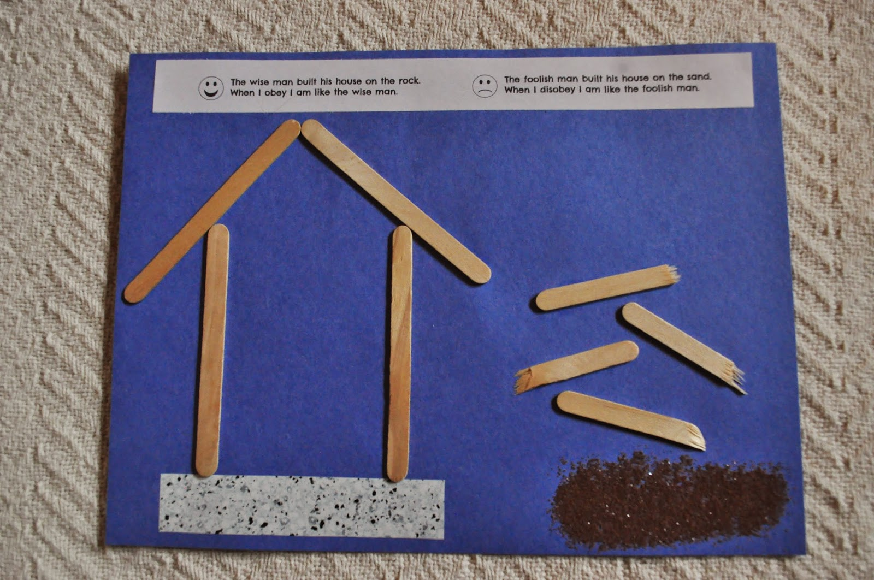  Jesus told a crowd of people this story in the Bible. Does this story have meaning? If so, it is called a...?  Suggested activities:  Give the children a piece of paper, on one side illustrate the house built on rock and the house standing firm. On the other side of the paper draw the house on the sand collapsing as the rain falls. Put this on a thread and stick into book so that both parts of the story can be shown by turning the paper over.  OR:  In pairs, children make two houses: See resources section for an example.  Houses can also be made out of jenga, lego, carboard. Houses are then placed on sand or stones. A watering can is poured over the houses to create the storm, which houses remain standing?  Plenary:  Personal reflection:  Set a treasure trail in the classroom/playground. Children have to follow the instructions in order to reach the treasure.  Key questions:  - How did you feel when you found the treasure?  - What helped you find the treasure? (following the instructions)  - What would have happened if you had ignored the instructions?  - How would you have felt if you hadn’t found the treasure?  Notes for teachers to share with children:  This parable teaches Christians that it is important to listen to Jesus and to behave the way he has shown them and taught them. When Christians follow Jesus’ instructions they believe that they are able to live honest and good lives which are built on solid foundations. When difficulties appear in life, Christians believe that God will help them through – they will not crumble like the house that was built on sand. They will be able to stay strong like the house on the rock stood firm.  Give children a selection of teachings from Jesus – children in small groups decide the top two teachings that they think are the most important and explain why.  (Assessment opportunity: to begin to express their ideas and opinions)  This could be done as a whole class, giving children the opportunity to discuss in talk partners.  Eg: Teachings  Love your neighbour as yourself.  Forgive others just as God has forgiven you.  Listen to God’s word and follow it.  Love the Lord your God. | Refer as often as you can to the fact that these parables are found in the Bible.  Refer to ‘working wall’.
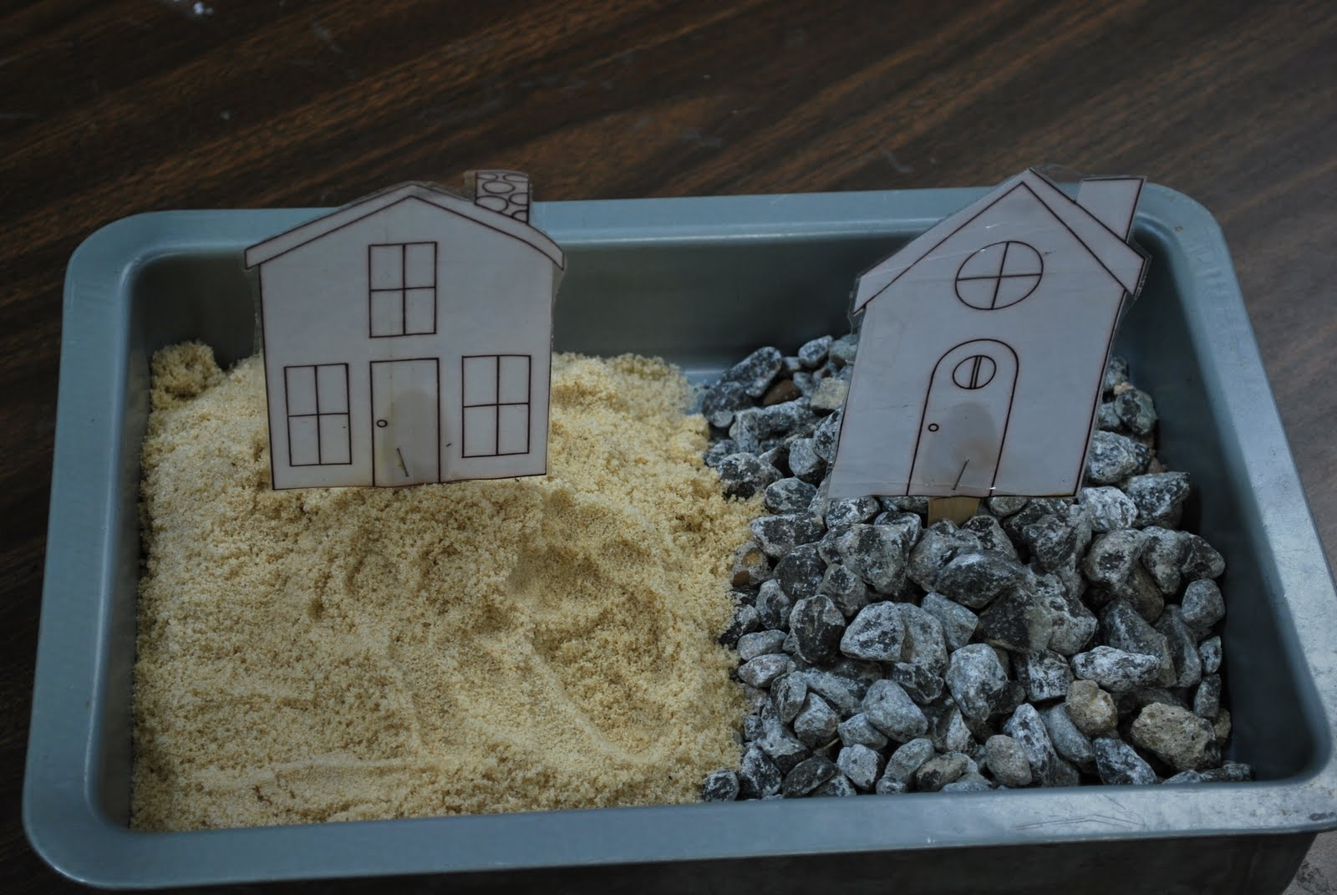
Resources:
Bible
Sand tray
Sand
Building- blocks
Watering can
Signs/Instructions
Sensitivities:
Refer to the fact that these stories have important messages for Christian living, but that the messages about how to live your life are relevant/inclusive to all.

Lesson 5: What makes someone a good friend? What is Jesus’ understanding of friendship?

Learning Objectives | AT1 | AT2 | Suggested Teaching Activities | Points To Note
Pupils should:  AT 1: to know that Jesus told stories as a way of teaching people  AT 1: to know that the stories that Jesus told are called parables  AT 1 to know the parable of The Good Samaritan  AT 1: to retell and suggest a meaning behind the religious story  AT 2: to discuss and reflect on what it means to be a friend to someone  AT 2: to begin to express their ideas and opinions |  |  | What makes someone a good friend?  What is Jesus’ understanding of friendship?  Introduction:  Once the class are settled on the carpet, the teacher gets up and tries to move something really heavy. She/he struggles to move it and the TA immediately offers to help and the job is completed with ease.  Act as if you have just had a ‘light bulb’ moment, you have just thought of a parable that Jesus told that tells how a man stopped and helped someone. Can the children think what this parable is?  Main:  Tell/read the story to the class. Luke 10: 25 -37  Options:  Godly play style:  What part of the story did you like best?  What part of the story did you not like and why?  Who do you think was the Samaritan’s friend?  Who do you think was the priest’s friend?  Who do you think was the robber’s friend?  Who do you think was the Levi’s friend?  Where are you in the story?  Act out the story  Discussion following the telling of the parable: Talk partners then feedback.  - Can you think of a time when someone has stopped to help you? How did it make you feel?  - Can you think of a time when you have helped someone? How did it make you feel?  - When someone helps you, what is it important to do? (Say thank you)  - How do people say thank you to God for the things He has done for them? (through prayer, through the way they treat others)  Activity:  Either - Children record a time when they have been a Good Samaritan in pictures and writing. Children reflect on how it made them feel and why they did what they did.  Or – Children are given the opportunity to make a thank you card that they can give to the person that helped them in some way e.g. a friend, a teacher, a TA, a parent etc.  Plenary:  Challenge the children to spot someone who needs help and then to go and help them.  Consider if we need to know the person to help them. Remind them of Harvest gifts that may be shared with Homeless agencies or things the children might do for charity.  Teacher notes to share with children:  Christians believe Jesus taught them they must always try to show friendship even when it is difficult, because that is what God wants them to do.  Personal reflection question:  - When might Christians today find it difficult to show friendship and how would they ask God to help them? (Teachers make notes of children’s responses as part of assessment.)  - When might you find it difficult to show friendship and what could help you to overcome this difficulty? (to show friendship to someone who has been unkind to me or someone I love)  - Is it ever ok not to help someone?  Assessment opportunity: (begin to express their ideas and opinions)  Assessment opportunity: (to find out about questions of right and wrong) | Refer as often as you can to the fact that these parables are found in the Bible.  Refer to the ‘working wall’ of parables each week.
Resources:
A simple version of the parable of The
Good Samaritan – Luke 10: 25 -37.

Blank folded cards to make into thank you cards.

Sheets for recording times when they have been a good Samaritan.
Sensitivities:

Refer to the fact that these stories have important messages for Christian living, but that the messages about how to live your life are relevant/inclusive to all.

Lesson 6/7: Assessment Week – unit plenary. Why is it good to listen to and remember the stories Jesus told?

Learning Objectives | AT1 | AT2 | Suggested Teaching Activities | Points To Note
Pupils should:  AT 1: to know that Jesus told stories as a way of teaching people  AT 1: to know that the stories that Jesus told are called parables  AT 1 to be able to retell a favourite parable including its meaning.  AT 2: to be able to share a favourite parable and explain its meaning to a younger child.  AT 2: to begin to express their ideas and opinions |  |  | Assessment Week – unit plenary.  Why is it good to listen to and remember the stories Jesus told?  Introduction:  Show the children a published book which contains a number of stories from the Bible. Tell them that today we will make a book/film/ PowerPoint for our school that has our favourite parables inside.  Main:  Look at the working wall at all the parables we have learnt about – including any additional ones the children have researched themselves or heard at church or in collective worship. Children share their favourites with talk partners. Explain that we are going to visit another class with our versions of the parables and share them with the children.  Children work in small groups to create their favourite parable and explain its meaning for Christians today and the world.  Possible options:  - Make a class book of words and text.  - Make a class film of favourite parables. Children act out the parable and explain its meaning – this is then filmed.  - Make a class PowerPoint with each group doing slides for their favourite parable with its meaning.  - Children create an art exhibition with pictures/paintings/collages/3D models that tell the parables and their meanings for the Christian community and world today.  Ensure that key religious vocabulary is available on the ‘working wall’ for the children to use in their writing.  Assessment:  As the children are working, teacher moves around the room listening to the children explaining the parables and their meaning.  (To retell and suggest meaning to some religious stories.  Begin to express their ideas and opinions.)  Plenary:  Go to another class (year group either side) and give the children the opportunity to share their learning.  Personal reflection: Teacher to record children’s responses for assessment purposes.  - What is your favourite parable and why?  - What messages will you take away from this unit of learning?  - What do you think Jesus in his parables, is trying to tell believers about the nature of God? (God is love.)  Return to the working wall and first session where children wrote their observations around the pictures representing the parables,  Key question: What more can we now add to each picture? Eg – the meaning behind each parable. The key message for Christians and others on how to live their lives – ie God loves everyone one. Treat everyone equally. (The lost sheep.) Forgiveness. Forgive those that hurt you. (The lost son.) Listen to God’s word and follow it. (The parable of the sower.) Build your life on firm foundations. Follow God’s instructions. (The wise and foolish man.) Be a good friend to everyone including the stranger. (The good Samaritan.)  Alternative: Year 1/ children with lower attainment in year 2  Give each child a picture of each parable explored and the key messages.  Children link up the message to the correct parable. | Refer to the ‘working wall’ of parables each week.  Pre-warn another class of your visit.  Ask HT to allocate time for the class to present their presentation at an appropriate collective worship.
Resources:
Bible
Pictures of the parables
Key vocabulary
Paper

Sensitivities:
Refer to the fact that these stories have important messages for Christian living, but that the messages about how to live your life are relevant/inclusive to all.

