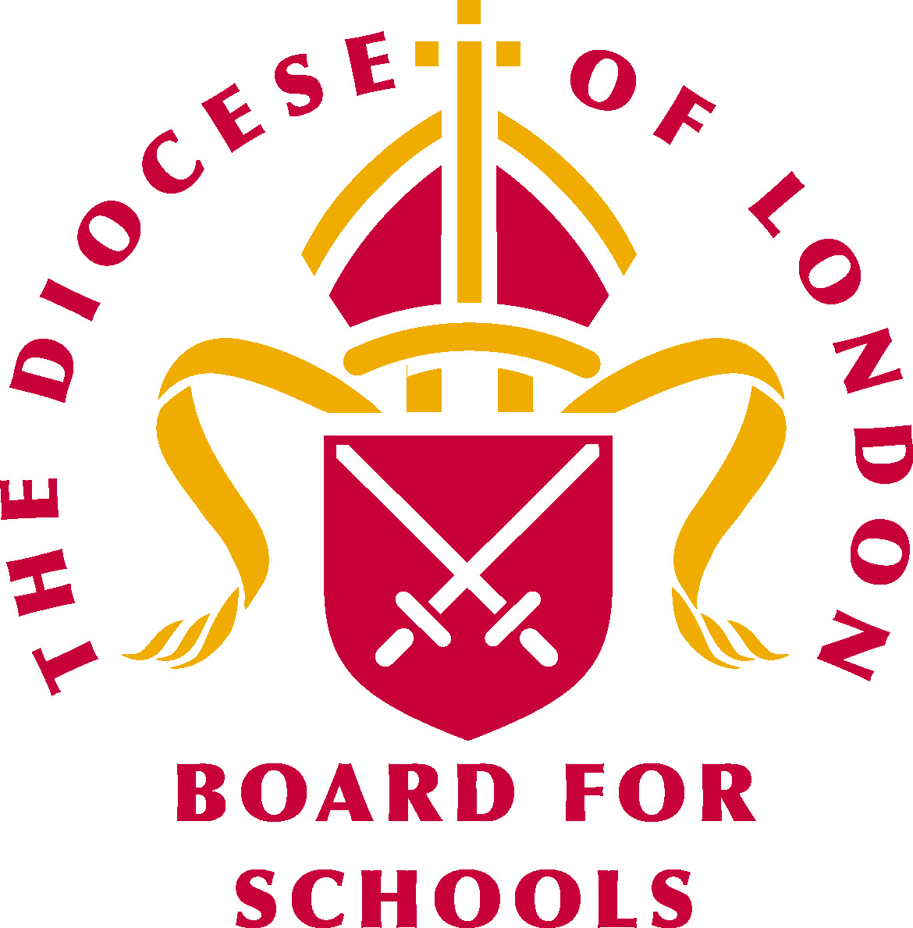 | London Diocesan Board for Schools  School Collective Worship Calendar 2018-19

2018: the first European Year of Cultural Heritage
2018: 70th Anniversary of the Universal Declaration of Human Rights (10th December)

Date | Event | Suggested Theme | Bible Reference
1st September – 4th October | Creation Season
3rd – 9th September | Organ Donation Week
5th September | International Day of Charity | http://www.un.org/en/events/charityday/
6th September | Read a Book Day | Reading
8th September | Birth of the Blessed Virgin Mary | Joy | Luke 1 v46-55
 | International Literacy Day | Reading & Understanding | Daniel 5 v 5-8
9th September | Education Sunday | www.cte.org.uk | Luke 15 v1-10
10th September | Rosh Hashanah | Jewish New Year | Micah 7 v18-20
13th September | Roald Dahl Day | Reading
14th September | Holy Cross Day | The Cross of Christ | Mark 8 v34-35
 | National Quiet Day
 | National Teaching Assistants Day | Teaching  http://www.nationalteachingassistantsday.co.uk/
15th September | International Day of Democracy
 | International Dot Day
16th September | International Day for the Preservation of the Ozone Layer
16th-22nd September | European Mobility Week | Multimodality  http://mobilityweek.eu/theme-2018/
17th – 23rd September | National Coding Week | https://codingweek.org/?edition=GB
19th September | Yom Kippur | Jewish Day of Atonement | Leviticus 16 v 30
21st September | St Matthew | Forgiveness | Matthew 9 v9-13
21st September | International Day of Peace | The Right to Peace – The Universal Declaration of Human Rights at 70 www.internationaldayofpeace.org | John 14 v27
 | World Gratitude Day | Thank You | Luke 17 v 12-19
 | Jeans for Genes | www.jeansforgenesday.com
22nd September | World Car Free Day | http://www.worldcarfree.net/wcfd/
22nd September | Autumn Equinox | Season | Ecclesiastes 3 v1-8
23rd September – 23rd October | Seed gathering Season | www.treecouncil.org.uk | Isaiah 61 v11
24th-30th September | National Eye Health Week | Vision (11th October: World Sight Day) http://www.visionmatters.org.uk/
24th September | First Day of Sukkot | Judaism | Exodus 40 v 38
26th September | European Day of Languages | Communications – European Year of Cultural Heritage  http://edl.ecml.at/ | Acts 2 v5-6
Date | Event | Suggested Theme | Bible Reference
29th September | World Heart Day | http://worldheartday.org/
29th September | St Michael and All Angels | Remembrance | Revelation 12 v7-9
1st – 31st October | Fair Trade Month
1st – 31st October | Black History Month | Everyone made in Gods image  http://www.blackhistorymonth.org.uk/ | Galatians 3 v25
1st – 31st October | International walk to school month | Being healthy  http://www.walktoschool.co.uk
 | The Big Draw | Play!  http://www.thebigdraw.org/organise-an-event
 | Family Learning Festival | http://www.familylearningfestival.com/
1st October | World Habitat Day | The environment / Cities and Climate Change  https://unhabitat.org/world-habitat-day/ | Luke 12 v6-7
 | International Day of Older Persons | Anna at the Temple  http://www.un.org/en/events/olderpersonsday/ | Luke 2 v36-38
 | World Architecture Day |  | Ephesians 2 v20-21
2nd October | Simchat Torah | Judaism | Deuteronomy 34 v10-12
4thOctober | St Francis |  | Luke 12 v23-24
4thOctober | World Animal Day | www.worldanimalday.org.uk | Genesis 1 v24-25
 | National Poetry Day | Change https://nationalpoetryday.co.uk/about-npd/
4-10th October | World Space Week | Space Unites the World  http://www.worldspaceweek.org/
5th October | World Teachers’ Day |  | Acts 4 v1-2
 | World Smile Day | Acts of Kindness www.worldsmileday.com | Luke 12 v23-26
6th October | William Tyndale | Translating the Bible | 2 Timothy 3 v14-15
8th – 13th October | Libraries Week | http://www.librariesweek.org.uk/
9th October | World Post Day | http://www.upu.int/en/the-upu/world-post-day/about-wpd.html | Epistles in the New Testament
10th October | World Mental Health Day | www.mentalhealth.org.uk
11th October | International Day of the Girl Child | EmPOWER girls: before, during and after conflict http://www.unwomen.org/en/news/in-focus/girl-child
12th October | World Sight Day | Eye Care Everywhere | Mark 8 v22-26
14th – 21st October | Week of Prayer for World Peace | http://www.weekofprayerforworldpeace.com/dates.html
15th-21st October | National Baking Week | www.nationalbakingweek.co.uk | Exodus 12 v37-39
15th-21st October | National Adoption Week | www.nationaladoptionweek.org.uk | Ephesians 1 v4-5
16th October | World Food Day | Sustainable Food Systems  http://www.wfp.org/WorldFoodDay | Mark 6 v35-43
 | Restart a Heart Day | https://www.bhf.org.uk/heart-health/how-to-save-a-life/cpr-kits/cpr-training-for-schools/get-involved-on-restart-a-heart-day
18th October | St Luke | The doctor | Luke 1 v1-4
 | Conflict Resolution Day
 | World Values Day | https://www.worldvaluesday.com/

Date | Event | Suggested Theme | Bible Reference
21st October | Apple Day | http://www.national-awareness-days.com/apple-day.html | Psalm 17 v8
21st–28th October | One World Week | The World is Changing – How about us? https://www.oneworldweek.org/
27th October | National Mentoring Day | http://nationalmentoringday.org/
28th October | St Simon & Jude |  | Ephesians 2 v19-22
30th October – 4th November | National School Meals Week | http://www.thegreatschoollunch.co.uk/ | John 6 v 1-13
31st October | All Hallows Eve
31st October | Reformation Day | http://www.reformation500.uk/
1st November | All Saints | Remembrance | Matthew 5 v1-12
1st-30th November | National Novel Writing Month
2nd November | All Souls | Remembrance | Psalm 23
3rd November | World Kindness Day
5th November | Bonfire Night
7th November | Diwali | Hinduism
 | National Stress Awareness | https://www.mind.org.uk/workplace/national-stress-awareness-day/
11th November | Armistice Day | War and Peace | Psalm 62 v6-8
 | Remembrance Sunday – 2nd before Advent | The parable of the sower | Matthew 13 v1-9, v18-23
 | 100th Anniversary of the end of World War I
11th – 18th November | Inter Faith Week | https://www.interfaithweek.org/
12th – 16th November | Anti-Bullying Week | Choose Respect  https://www.anti-bullyingalliance.org.uk/anti-bullying-week | Luke 19 v1-10,
12th – 18th November | National Recycling Week
16th November | International day for Tolerance | http://www.un.org/en/events/toleranceday/ | Proverbs 16 v23-24
19th November | International Men’s Day | Positive Male Role Models  http://www.internationalmensday.com/
19th– 25th November | World Nursery Rhyme Week
20th November | Universal Children’s Day | http://www.un.org/en/events/childrenday/ | Mark 10 v13-16
20th November | Christ the King |  | Luke 23 v33-43
20th – 26th November | Road Safety Week | Bike Smart http://roadsafetyweek.org.uk/our-theme
21st November | World Hello Day | http://www.worldhelloday.org/
23rd November | St Clement | Loyalty | Philippians 4 v2-3
 | Buy Nothing Day | http://www.buynothingday.co.uk/ | Luke 12 v 17-29
24th November – 2nd December | National Tree Week | www.treecouncil.org.uk
30th November | St Andrew’s | Fishers of Men | Mark 1 v16-18
1st December | World AIDS Day | https://www.worldaidsday.org/events

Church of England lectionary year C begins

Date | Event | Suggested Theme | Bible Reference
2nd December | 1st Sunday of Advent (Year C) | Signs and Wonders | Matthew 24 v23-27
 | International Day for the Abolition of slavery | http://www.un.org/en/events/slaveryabolitionday/ | 1 Corinthians 12 v12-13
2nd-10th December | Hanukkah | The miracle of light
5th December | World Soil Day | Be the Solution to Soil Pollution!
 | International Volunteers Day
6th December | St Nicholas | Bringer of gifts | Mark 10 v13-16
8th December | Feast of the Immaculate Conception |  | Isaiah 7 v14
9th December | 2nd Sunday of Advent | John the Baptist | Matthew 11 v2-11
10th December | Human Rights Day | 70th Anniversary of the Universal Declaration of Human Rights http://www.un.org/en/events/humanrightsday/ http://www.standup4humanrights.org/en/index.html
13th December | St Lucy | Light | 2 Corinthians 4 v6
14th December | 100th Anniversary of Women’s first vote in General Elections (1918)
16th December | 3rd Sunday of Advent | The Witness | Matthew 11 v2-5
21st December | December Solstice | Season
21st December | St Thomas
23rd December | 4th Sunday of Advent | Joseph’s Dream | Matthew 1 v18-21
25th December | Christmas Day
28th December | Holy Innocents

2019: International Year of Indigenous Languages
2019: International Year of Moderation
2019: International Year of the Periodic Table of Chemical Elements

Date | Event | Suggested Theme | Bible Reference
1st January | New Year’s Day
4th January | World Braille Day
6th January | The Epiphany | The Wise Men | Matthew 2 v1-12
7th January | Orthodox Christmas Day | Christianity
8th January | Baptism of Christ |  | Matthew 3 v13-17
14th January | Orthodox New Year
18-25th January | Week of prayer for Christian Unity | Crossing Barriers  https://ctbi.org.uk/week-of-prayer-for-christian-unity-2018/
20th January | World Religion Day
25th January | St Paul's Day | Conversion of St Paul | Acts 9 v1-9
26th January – 2nd February | National Storytelling Week | https://www.sfs.org.uk/
27th January | Holocaust Memorial Day | Torn from Home  www.hmd.org.uk
2nd February | Candlemas | Light of Christ | Luke 2 v25-35
5th February | Chinese New Year | The Year of the Pig
14th February | St Valentine | Love | John 3 v16

Date | Event | Suggested Theme | Bible Reference
14th – 21st February | National Nest Box Week | https://www.bto.org/about-birds/nnbw
21st February | International Mother Language Day | http://www.un.org/en/events/motherlanguageday/
1st March | St David’s | Patron Saint of Wales | 2 Samuel 23 v1
5th March | Shrove Tuesday | Christianity
6th March | Ash Wednesday | Christianity | Matthew 6 v1-4
6th March – 18th April | Lent
7th March | World Book Day | http://www.worldbookday.com/
8th March | International Women’s Day
12th March | 25th Anniversary of the Church of England ordination of first women priests (1994)
17th March | St Patrick’s | Patron Saint of Ireland | Luke 10 v1
19th March | St Joseph | Fathers and Carers | Matthew 1 v18-21
20th March | St Cuthbert | Lost Sheep | Matthew 18 v12-14
 | Spring Equinox | Seasons | Genesis 1 v14-19
21st March | Purim | Courage | Esther
22nd March | World Water Day | http://www.unwater.org/campaigns/world-water-day/en/ | Hosea 6 v3
 | Earth Day
25th March | The Annunciation | The Angel appears to Mary | Luke 1 v26-33
31st March | Mothering Sunday |  | Exodus 2 v1-10
14th April | Palm Sunday | Betrayal | Matthew 26 v14-19
18th April | Maundy Thursday | The Last Supper | Matthew 26 v20-28
19th April | Good Friday | Crucifixion | Matthew 27 v 21-31
19th-27th April | Passover | Judaism | Exodus 12 v11-14
20th April | Holy Saturday
21st April | Easter Sunday | Resurrection | Matthew 28 v1-8
21st April | The Queen’s Birthday – 93 years | The Royal Family | Psalm 72 v1-7
23rd April | St George | Patron Saint of England | Ephesians 6 v10-20
 | Shakespeare Day
25th April | St Mark | Spreading the word of God | Acts 12 v24-25
1st May | May Day
1st May | St Philip & St James | Spreading the word | John 12 v20-24
5th May – 4th June | Ramadan | Islam
14th May | St Matthias | Becoming an apostle | Acts 1 v15-17
15th May | International Day of Families | https://www.un.org/development/desa/family/international-day-of-families.html
17th May | International Day Against Homophobia & Transphobia | http://dayagainsthomophobia.org/
30th May | Ascension Day | Christianity | Acts 1 v1-11
5th June | Eid al Fitr | The end of Ramadan
8th June | World Ocean Day | http://www.worldoceansday.org/ | Genesis 1 v9-10
9th June | Pentecost | The Holy Spirit | Acts 2 v1-4
11th June | St Barnabas | The companion | Acts 14 v11-15
16th June | Trinity Sunday | Christianity | Romans 5 v1-5
 | Father’s Day | Love | Genesis 3 v1-4
20th June | Corpus Christi | Celebration of Holy Communion | I Corinthians 11 v23-26
21st June | Summer Solstice
Date | Event | Suggested Theme | Bible Reference
22nd June | St Alban | Prayer | Matthew 6 v7-15
24th June | St John the Baptist
29th June | St Peter & St Paul | Faith | Acts 12 v1-11
3rd July | St Thomas | Doubt | John 20 v24-29
11th July | St Benedict | Laying foundations | 1 Corinthians 3 v10-11
14th July | John Keble | A guide for living | Matthew 5 v1-8
 | Bastille Day | Freedom
15th July | St Swithum | Weather | Romans 16 v25-27
21st July | 50th Anniversary of the first Man on the Moon (1969)
22nd July | St Mary Magdalene | Love | Luke 24 v1-10
25th July | St James | Following Jesus | Mark 5 v21-43

