Christmas briefing paper
Background knowledge for teachers:
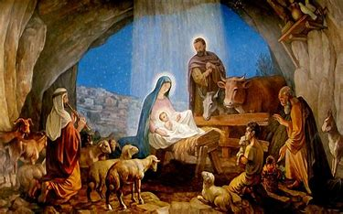
The meaning of Christmas for Christians:

- The New Testament presents Jesus as the answer: The Messiah and Saviour, who will repair the effects of sin and the Fall and offer a way for humans to be at one with God again. Incarnation means that Jesus is God in the flesh, and that, in Jesus, God came to live among humans. Christians celebrate Christmas as a way to commemorate the beginning of Jesus’ life on Earth.
- Christians believe that the Nativity is ‘good news.’ They see Jesus as their rescuer or saviour.
- The Gospels of Matthew and Luke give different accounts. It is from them that the Nativity story is pieced together.
- The Gospel of Mark and John do not give an account of the Nativity.
- The Gospels do not mention the date of Jesus’ birth. It was not until the 4th century AD that Pope Julius I set 25th December as the date for Christmas. This was an attempt to Christianise the Pagan celebrations that already took place at this time of year. By 529, 25th December had become a civil holiday and by 567 the twelve days from 25th December to the Epiphany were public holidays.
- Giving and receiving gifts is an important part of Christmas. It is in inspired by the giving of Jesus; God’s greatest gift to the world, also by the gifts from the magi in the Nativity story.

Background knowledge for teachers:
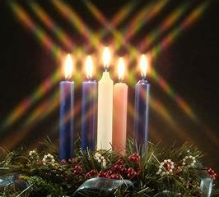The meaning of Advent:

Advent means ‘to come’. The season of Advent for Christians is a time of reflection and penitence in preparation for Christmas. The predominant theme is one of hope linked to the ‘coming of the kingdom.’ It is a time of waiting. Advent is the beginning of the Christian year.

Advent wreaths are popular especially in churches. They are made with fir branches and five candles. Candles are lit throughout Advent.

First candle represents the Patriarchs: Abraham, Isaac, Jacob: (A patriarch is the male head of the family – the highest ranking.) Abraham is known as the founder of the Jewish faith upon which Christianity developed out of. Genesis 12-25

Second candle represents the prophets: The Jewish prophets wrote a great deal about the age of the Messiah (Messiah with a capital ‘M’ refers to the future leader). The Jews were waiting for their future leader to come – waiting for the time when God’s presence would be felt by all people. Their future leader would be just and fair and he would bring peace and love. Jesus was the Messiah – the anointed future leader – but the Jews did not recognise or accept him – he did not come in the way they expected.

Third candle represents John the Baptist: John the Baptist was the cousin of Jesus. His mother was Elizabeth. He preached the need for repentance and to be baptised. He prepared the way for Christ. He is known as the forerunner of Christ. He told people that he baptises with water but the one that follows will baptise with the Holy Spirit.

4th candle represents Mary: Mary – very young girl (around about the age of 12/13). Engaged to be married to Joseph, an ordinary carpenter. She was an ordinary Jewish girl. She was a virgin – means young girl as well as someone who has not had intercourse. Obedient to God. Mary was poor.

Fifth candle represents Jesus: Christians believe Jesus to be the incarnation of God. God’s ultimate gift of love to the world.

Background knowledge for teachers:

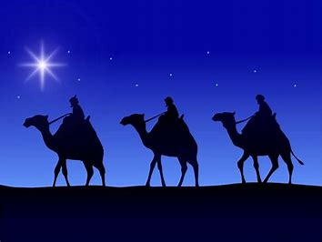
The meaning of Epiphany
The Epiphany is an ancient Christian feast day and is significant in a number of ways. In the East, where it originated, the Epiphany celebrates the baptism of Jesus by John the Baptist in the River Jordan. It also celebrates Jesus' birth.
The Western Church began celebrating the Epiphany in the 4th century where it was, and still is, associated with the visit of the magi (wise men) to the infant Jesus when God revealed himself to the world through the incarnation of Jesus. According to Matthew 2:11 they offered him gifts of gold, frankincense and myrrh.

Symbolism of the gifts: A suggestion to their meaning.

Gold symbolising the Kingship of God
Frankincense symbolising the High Priest of God. Jesus being the High Priest. Frankincense is often seen as a symbol of prayer. Frankincense is sometimes used in worship in churches to symbolise the prayers of the people rising upwards.
Myrrh pointing to Jesus’ suffering and death. Myrrh was a spice used for medicine, cosmetics, and anointing oil. It was mixed into the oil that was used to anoint prophets for the divinely appointed work of revealing God and communicating His will and words to His people. It was also a perfume that was used to anoint the dead.

Background knowledge for teachers
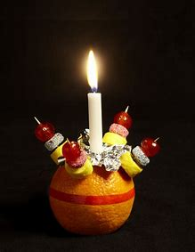
The meaning of the Christingle:
Christingles began in the Moravian Church in Germany. At a children’s service in Marienborn in 1747, Bishop Johannes de Watteville looked for a simple way to explain the happiness that had come to people through Jesus.
He decided to give the children a symbol to do this. In 1968, John Pensom of The Children's Society adapted Christingle and introduced it to the Church of England. This involved children decorating an orange with a red ribbon, dried fruits, sweets and a candle to create a new visual representation of Christ, the light of the world, celebrated by the lighting of the Christingle candles.
The symbolism of Christingle
Each element of a Christingle has a special meaning and helps to tell the Christian story:
- The orange represents the world
- The red ribbon (or tape) symbolises the love and blood of Christ
- The sweets and dried fruit represent all of God’s creation
- The lit candle represents Jesus – the light in the world, bringing hope to people living in darkness.

Background knowledge for teachers
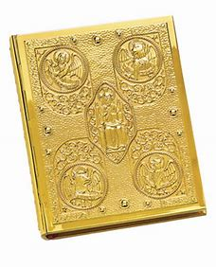
The account of the Nativity in St Matthew’s Gospel
This Gospel account has been attributed to Matthew the apostle and tax collector. It is not known for certain when it was written – probably around AD 50 and AD 100. Matthew is writing for his fellow Jews. He therefore concentrates on Jesus as the long-awaited Messiah, hence the long list of family genealogy in Chapter 1 and the Old Testament quotations from the prophets Micah, Hosea and Jeremiah. The Jews were expecting the Messiah to be a political leader and to release them from Roman rule and Matthew focuses on what Jesus says about his kingdom – the Kingdom of Heaven. Matthew is concerned with highlighting the majesty and kingship of Jesus.

Matthew focuses on Joseph and his human dilemma. He very much tells the account from Joseph’s view point. In Jewish culture, the relationship with the legal father was especially important, because it conferred rights of inheritance including the fulfilment of Messianic promises to the Jewish people. Given the priority of St Joseph’s role in this account, it’s only natural that Matthew would have focused on Joseph’s dreams, his interior struggle, and the events that prompted him to take the Holy Family to Egypt.

Matthew doesn’t mention the lowly shepherds but the wisdom of the astrologers – the Magi or Wise Men. They knew what the new star meant, that the promised king of the Jews had been born. But cruel Herod was none too pleased at this news and ordered the massacre of baby boys.

Background knowledge for teachers

The account of the Nativity in St Luke’s Gospel

It is presumed that Luke was also the author of Acts, and the same Luke that Paul mentions as his companion in some of his letters. It is also accepted that Luke was a physician. He is Greek and the only Gentile Christian writer of the New Testament.

The very beginning of Luke’s Gospel shows that Luke had read and had access to other written sources about the life of Jesus Christ – these accounts handed to him by ‘eyewitnesses and servants of the word.’ It is suggested that Luke wrote his Gospel between AD 50 and AD 90 – just as the Roman forces were destroying Jerusalem in AD 70 and many of the surrounding sites where Jesus had been seen and known. So Luke had great motivation to get this written during a time of war and change. Luke was writing to Gentiles (non-Jews) – those who may not have been brought up in the traditions of the Jewish faith.

Luke chooses the focus for his Gospel to highlight the plight of women, children, the poor, the sick and the oppressed – those who were marginalised or outcast by society.

Luke tells the account of the Nativity primarily from Mary’s point of view. His account focuses on the events in which she and her extended family are involved: the birth of St John the Baptist, the Annunciation, the Visitation, and all the other memories that she kept ‘pondering…in her heart (Luke 2:19).

Luke’s account of the Nativity mentions the shepherds. Shepherds were not considered full members of society – they were poor, and spent most of their time out on the surrounding hillside. And yet we see that God chose to reveal the miracle of the incarnation to shepherds – the lowest of the low. Why? Luke wants to make it clear that the Good News of Jesus Christ is available to everyone – rich, poor, Jew, Gentile, male, female.

