Forgiveness

Good Friday
Jesus said. “It is finished.” With that, he bowed his head and gave up his spirit.
John 19:30

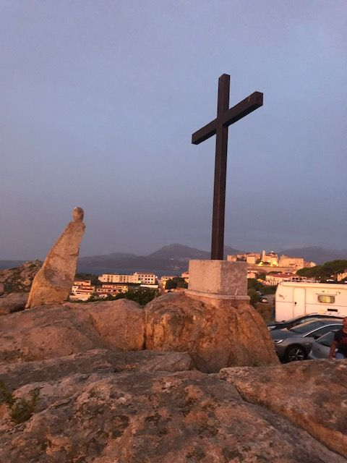

Good Friday is a day when Christians remember what Jesus did for the whole of humanity. It is the day when God allows Jesus, his perfect son, to take the world’s sin, onto Himself. It is because of God’s offering of Himself that humanity can be restored.
Equipment:

- Paper rock
- Bowl

Instructions:

- Place the bowl in the centre of your circle.
- Give each person a paper rock.

Reflection: Begin by watching this clip of the Easter story

The Story of Easter (Jesus' Sacrifice) Youtube
Jesus had done all that he had been put on this earth to do. He has healed the sick, challenged the authorities and loved those, others rejected. It was now time for him to die, to give all that he had over to God.

The cross is the place of rescue. It is the place where we can come and leave behind those things that we know we do that hurt others and ourselves. At the foot of the cross we can ask for forgiveness knowing that we will be forgiven.

Time to be still and quiet:

Children, I invite you to take one of the paper rocks and sit very quietly with it. What is it that you want to say sorry for? Perhaps you would like to write it down on your rock.

When you are ready, place the paper rock in the bowl. I invite you to say this prayer: Dear God, I am sorry for the times I have hurt you and others. Forgive me and give me the strength to start again. Amen
