Gratitude

Jesus said: ‘ Look at the birds in the air. They don’t plant or harvest or store food in barns. But your heavenly Father feeds the birds. And you know that you are worth much more than the birds.’ Matthew 6:26

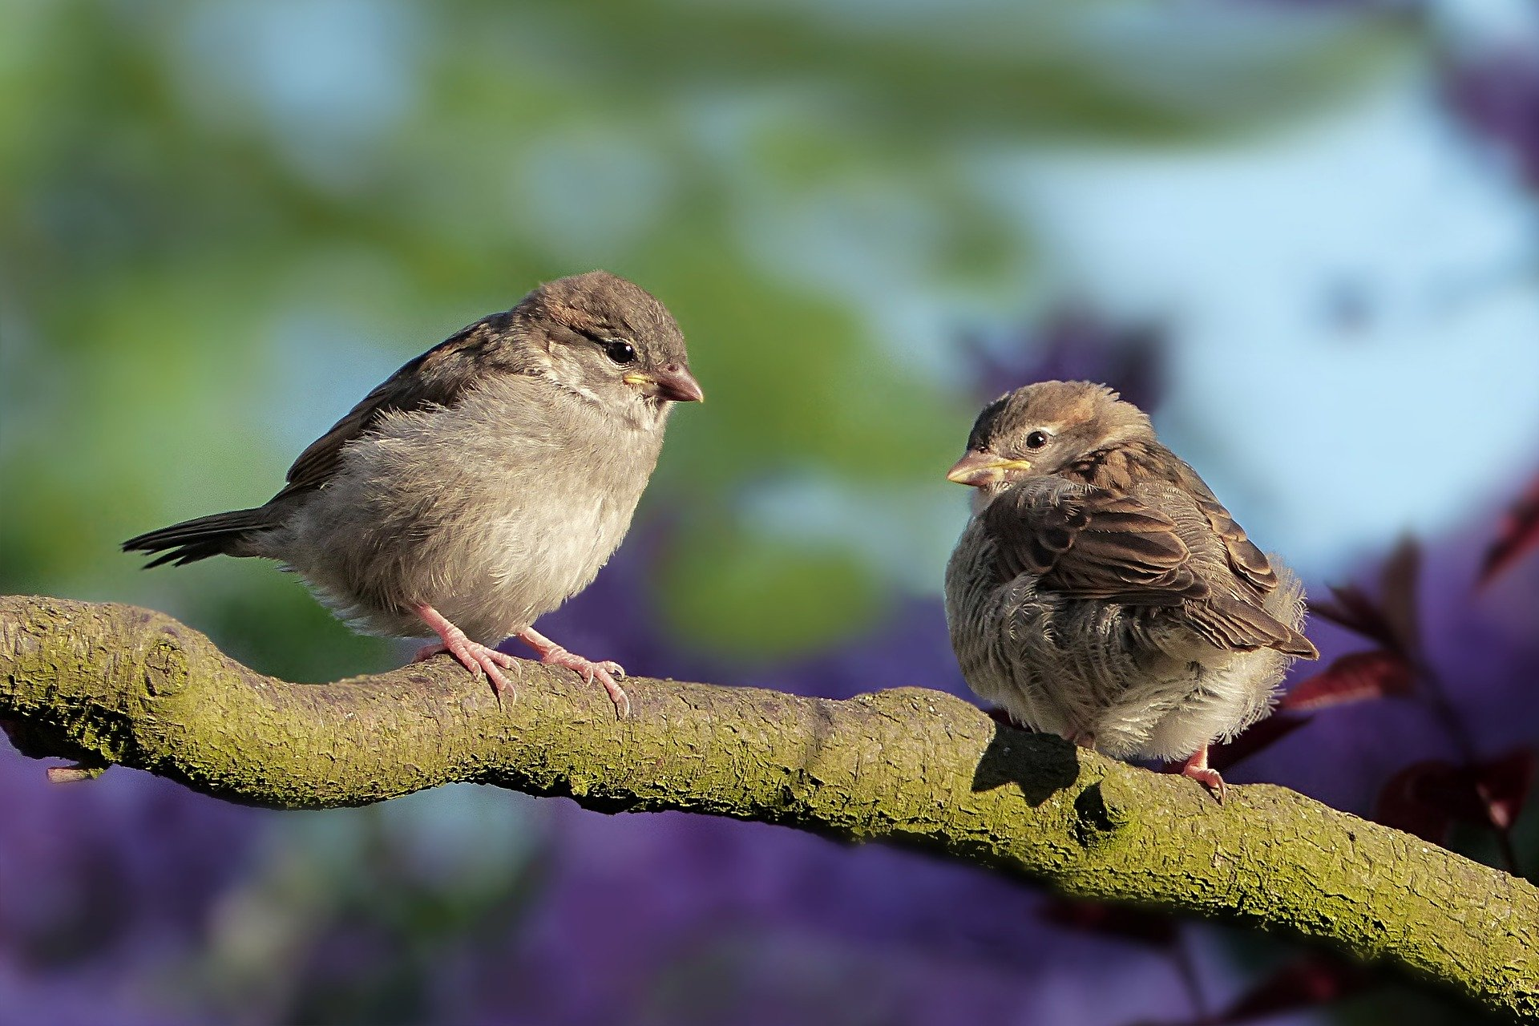
We are bombarded with frightening news at the moment but even during this worrying time there are things that we can thank God for. This prayer/reflection activity is to help us to look around and notice the good things that are around us. It is linked to birds and flowers because they are signs of spring and they also link into Jesus’ words about God’s care in Matthew 6: 26-34.

Equipment:
- A jug of spring flowers/plant
- Some photos of signs of spring such birds and flowers
- Paper bird or flower shapes, an outline is attached
- Pens
- Dish for collecting the completed prayers in

Instructions:
- Copy the flower or bird outlines.
- If you are going to put the drawings and prayers in a dish, lay the dish in the centre of table.
- Arrange the jug of flowers/plant as a focal point. Add photographs of signs of spring if you have them or use the picture below and have the laptop near your table.

Reflection:
If you look outside you will see lots of signs of spring. What other good things have you seen this week? Think about the acts of kindness you have seen in your home or heard about on the TV.

In the Bible Jesus said that God cares for the birds and made wildflowers and weeds look beautiful. How much more then does he care for each one of us.

Time to be still and quiet:
On a bird or a flower shape, write or draw something good that you have seen in creation or in your home. You might like to write a prayer giving thanks to God for all that is good in our world.
If you can’t print off the outline, find a piece of paper in your home and write/draw on this.

Put your picture or prayer into the dish and as you do this, I invite you to say thank you to God for all that we have been given.

Adults should be aware that children may want to talk about their worries and find it difficult to find positive things to thank God for, depending on their personal circumstances. Gently encourage them to find one good thing to notice, it will help them.
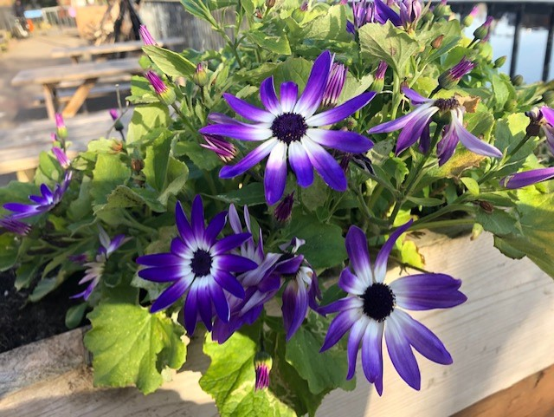

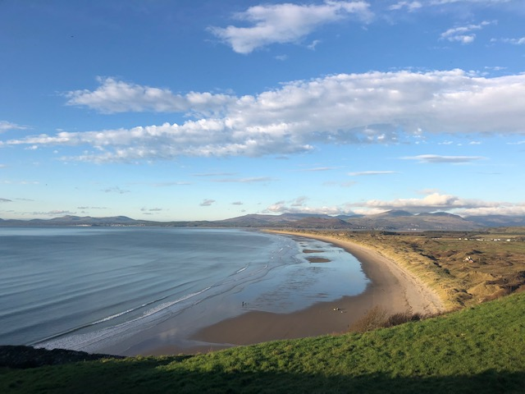

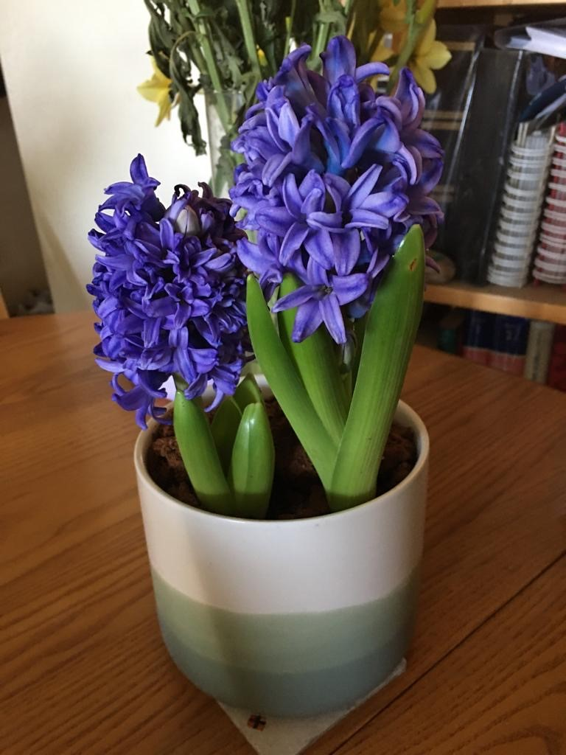

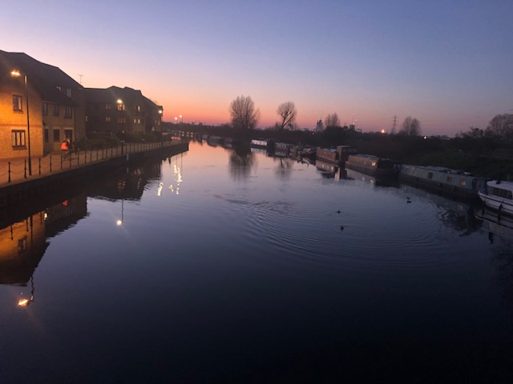

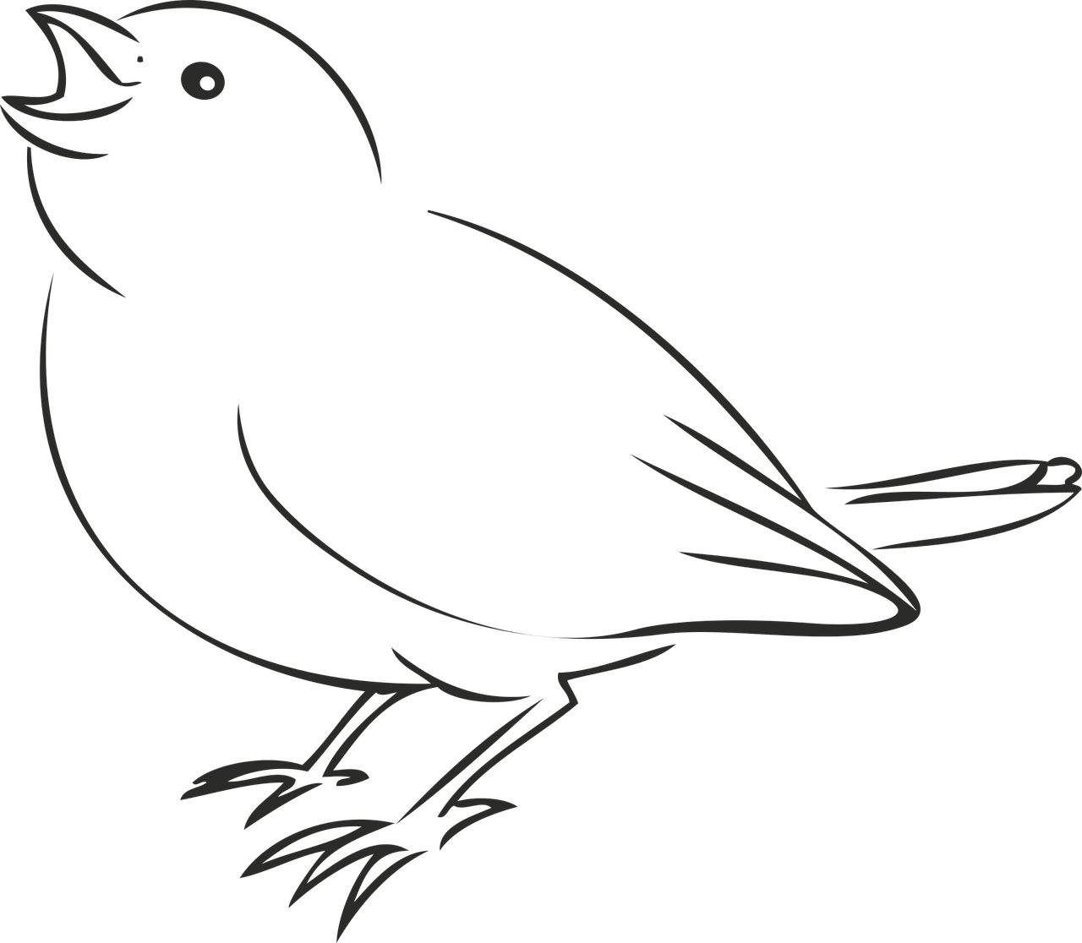 | 