Light in the darkness

The Light shines in the darkness. And the darkness has not overpowered the Light. John 1:5
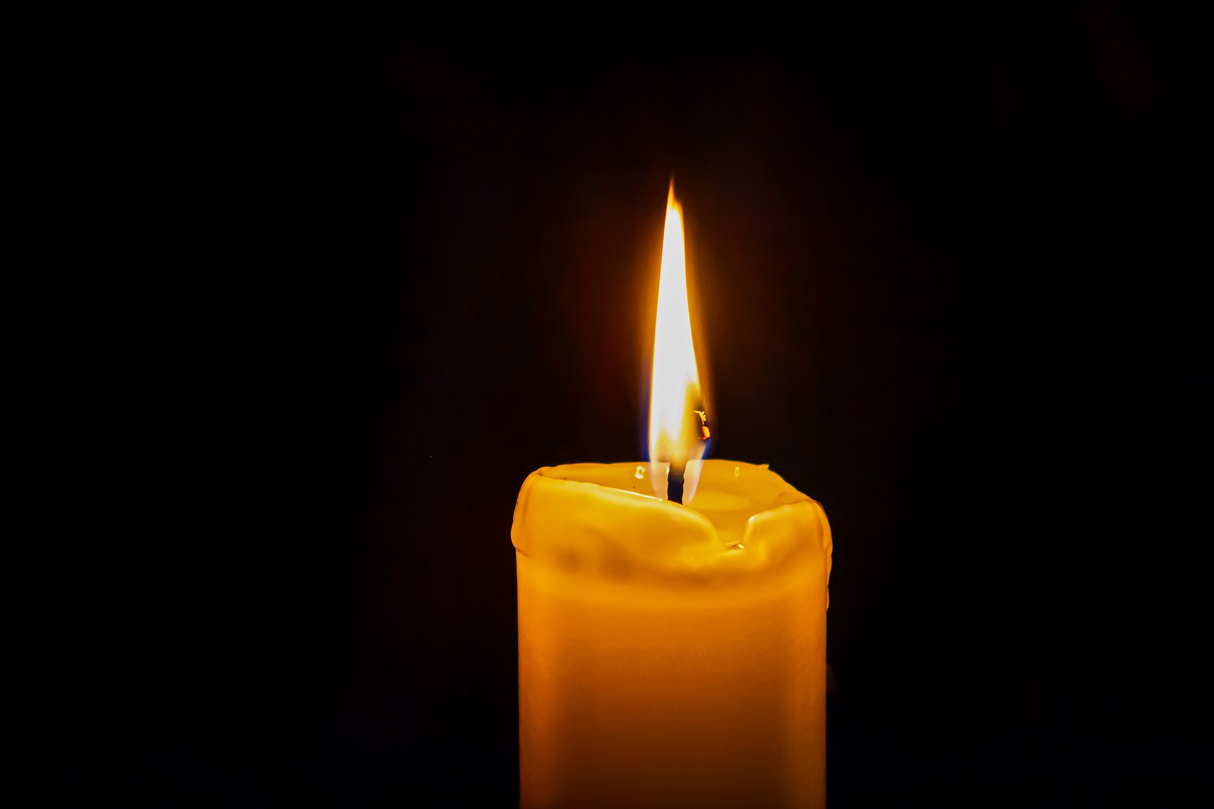
This is an opportunity for us all to acknowledge our anxieties and fears and give them to God. Even a small tealight makes a difference in a darkened room. Jesus offers us hope always.

Equipment:
- Battery operated tealights or a cut out candle
- Small bowl

Instructions:
- Light one tealight or take one of the cut-out candles and place it in the middle of the table.
- Place the other tealights/cut-out candles in the small bowl on the edge of the table.

Reflection:
Notice/imagine how one tiny candle makes a difference in a dark room. Jesus said that He is the light of the world. When it is dark it makes us feel safe to have a light with us. I wonder if there are things that you are feeling worried or frightened about? It is quite alright to be worried; God is with us in our worries. Him being with us is like the light that the candle made; it helps us to feel safe.

Time to be still and quiet:
Take one of the tealights/cut-out candles from the bowl. Hold it in your lap and be very still and quiet.

If you are feeling worried about something, now is the time to light the tealight and place it next to the light on your table. If you are using the cut-out candles, do the same. As you place the candle down on the table, I invite you to ask God to be with you and help you with that worry, trusting that He hears our prayers and is with us in our worries.

Adults should be aware that children may want to talk about their concerns and fears for family and friends. Some of these people could be very ill. It is important to take care not to promise that everyone will get better. Focus on God being with them and caring for them.

