Others First

Jesus said: ‘Love your neighbour as you love yourself.’ Mark 12:31

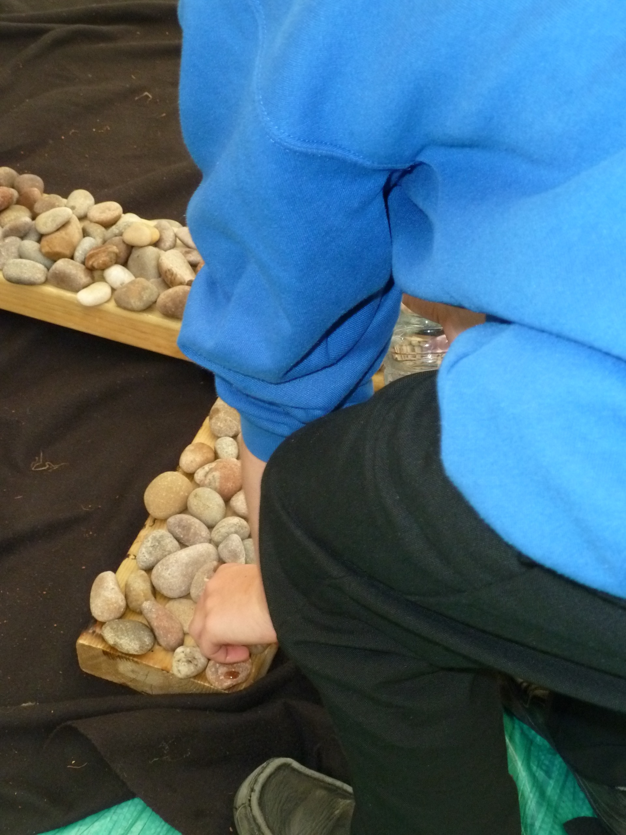
When we are worried it is easy to put ourselves first and forget about what others need. This prayer/reflection activity helps us to think about when we have sometimes wanted to put ourselves first and not others.

Equipment:
- A plate or a cross if you have one in your home
- Pebbles or stones. One for each child. (If you don’t have pebbles then use a pasta shell)
- An image of empty shelves one is attached

Instructions:
- Each person to take a stone/pasta shell and place it in front of them.

Reflection:
When we are worried about something it is easier to think about what we need and forget what other people need. Recently people have been buying lots and lots of toilet rolls and pasta, which has meant that other people have not been able to buy any toilet paper or pasta. If everyone had only bought what they needed there would have been enough to go around.

Time to be still and quiet:
Take a stone and hold it as you remember times when you have wanted to put yourself first. Think about putting others first in the future.

When you are ready, lay the stone/pasta shell on the cross or on the plate as a sign that you want to put other people first. I invite you to pray quietly asking God to help you think of others before yourself at all times.

Adults should be aware that children may want to talk about their worries about food shortages. They will need reassurance that they will not go hungry and that their family and school will make sure they are all fed each day.

