New life

Easter Sunday
“I am the resurrection and the life.” John 11:25

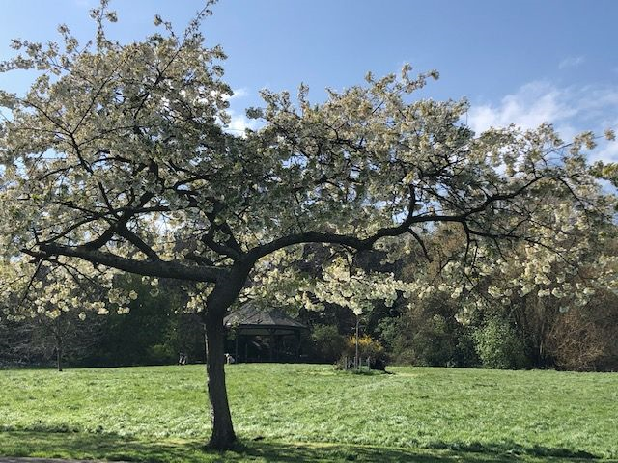

Easter is a time when Christians are reminded of God’s salvation. Jesus was resurrected, brought back to life. He appeared to the women and his disciples and ascended into heaven to be with his Father. For many Christians, this provides a sense of hope, that even in the midst of darkness and despair, God is a God of unconditional love, a God who forgives and through Jesus Christ, offers eternal life.
Equipment:
- Outline of a tree
- Pens/felt tips
- bowl

Instructions:
- Give each person a tree shape and a pen. If you don’t have a printer, draw a tree shape on a piece of paper.
- Place the bowl in the centre of the circle.

Reflection: Begin by watching this clip of the Easter story

The Story of Easter (Jesus' Sacrifice) Youtube

Easter is a time of celebration. A time to rejoice. A time to celebrate life. It is difficult at times like these to truly celebrate when we are so aware of so many people suffering in our world. However, let’s just take a look for a moment at the world around us. In creation, we see so many signs of new life. Blossom on the trees, flowers blooming, the sun is shining, and the days are getting longer. Spring is really here. Easter gives us all a chance to celebrate in those things that give us life.

Time to be still and quiet:
In the quietness of your own home, take one of the tree shapes, and write or draw on it all the things that are signs of new life and the things that give us life. Eg, flowers, blossom, birth of a new baby, water, food, a smile, a kind gesture.
Place your tree in the bowl. As you do this, I invite you to say this prayer: Dear God, thank you that you show us through your creation and the acts of kindness we see around us, that you are alive and are with us always. Amen

