Recognising
When he was at the table with them, he took bread, gave thanks, broke it and began to give it to them. Then their eyes were opened and they recognised him and he disappeared from their sight.
Luke 24: 30 – 31

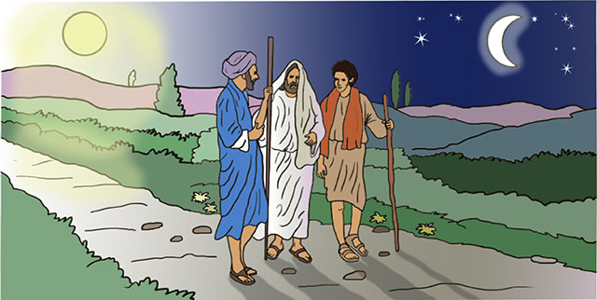

In this picture, we see two of Jesus’ disciples walking back from Jerusalem to their home in Emmaus. They are talking about all that has happened. Jesus appears alongside them, but they do not recognise him.

Equipment:

- Photo of you
- Paper
- Pens/pencils/colouring pencils

Instructions:

- During the quiet reflection time, place the photo of you in the centre of your circle. If you are alone, place the photo in front of you.
- After the reflection, it is time for you to do an activity:
Think of a moment in your life that you would like to share with someone else. It could be when you celebrated your Birthday. It could be an occasion you enjoyed sharing with your family - a trip to the park/a holiday. It could be the day a new member of your family was born.
Options: Draw a picture of the occasion/write about that occasion and how it made you feel/write a poem or song about the occasion.
- Share your work with someone in your family. By sharing it, you are telling them about something that is important to you, that makes you unique and that they can recognise you by.

Reflection: Begin by watching one or both of these clips

Recommended for: EYFS, K.S 1 and Year 3 and 4

Road To Emmaus I Stories of Jesus I Animated Children's Bible Stories| Holy Tales Bible Stories

Year 5 and 6

Road to Emmaus by John Henderson

On the road to Emmaus, Jesus shares with the two disciples his story. He speaks to them about Moses and the prophets and he explains to them that all that they had read about Christ suffering and entering into glory, was about himself. The disciples do not recognise Jesus until he takes the bread, says the blessing, breaks it and hands it to them. At this point, the disciples’ eyes were opened and they recognised him.

How do we recognise God in our own lives? How do we know he is with us? Do we sometimes, like the disciples, walk by, miss or ignore his presence?

Jesus shared his story with his disciples. We all have our own life stories to tell which are important to us. People know who we are because they recognise us by what we look like but also through our story. What makes each one of us precious and unique, is our own story that only we can tell.

Time to be still and quiet:

When you are ready, place your photo in the middle of the circle. If you are with your family, share with them, an occasion in your life that makes you feel happy when you remember it. If you are alone, look at your photo now and think about an occasion in your life that makes you feel happy when you remember it.
I invite you to say this prayer: Dear God, thank you that you know each one of us by name. You recognise us and love us. Thank you that each one of us has our own important story to tell. Give us the confidence to share our story with others. Amen
(Scroll down for a template to complete the activity on.)

My story

Enjoy writing about an occasion that brings back happy memories and you would like to share with others.

It is your story that people recognise you by.

