Abundance
“I have come in order that you might have life - life in all its fullness.”
John 10: 10

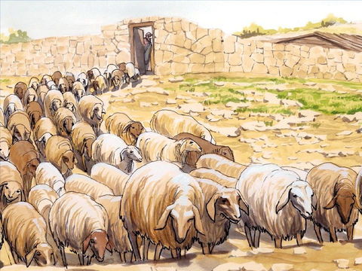

Jesus knows each of his sheep by name. They hear his voice and follow him.

Equipment:

- Paper
- Pens/pencils/colouring pencils

Instructions:

- Draw a large outline of a person on your sheet of paper
- During the quiet reflection time, write down or draw inside the shape as many things you can think of that you have in abundance. (Abundance means to have large amounts of something.) Eg: Smiles, hugs, friends, family members, water to drink, food to eat, books to read, toys to play with.
- After the reflection, it is time for you to do an activity:
Options: Play, bake, design, sing. See details below.

Reflection: Begin by watching one of the clips. Note which

Recommended for: EYFS

The Baa Baa Song (He's the Good Shepherd) - Sibling Harmony

Recommended for: K.S 1 and Year 3 and 4

I am the Good Shepherd
https://www.youtube.com/watch?v=ar732X9uO3I

Recommended for: Year 5 and 6

I am the Good Shepherd
https://www.youtube.com/watch?v=Z83TjsS7Et4
In the parable of the Good Shepherd, Jesus speaks about himself being the gatekeeper - the person that opens the gate for the sheep. They hear his voice as he calls each of his sheep by name, and he leads them out. The sheep follow him because they know his voice. Back in Jesus’ time, though the sheep would be secure in their sheep pen, there would be space where, instead of a gate, the shepherd would lie down to watch his sheep, to keep them secure in the pen, and to be alert should an enemy, like a wolf, seek to attack. Jesus also tells his followers that he has come so that they might have life – life in all its fullness. He is the Good Shepherd. Unlike the hired man who when the wolf comes to take the sheep, he runs away, the Good Shepherd protects his sheep. He is even willing to die for them.

To God, we are his sheep. He knows each one of us by name. He has come so that we might have life – life in all its fullness. God makes sure we have enough of what we need. Do we recognise his voice when he calls us? Do we give thanks to God for all that we have? Are we people who share what we have with others? Do we fill our lives and time with good things?

Time to be still and quiet:

During this time of quiet, write down or draw inside your shaped person as many things you can think of that you have in abundance. (Abundance means to have large amounts of something.) Eg: Smiles, hugs, friends, family members, water to drink, food to eat, books to read, toys to play with.

Around the outside of the person, I want you to think of people you could share the things in the middle of your person with.

I invite you to say this prayer: Dear God, thank you that you are the Good Shepherd who cares and loves each one of us. Thank you that you give us all that we need. Help us today and this week to share our things with others in our family. Amen
(Scroll down for a template to complete the reflection on and other activities to do.)

Play:

Picture quality

Divide into pairs and give each pair some paper, a pencil and a blindfold. Explain that one of each pair will now be blindfolded and guided, in word only, by their partner to draw something simple, e.g. a house. Then ask the pair to swap roles. How did it feel to have to listen to someone else leading you? How often do we listen for God leading us?

Create:

Design a ‘good shepherd’
The ‘good shepherd’ is one of the oldest known images in Christian art. It has also been found to be the image of Jesus to which young children relate to best.

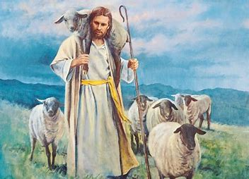
Think of characteristics that make this such a powerful and attractive image. Eg – a guide, protector, comforter, looks out for you etc.

Have a go at making a symbol that represents the ‘good shepherd’. What would your symbol include in it?

Pasture biscuits - An idea to do in the week if you don’t have the ingredients in the house at the moment.

Make an edible reminder of abundance
You will need: plain biscuits, paper plates, green icing, spoons, long sweets, e.g. cola strips, liquorice laces, and mini marshmallows.

You will need a plate and two biscuits. Cover the top of the biscuits with green icing using a spoon.
Place long sweets around the outside edge of the biscuits to make a fence (leaving a gap for the gate) and add a few marshmallows to the centre of each biscuit to represent sheep.
Eat one and give the other to someone else in your family.

A song for younger children to enjoy singing.
Jesus shepherd (Tune: Baa baa black sheep), words by Emily Hoe-Crook)
Jesus shepherd, helping me to grow,
follow, follow, show me where to go.
If I turn away from him, Jesus loves me back again.
Jesus shepherd, helping me to grow,
follow, follow, show me where to go.

