I am the way
Jesus answered, “I am the way, the truth and the life. No one comes to the Father except through me.”
John 14: 6
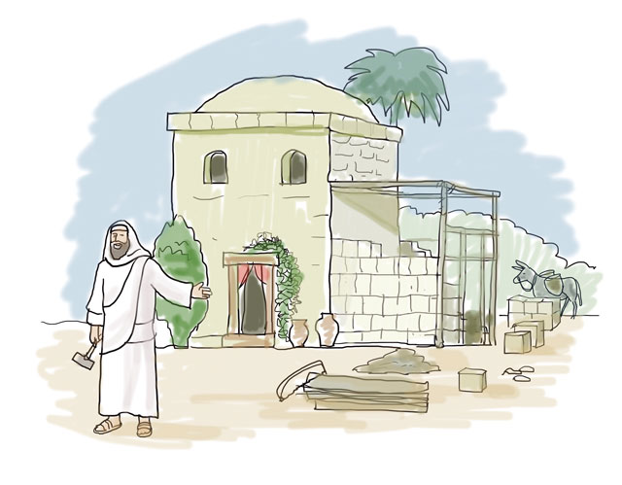

Jesus prepares his disciples before he returns to his Father in heaven by assuring them that he himself is the way that they need to travel.
Equipment:

- Paper
- Pens/pencils/colouring pencils

Instructions:

- Draw a map of your flat/house. On your map include all the rooms.
- Next to your map, draw a key. In the key, write a sentence that describe the main activities that go on in that room. Eg: Kitchen – preparing the food. Place to sit and eat. Front room/lounge – the place the family watches T.V, talks, meets together.
- In each room on your map, place a heart and on the heart write the names of people who spend time in that room.

Reflection: Begin by watching the clip.

John 14: 1 - 14

https://www.youtube.com/watch?v=xmZ8qqNjfwY

In the short clip which you have just watched, you will have heard Jesus reassuring his disciples that when he leaves them, he has not forgotten them but is going to prepare a place for them in heaven and that he will return. This he does at Pentecost through the Holy Spirit. Jesus tells his disciple that he is the way. He asks them to follow him and show others the way to him through the things they say and do. For example, caring for those who are hungry and lonely and showing acts of kindness and love to those we meet.

Time to be still and quiet:

Please note: Parents and teachers be very sensitive to those children who may have experienced loss and grief or who are struggling at this time from separation from loved ones. Give them the space to talk about this if they so wish to.

It has been a long time since some of you will have been in school or been able to see family members or your friends. Someone you know may have died. You may be feeling a bit like the disciples were feeling when Jesus spoke to them about leaving – anxious, afraid and sad. It is important to remember, that you have not been forgotten. Your Headteacher and teachers are still there for you. God has not left or abandoned you. He remains very close to you and loves you just as you are.

During this time of quiet, place your map in the centre of your circle and place the hearts on each room. As you do this, I invite you to remember the people you have written on the heart in the silence and if you wish to, pray for them by name and give thanks to God for each one of them.

I invite you to say this prayer: Dear God, be with me this day. Comfort me when I feel afraid and sad. Help me to trust in you. Help me to know that you will never leave me. Thank you for loving me just as I am. Amen.
(Scroll down for a template to complete the reflection on.)

Heart shapes - one for each room in your flat/house.

