Waiting
“It is not for you to know the times or dates the Father has set by his own authority. But you will receive power when the Holy Spirit comes on you; and you will be my witnesses in Jerusalem, and in all Judea and Samaria, and to the ends of the earth.”

After he said this, he was taken up before their very eyes, and a cloud hid him from their sight.

Acts 1: 8 - 9

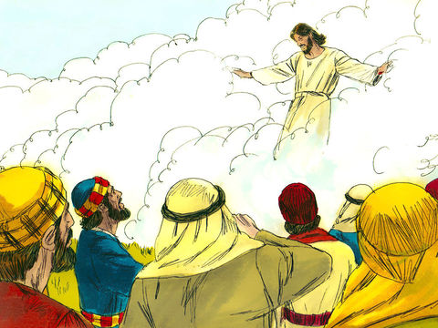

Equipment:

- Pens/pencils
- Paper

Instructions:

- Draw a poster or write a list of all the things you are waiting for right now. Eg – seeing family and friends again. Returning to school. Going to the park with your friends.

Reflection: Begin by watching one of the clips below.

Jesus goes to heaven: K.S 1 and Year 3 and 4
https://www.bing.com/videos/search?q=86+jesus+goes+to+heaven&docid=608016774403131003&mid=C7F9F71CC747FDBE1145C7F9F71CC747FDBE1145&view=detail&FORM=VIRE

Jesus’ ascension: Year 5 and 6
https://www.bing.com/videos/search?q=86+jesus+goes+to+heaven&&view=detail&mid=DEF5AD6DD41F5B72F609DEF5AD6DD41F5B72F609&&FORM=VDRVRV

How good are you at waiting? Think how many times in a day you are asked to wait for something you want to happen. Waiting for a parent to help you do something. Waiting for a meal to be cooked. Waiting in a queue outside the supermarket. Then there are bigger and more important things we have to wait for. The arrival of a new born baby. Waiting for our Birthday. Waiting for a festival. Many of you will have experienced recently, waiting for Eid.

In today’s story, Jesus is taken up to heaven. He asks his disciples to wait in Jerusalem until they receive the gift of the Holy Spirit. Once they have received the Holy Spirit, then they can go out and be his witnesses, spreading the Good News to everyone. Last Thursday, the Church celebrated Jesus’ return to Heaven. This is known as Ascension Day.

When we are asked to wait, it is important that we are patient and we use the ‘waiting time’ wisely so that when the occasion happens, we are ready and prepared to rejoice and celebrate in the thing or experience we have been waiting for.

Time to be still and quiet:

In the silence of your home, bring before God those things that are on your poster or on your list, trusting that soon you will be able to have those things again.

I invite you to say this prayer: Dear God, help me to wait patiently for the people I long to see again and the things I long to do. Thank you that you are with me in my waiting.
Amen

