Lesson 2:
THE BIBLE’S BIG STORY
Props provided in this box
Two contrasting runner-cloths,
Blue for Old Testament
Red for New Testament
Labels for ‘Old Testament’ and ‘New Testament’ (you won’t need the others in the box)

The props for this story are located in small storage bags in the box. You will need to find:
- a manger from a toy nativity set
- OLD TESTAMENT: a globe, a snake, an apple, a rainbow, a ram, two ‘stone’ tablets, a trumpet, one small smooth stone, a sheep, a toy whale; a toy lion;
- NEW TESTAMENT: baby Jesus from the same toy nativity set, a sheep, a heart shape, a small hand soap & flannel (towel), a cross and egg that can be opened to show it’s empty, the newspaper with Jesus feeds 5,000 as the headline; a battery tea light, a boat and a small map of Paul’s journeys; two envelopes with stamps: one addressed ‘to the Church in Rome’, the other ‘to Timothy’; the newspaper with the foodbank headline; a crown; a speech bubble with words from Revelation printed on it.

Setting up

Lay the blue cloth to your right and the red cloth joining on the end of it to your left.

The cloths provided are probably longer than you need for the story so you may need to fold them to fit in your space.

To keep the flow of the story going it is helpful to take the props out of the little storage bags before you start, have them in order behind you as you tell the story.

Telling the story
Have the audience sitting the other side of the cloths to you, they will see the story go left to right.
As you tell the story lay the props from right to left on the blue cloth for the Old Testament and the red cloth for the New Testament. The manger should be on the overlap of the blue and red cloths.

© Rachel Boxer and Jane Whittington
Guildford Diocese

Introduction:

The Bible is a very BIG book! It’s a book with two parts – the Old Testament and the New Testament, and it’s full of stories; many of them you may have heard here at school or maybe in church. With so many stories, it’s really easy to forget that the Bible actually tells one BIG story….God’s story. It takes the whole of the Bible to tell this story….and at the very centre of it all is God’s BIG RESCUE PLAN [place empty manger], but we can’t start there, so let’s start where all stories should.....at the very beginning!

Props for this section
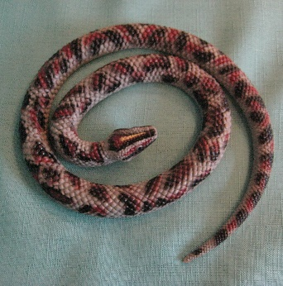
At the very beginning, before there was anything else, God was there….. and with just a word, God made His perfect world.... [place globe] But God’s enemy [place snake] had other ideas: he hatched an evil plan to trick Adam and Eve, and make them lost from God forever, using nothing more than a lie and some fruit [place apple]…. But don’t worry, because God had a plan, a BIG RESCUE PLAN, that would only happen when the time was perfect….

Props for this section
 | 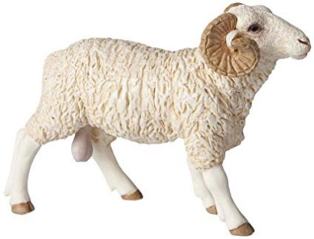 | 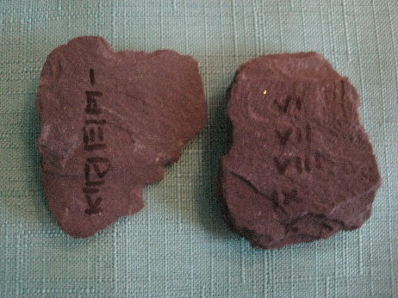
There are lots of stories in the Old Testament about how God has rescued his people, the people of Israel, many times from dreadful disasters and silly mistakes, and helped them do amazing things. Noah [place rainbow] and all his family were rescued from a flood. Abraham’s son, Isaac, was saved from death by a ram sent by God to take Isaac’s place. God rescued his special family from the cruel Egyptians and then in the desert, God gave Moses and the people ten rules that would help them to live good lives. But it wasn’t time for the BIG RESCUE PLAN yet……
Props for this section
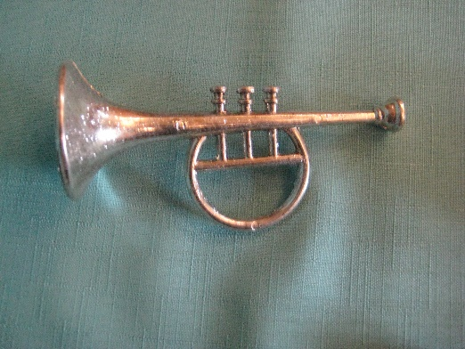 |  | 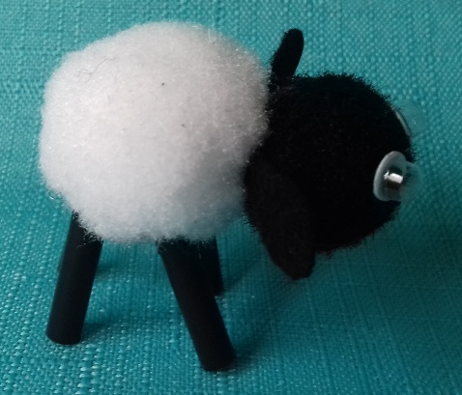
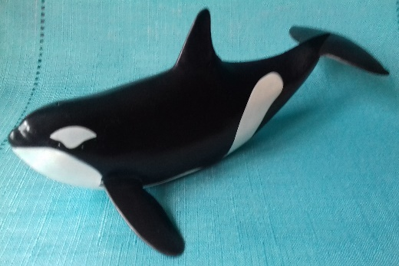 | 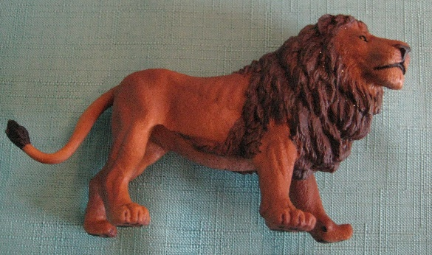
And so God continued to rescue his people: Joshua marched round Jericho 7 times and blew trumpets [place trumpet], which made the walls fall down! David, the Shepherd-King, killed the giant Goliath using just one small stone [place stone]…. and also wrote many songs and poems, including a very famous one about God the good shepherd [place sheep] who keeps his people safe. Jonah, who moaned, was rescued from the belly of a great whale [place whale] and Daniel, who was brave, was saved from a den of lions [place lion]….. And still the people of God waited for the BIG RESCUE PLAN….. [PAUSE, for a long time!]

NEW TESTAMENT
Props for this section
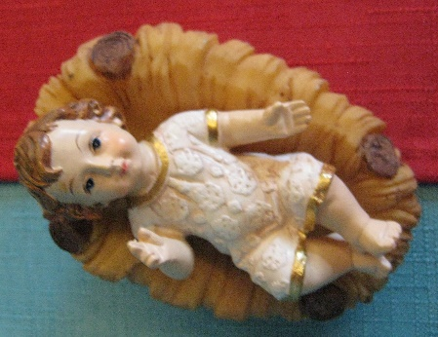 | 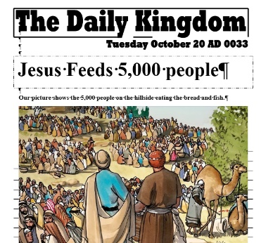
And then, at long last, the time was perfect for God’s BIG RESCUE PLAN …the Great Rescuer was on his way….but he didn’t come as a mighty warrior…..instead, the Great Rescuer, was born in a stable [place Jesus into manger], and called Jesus (which means ‘God saves’!)…. and it was GOOD NEWS, not just for God’s special family, but for the whole world. (place newspaper with Feeding of 5,000) So the parts of the Bible that contain the stories of the Great Rescuer are called….. GOSPELS, which means ‘Good News’.
Props for this section
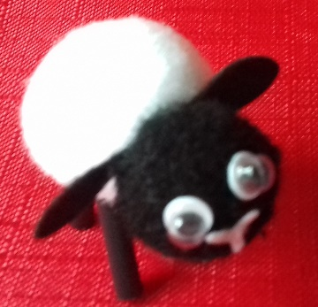 | 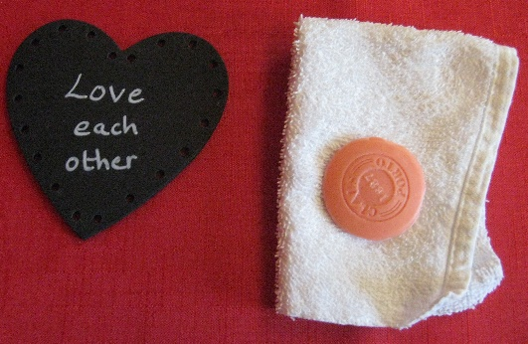 | 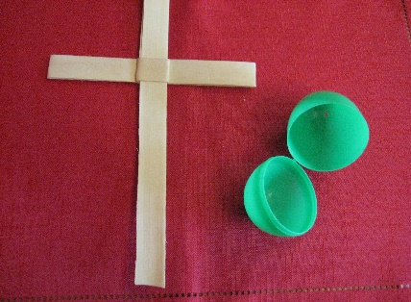
Jesus the Great Rescuer told people stories about being lost and found…..about a woman who lost a coin, a father who lost a son and a Good Shepherd who set out on a dark night to rescue his lost sheep [place sheep]
Jesus the Great Rescuer showed lost people how to find the way back to God……and loved people [place heart] who had forgotten how love felt…..He showed them how to love and care for each other through serving [place small soap & flannel)…..But when Jesus died [place cross]….it seemed as if the BIG RESCUE PLAN had gone all wrong, when in fact it had gone ALL RIGHT, just as God had planned it…..Jesus the Great Rescuer, had not only saved the world, but defeated death itself [open and then place egg] and rose to life again.

Props for this section
 | 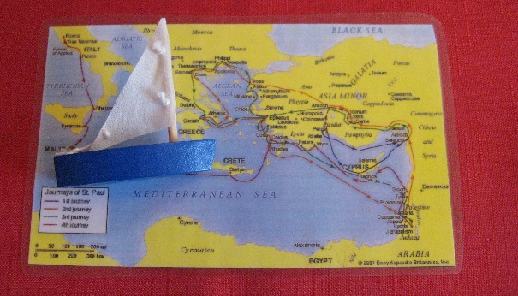 | 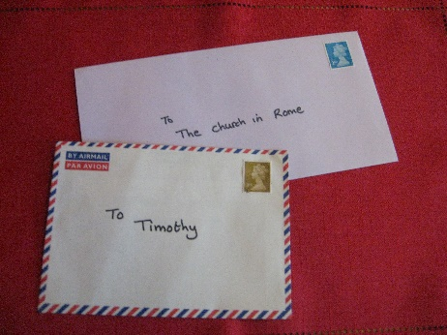
Now anyone who followed Jesus could have a place in God’s Kingdom….and carry on with the great rescue plan…..as a leaving present, Jesus gave them a little piece of Himself that would live in their hearts to help them….the Holy Spirit [place tealight and turn on]……This new family would have great adventures on their rescue mission….and the rest of the New Testament tells some of their stories…. especially of Paul, who travelled over 10,000 miles [place map of his journeys], spreading the Good News of God’s rescue plan wherever he went…..There are tales of his long voyages across land and at sea [place boat], shipwrecks, rescues, capture by Roman soldiers, prisons and earthquakes….And because there were no mobile phones back then, the first Christian leaders wrote LETTERS [place letters]….. Like letters you might have received, they contain greetings, encouragement and lots of good advice about living God’s way.
Prop for this section
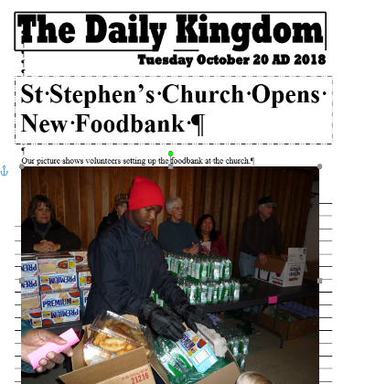 | 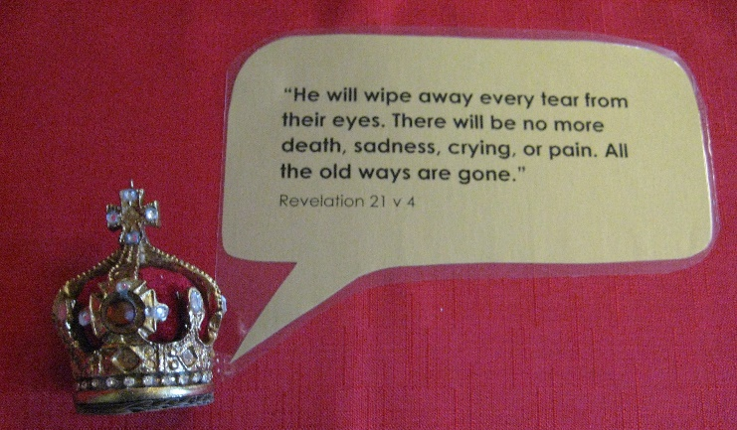
Today God’s very special family, the Church, is spread across the world. They carry on with God’s rescue plan, sharing the Good News and living in God’s Kingdom here on earth. (place Food bank newspaper). And the Bible ends with a final rescue and a brand new beginning…. with a picture of the future that Jesus the Great Rescuer gave his life for…… Jesus, the Lamb of God, is seated on the throne [place crown] at the centre of everything …..and everything is now just as it should have been all along: (place speech bubble with Bible verse)

“And God himself will wipe every tear from their eyes. There will be no more death or mourning or crying or pain, for the old order of things has passed away….God’s dwelling place is now with his people”

