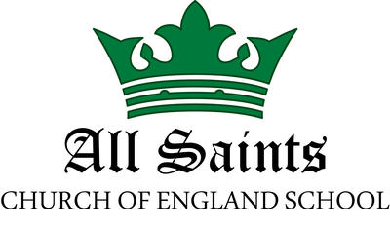
“Learning with Faith”

Head of School
Recruitment Pack

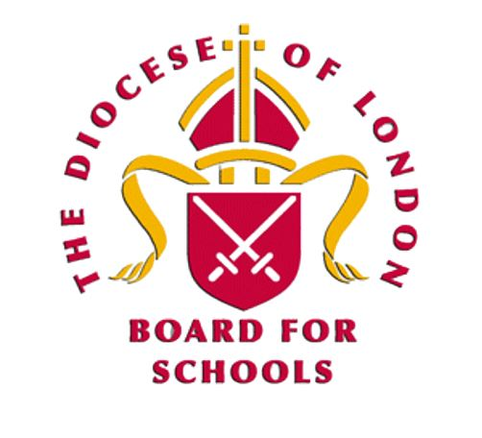

Contents

Ethos and Vision 3
Letter from Chair of Governors 4
Our whole school community has the following priorities for our new Head of School: 5
Head of School Job Description 6
Head of School Personal Specification 9
School Attainment Figures for 2019 11
Why join a school which is part of the London Diocesan Board for Schools? 11
Current Staffing structure 12
Safeguarding 13
Church and School 13

Ethos and Vision

All Saints is a small, friendly, safe, and inclusive Church of England School.
Our Vision
We aspire to learn with faith.
Faith that enables us to recognise everyone in our community as loved by God.
Faith that enables us to create a compassionate, inspiring and nurturing environment
in which everyone flourishes. We aim to achieve this through high educational
standards, and personal, spiritual and physical development.
Our Values
To achieve this vision the following are our key values, which underpin all aspects of
our life together:
Compassion
Hope
Perseverance
Respect
Trust
Wisdom
Our Christian Ethos
Everything we do is built on our Christian Ethos which is expressed in these verses
from Paul’s letter to the Ephesians:
“I pray that you may have the power to comprehend, with all the saints,
what is the breadth and length and height and depth,
and to know the love of Christ that surpasses knowledge.”
Ephesians 3: 18 & 19

This means we are serious about providing high-quality education for every member
of our school across the breadth and length and height and depth of knowledge, not
limited to the core curriculum. At the same time, our faith in Christ reminds us that
first and foremost, every member of our community should be shown the love of God
in the way, we care for them as individuals and we shall enable them to flourish in every way.

Letter from Chair of Governors

Dear Applicant,
On behalf of the Governing Board, I am delighted that you are interested in applying for the post of Head of School at our wonderful school.

We have recently restructured our school staffing and we are looking to appoint an inspirational Head of School who will provide effective operational leadership for All Saints’ School securing success and continuous improvement across the schools and ensuring the highest quality education for all pupils. Providing a well-organized environment for pupils and staff where policies are implemented in accordance with statutory requirements and strategic vision.

We are particularly interested in applications from those with the ambition and energy to bring transformational leadership to our school.

About our School

All Saints’ CofE School was founded in 1856.

Although the original building was replaced, the school’s distinctive ethos has been maintained and developed into a vision that still drives us today. All Saints’ is a Voluntarily Aided one form entry primary school, supported by both the London Borough of Barnet and the London Diocesan Board for Schools. Pupils come to our school from a diverse community, that is multi-cultural and multi-faith in nature. Many of our pupils are bilingual with 59% EAL.

Our school has a stretched but balanced budget and the building and facilities are in good condition and well maintained. Parents, carers and staff are supportive and committed to the education of all pupils and to the success of the school.

At our last Ofsted inspection in 2019, our school was judged to be “Good” in all areas.

Governors would like to appoint a Head of School who is looking for the opportunity to create an inspiring, innovative school with an exciting and inclusive curriculum and learning opportunities for pupils and staff. We encourage you to visit the school to find out more about us. To arrange a visit please contact us at chair@aspnw2.barnetmail.net We look forward to welcoming you and to receiving your application.

Yours sincerely

Mariann Hart
Chair of Governors

Our whole school community has the following priorities for our new Head of School:

Head of School Job Description

Accountability and responsibilities

The Head of School is accountable to the Executive Headteacher and the Governing Board

To be met in accordance with the provisions of the School Teacher’s Pay and Conditions Document and within the range of teachers’ duties set out in that document, and the National Standards for Headteachers.
The postholder will be required to take on any other responsibilities as directed by the Executive Headteacher.

Responsible for
The Head of School will provide effective operational leadership for All Saints’ School securing success and continuous improvement across the school, ensuring a high-quality education for all pupils and the highest standards of learning and achievement in accordance with statutory requirements. As a Church of England School, the Head of School will be required to uphold the ethos and values within day-to-day working practices.

Shaping the Future
In partnership with the Governing Body and Executive Headteacher, the Head of School will:
- Articulate and communicate a shared vision and translate the vision into clear objectives that promote and sustain school improvement
- Establish and implement a strategic plan
- Monitor and evaluate the effectiveness of the school
- Ensure that the school moves forward to the benefit of the pupils and wider community
- Motivate and inspire stakeholders to create a strong culture of learning within an inclusive environment
- Be responsible for producing regular headteacher reports for the governing body –initially alongside the Executive and then individually
Leading Learning and Teaching
It is an expectation of the governors that the postholder will have been evaluated at least a ‘good’ teacher over the previous two years (where applicable) under the Ofsted evaluation guidance and based on a range of evidence e.g. observations, quality and progress in pupils' work, achievement data and appraisal
The postholder will:
- Set high expectations and challenging targets for all pupils, monitoring effectiveness and evaluating outcomes
- Ensure all staff within the school focus on pupils’ achievement, using data and benchmarks to monitor progress in every child’s learning
- Establish creative, effective approaches to learning and teaching, responsive to the needs of the pupil community
- Ensure a culture that supports and facilitates pupil engagement in, and ownership of, their own learning
- Implement strategies to secure high standards of behaviour and attendance
- Monitor, evaluate and review classroom practise and promote improvement strategies, challenging underperformance and ensuring corrective action
- Developing the wider curriculum
- Follow and model safeguarding procedures and policy
Leading and Managing the Organisation
- Evaluating the school’s performance and setting appropriate school improvement priorities in the School Improvement plan alongside the executive headteacher
- Setting appropriate priorities for expenditure, allocating funds and ensuring financial control, in accordance with governing body policies and alongside the executive headteacher
- Working with the executive headteacher, governors and senior colleagues to recruit, induct and develop high-quality staff in line with safer recruitment guidelines
- Be responsible for the performance management of staff and guidance for appraisers
- Managing, deploying and developing staff to secure the quality of education and pupils’ achievement
- Managing and monitoring the use of resources in order to secure the quality of education and pupils’ achievement
- Ensuring best value deployment and use of human, financial and material resources alongside the executive headteacher
- Managing accommodation to ensure that it meets the needs of pupils, the curriculum and health and safety regulations alongside the executive headteacher
- Regularly evaluating the allocation of roles, responsibilities, finance and resources to ensure these underpin the best possible learning environment and highest standards
- Ensure that all staff understand the school’s obligations with regard to health and safety

Safeguarding
- Take responsibility for ensuring that all staff understand and follow safeguarding policies
- Ensure that all teaching and support staff are fully inducted in and made aware of the school safeguarding procedure including knowing the names of the designated CP officer (DCPO) and the Deputy DCPO
- Be responsible for monitoring that all policies and procedures are followed by all teaching and support staff
- Undertake the role of designated CP lead or ensure that the designated lead for CP is given the appropriate resources to carry out the duties of that role effectively

Developing Self and Others
In partnership with the Executive Headteacher, the Head of School enables staff to develop their potential and achieve high standards by:
- Building a collaborative learning culture within the school and actively engaging with other schools to build effective learning communities and partnerships
- Ensuring effective planning, coordination, support and evaluation, ensuring clear delegation of tasks and devolution of responsibilities
- Developing and maintaining effective strategies and procedures for the induction, professional development and performance review for all staff
- Setting high expectations for all and address underperformance using the relevant process and procedures to do so
- Acting as a role model for the highest professional standards
- Regularly self-evaluating, setting personal targets and taking responsibility for own personal professional development so as to be well equipped to deal with the increasingly complex role of leadership of the school community
- Ensuring both self and others achieve an appropriate work/life balance
- Building effective professional working relationships with all staff so as to motivate them and enable them to carry out their respective roles effectively
Securing Accountability
In partnership with the Executive Headteacher, the Head of School is accountable for the school and its work to a range of stakeholders, particularly pupils, parents, carers, and is accountable legally and contractually to the Governing Body. He/she exercises this accountability by:
- Using school self-evaluation processes, to report on the school’s performance and development to inform future school improvement planning alongside the executive headteacher
- Providing information, advice and support to the governing body in meeting its responsibilities for the effective teaching and learning, standards of achievement, efficiency and value for money
- Keeping parents and pupils informed about the curriculum, attainment and progress and school improvement plans
- Liaising, in the best interests of pupils with support services and other agencies
Strengthening Community
- Co-operate and work with relevant agencies and partners to ensure the well-being and learning of all children.
- Ensure learning experiences for pupils are linked and integrated with the wider community, local, national and global
- Build a school culture and curriculum that takes account of the richness and diversity of the schools’ communities
- Create and promote positive strategies for challenging all forms of prejudice and harassment
- Promote the concept of lifelong learning and family engagement with learning through partnership
- Manage effective relationships with all stakeholders and partners

Head of School Personal Specification
Specification: Essential | Specification: Desirable
1. Qualifications  - Qualified teacher status  - Evidence of further professional study and personal development. | - National Professional Qualification for Headship (NPQH)  - Higher degree (eg Masters or MBA)
2. Experience  - Effective senior leadership experience involving the Early Years Foundation Stage, Key Stage 1 and Key Stage 2  - Experience of successfully leading at least two whole school initiatives, or significant changes  - Experience of monitoring and improving teaching and learning  - Experience of successfully leading a team  - Experience of reviewing and developing the curriculum to meet the needs of all children resulting in pupil achievement rising significantly  - Experience of leading professional development that has had a demonstrable positive impact on the quality of teaching. | - Experience of setting, monitoring and managing budgets successfully, achieving excellent value for money  - Experience of a positive Ofsted inspection outcome.  - Substantial experience of exceptional teaching in more than one school
3. Leadership and Management  - Implementing strategic priorities and development plans  - Leading change by inspiring and empowering individuals to achieve high performance  - The ability to use pupil performance data for effective school self-evaluation  - The ability to embed effective processes and systems  - Makes well-informed, effective and sometimes difficult decisions for the good of the school and in the best interests of the children  - Experience of recruiting, deploying and developing strong staff  - Able to work well with others; to delegate responsibility and achieve goals through others | - Experience of being a Deputy Headteacher or Associate Headteacher  - Knowledge of how to optimise the use of school facilities  - Experience of managing all aspects of the extended school day
4. Teaching and Learning
- Up-To-Date knowledge of educational pedagogy and national developments in teaching, learning and assessment
- Understands the factors that create barriers to learning and employs effective strategies to overcome them
- Has the ability to set and achieve challenging targets for the school, teachers and pupils
- Excellent knowledge of the Early Years, Key Stage 1 and Key Stage 2 curriculum, with a commitment to a broad, rich and inspiring curriculum across all Key Stages
- Experience of developing positive learning behaviours and working with challenging behaviour
- Excellent understanding of working with pupils with a range of SEND
5. Personal Attributes and Skills
- Demonstrates a high standard of interpersonal, communication and presentation skills
- Ability to work closely with and motivate staff, parents, governors and other members of the school community to achieve common goals
- Has a firm and palpable commitment to developing children’s love of learning
- Fosters an open and fair culture; is sensitive and manages conflict effectively
- Deals effectively with pressure; remains optimistic, persistent and resilient, even under adversity.
- Self-motivated with a high level of organisational skills and the ability to prioritise workload effectively
- Excellent written and verbal communication skills
- Able to think creatively, solve problems and make decisions based on sound judgement
- Possesses high expectations
- Able to listen and to reflect.
6. Commitment
- Commitment and drive to move a school forward; to challenge and change
- Committed to articulating our Christian ethos and values
- Commitment to inclusive leadership and championing the needs of all children; respecting equality and diversity
- Commitment to partnership working to secure excellence
- Commitment to the highest possible standards in safeguarding; knowledge of safeguarding legislation and best practice
- Commitment to the belief that all children have the potential to develop and succeed (and able to make this happen).
- Commitment to strengthening the community by engaging with all stakeholders

School Attainment Figures for 2019
EYFS: In 2019, 72% of pupils in reception class achieved a Good Level of Development (GLD). This is up from 61% in 2018.
Y1 Phonics: 76% met expectation in 2019. This is down from the previous 93% in 2018 and is below the national and Barnet average. The cohort is very small only 18 at the start of Y1, 21 by the end who took the test.
KS1: In 2019, attainment in KS1 was above the national and Barnet proportions for children working at age-related expectations for Reading, Writing and Maths combined. 77% where at ARE with 15% of pupils reaching above age-related expectations. Writing and Maths are above or significantly above the national average.
KS2: In 2019 attainment was 64% in Reading, Writing, Maths combined. This is below the Barnet average but broadly in line with the national average. In these three areas individually the school is above the Barnet and National averages, apart from reading which is below Barnet but above national. SPAG is 93% which is above the national and Barnet levels. Progress is at or above national rates in Reading, Writing and Maths.

Why join a school which is part of the London Diocesan Board for Schools?

LDBS schools are more popular with parents with 3.09 applicants per LDBS reception place compared to 2.71 for non-LDBS schools.
LDBS has better Ofsted outcomes 96% of LDBS are good or better compared to 90% overall in the LDBS area. 27% of LDBS Primary Schools are outstanding compared to 19% overall in the LDBS area and the same at the secondary level.
6000 new Primary places have been created over the last 10 years and 8000 Secondary places as the LDBS schools continue to grow in popularity. In recent years there have been 27 new or expanded Primary Schools.

What makes a school in the LDBS special?

- World-class training provided by GROW education partners
- Being at the cutting edge of educational improvements
- Connections to Teaching London, the LDBS SCITT – an outstanding provider
- NQT recruitment and training second to none. Governor support and training
- A commitment to developing high-quality learning environments within school buildings
- Dedicated School Leadership Adviser providing support and challenge
- Being part of the LDBS is being part of a family of schools benefitting from support for school development, leadership and a core guiding principle

Current Staffing structure
SEND Co
2days/week
Head of School

Level 3 TA
Foundation Stage
33.75h

Administrative Staff
Clerical & Office Duties 36 hours
Caretaker
Safety and Security,
Site Maintenance, Contractor Management. 36.25 hours
MFL Teaching
3hours/ week
Music Teaching
1day /week
Level 2 TAs
Inclusion, SEND support, intervention
153.35 hours
Leadership group

Learning Mentor
Behaviour & Pastoral, sport co-ordinator Support 33.75hours
Assistant Headteacher
Class teacher
Teaching and Support staff

Phase Leader
Class teacher TLR 2
7 full time Class Teachers
Including AHT and Phase Leader

PPA cover Teacher / Intervention
3days/week
Executive Head Teacher

Computing Teaching
1day/week

Safeguarding

At All Saints’ we are committed to safeguarding and promoting the welfare, both physical and emotional, of every pupil both inside and outside of the school premises. We implement a whole-school preventative approach to managing safeguarding concerns, ensuring that the wellbeing of pupils is at the forefront of all actions taken. We are committed to:
- Creating a culture of safer recruitment by adopting procedures that help deter, reject or identify people who might pose a risk to children
- Teaching pupils how to keep safe and recognise behaviour that is unacceptable
- Identifying and making provision for any pupil that has been subject to abuse
- Ensuring that members of the governing board, the Executive Headteacher and staff members understand their responsibilities under safeguarding legislation and statutory guidance, are alert to the signs of child abuse and know to refer concerns to the DSLs
- Ensuring that the Executive Headteacher and any new staff members and volunteers are only appointed when all the appropriate checks have been satisfactorily completed

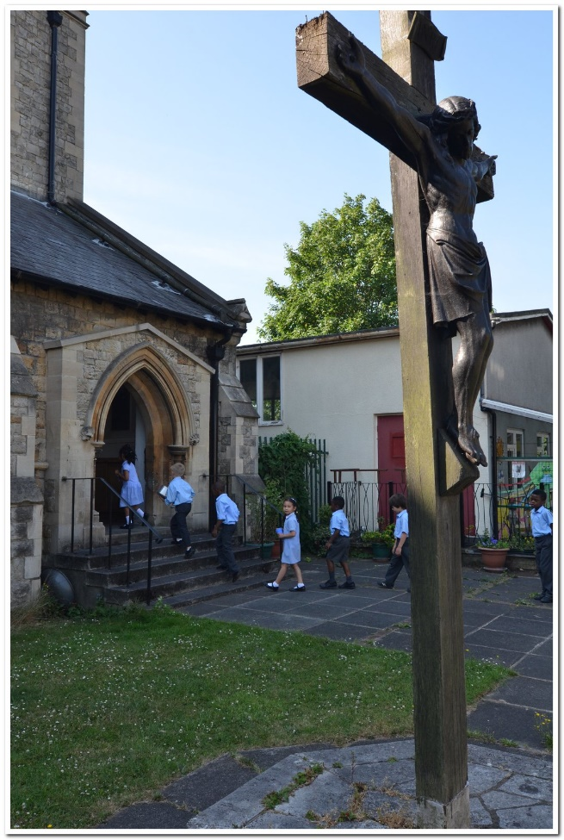

Church and School

Our school enjoys a close working relationship with our local parish church, and the priest has an active role at the school; as a governor, a parent and regularly leading collective worship. Staff, parents and pupils appreciate the support we get, and the church sees it as part of its mission within the local community. Links work both ways, the school and church support one another whilst forging strong relations. Opportunity for the church to work alongside young families as they grow and for our school to enhance the Church School ethos.

All Saints’ CofE Primary School,
Cricklewood Lane,
Childs Hill, London, NW2 2TH
Tel: (020) 8455 9091
Fax: (020) 8458 1066
www.allsaintsnw2.barnetmail.sch.uk

