Lesson 3: Possible paintings you may choose to use

'The Adoration of the Shepherds' Guido Reni about 1640
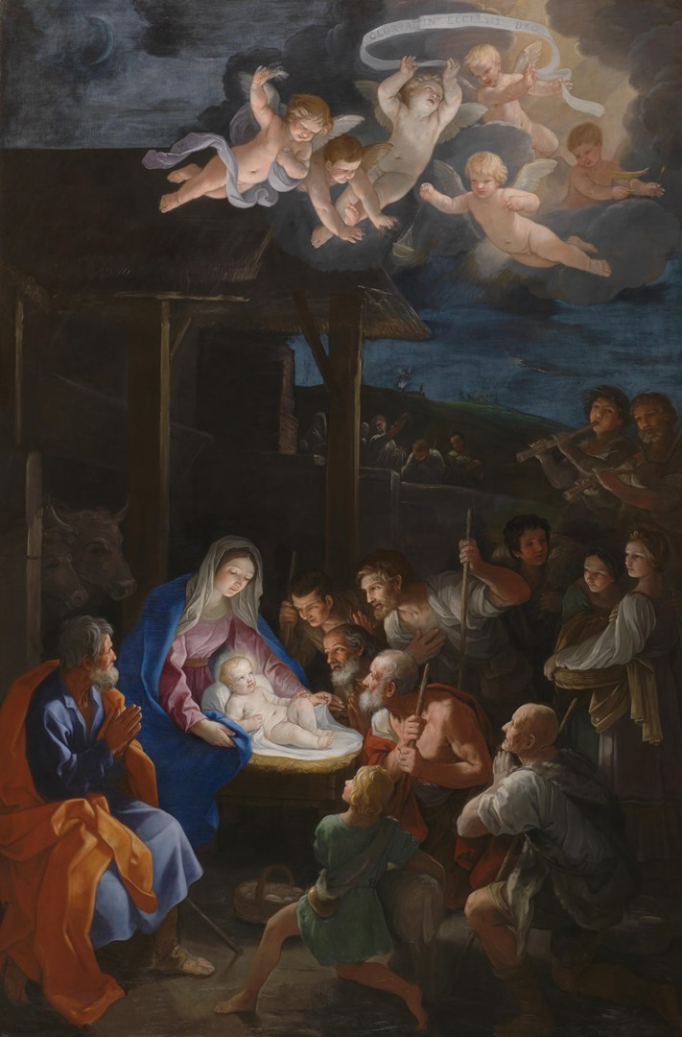
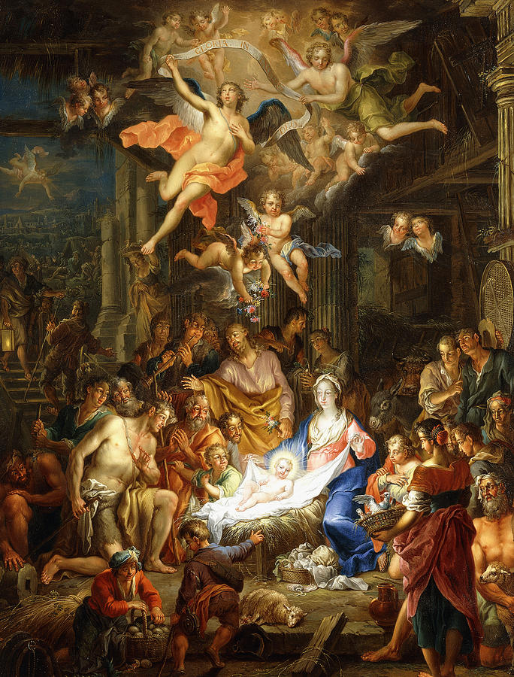
The Nativity Painting by Franz Christopher Janneck
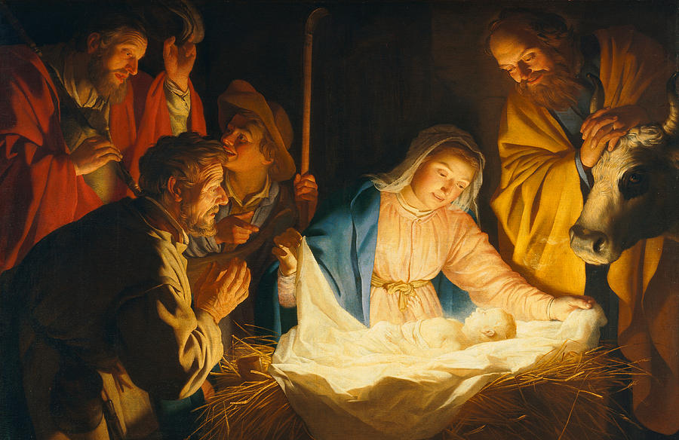
The Adoration of the Shepherds, 1622 (oil on canvas), Honthorst, Gerrit van (1590-1656)

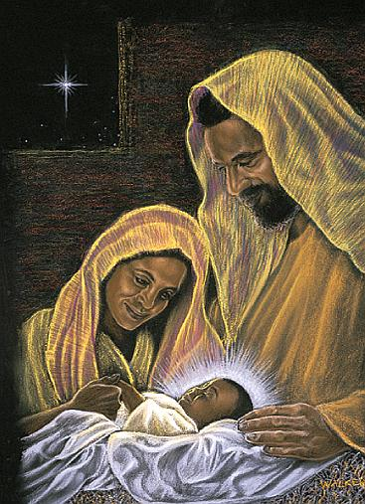

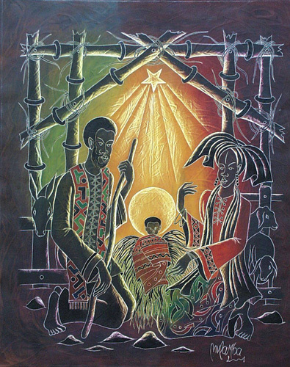
Democratic Republic of the Congo:
Joseph Mulamba-Mandangi Nativity 2001

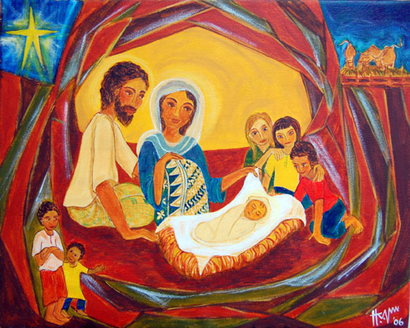

Hanna Varghese, God Is With Us, 2006. Acrylic on canvas

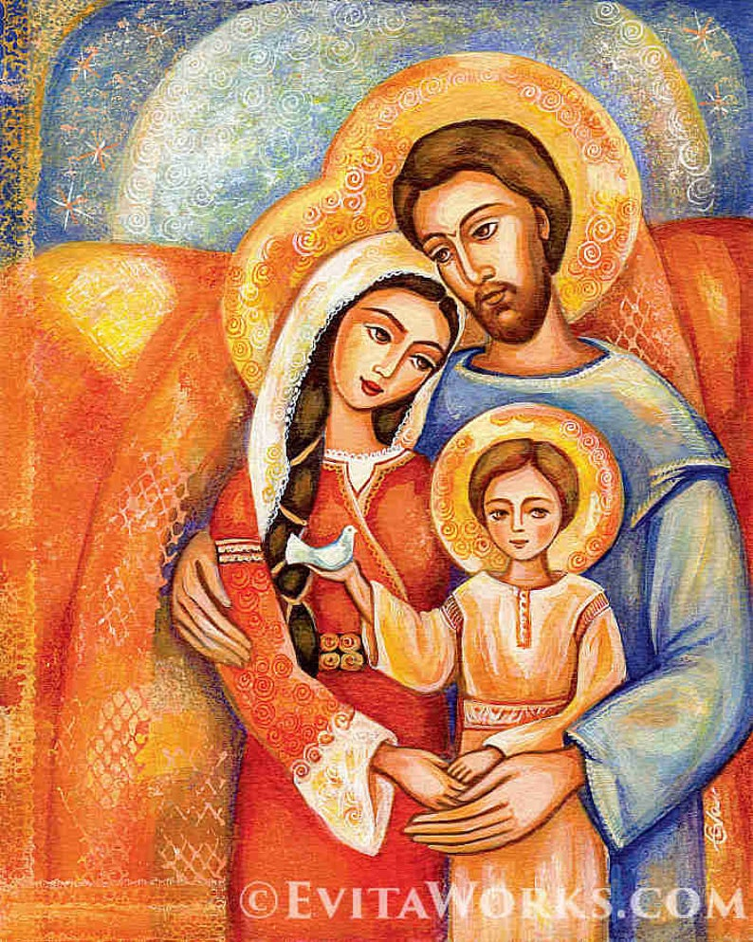
The Holy Family
This is a print of an original painting, named ‘The Holy Family’. It depicts three halo-glowing, beatified figures in ancient garb holding together; a lovingly father and mother embracing a child with their arms (Joseph, Mary, Jesus child). It was painted in a non-traditional style, resembling Eastern Orthodox Iconography. The original was painted with acrylic on paper, in vivid colour nuances of red, orange, blue.
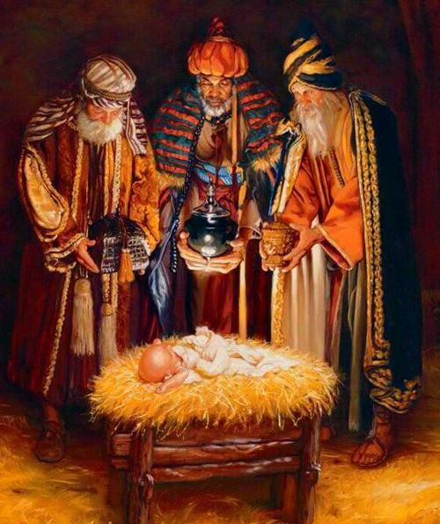

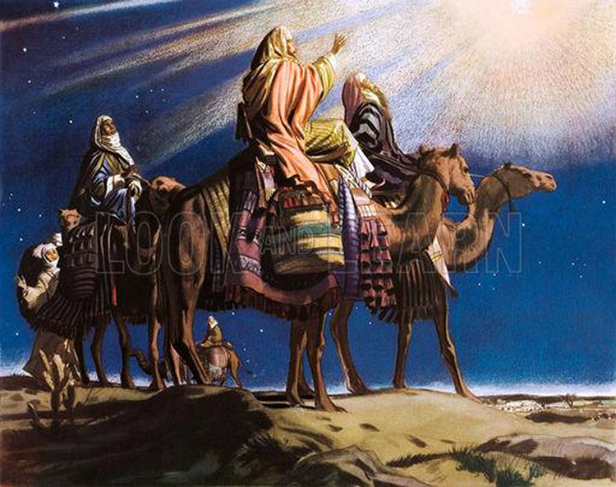
Artist: 20th Century unidentified artist

