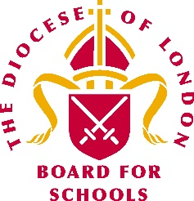 | London Diocesan Board for Schools  Vacancy – Governor Appointment Panel

The LDBS would like to appoint a Headteacher to join its Governor Appointment Panel for the calendar year 2021.

What does the Panel do?
The Panel is responsible for appointing LDBS Governors and Directors to the Governing Bodies and Trust Boards of Church of England schools in the London Diocese.

How often and when does the panel meet?
Monthly, by Zoom, during school hours.

How can I find out more about what LDBS expects of its governors? https://www.ldbs.co.uk/becoming-a-governor/

What are you looking for in the Headteacher who joins the panel?
- Current Headteacher in a Church of England school
- Committed Christian
- Committed to promoting and developing the Christian ethos of Church of England schools
- Strong understanding of what makes a good governor
- Applicants from Black, Asian or other backgrounds which are a minority in the UK are encouraged to apply; we want to address current under-representation

How can I apply?
Please write to penny.roberts@london.anglican.org, LDBS Executive Chair, explaining why you would like to join the Panel and how you meet the criteria.

What is the deadline for applying?
Monday 7 December

