Lesson 5a
What three things do you notice are happening in this picture?
What questions would you ask about this picture?
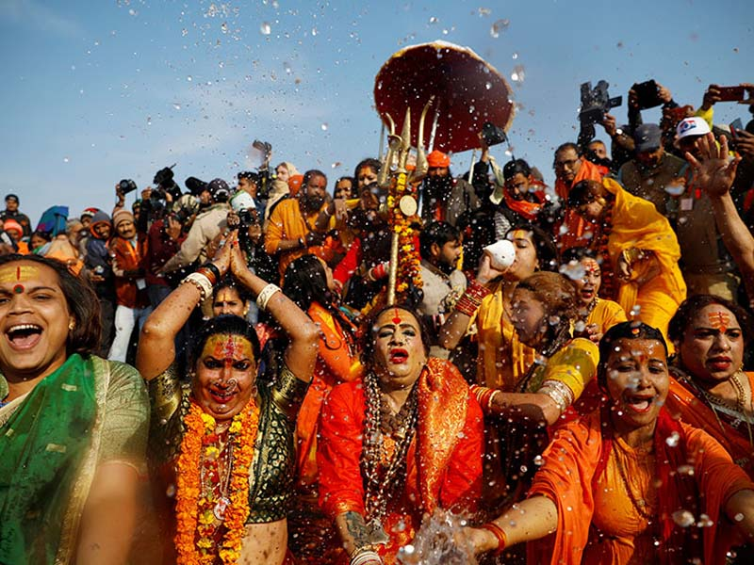
The Kumbh Mela
Give five words to describe how the people are feeling?

Where do you think they are?
What do you think this place might sound like?

