Lesson 6a
Using talking tubs
Talking tubs:

A talking tub is a collection of materials that are designed to stimulate talking and thinking about a concept. They can also be used to:
- assess prior knowledge and understanding;
- assess pupil knowledge and understanding part way through a teaching sequence or at the end of a unit of learning.

Possible content of a talking tub to explore the question: How do Hindus worship?

- Images of Hindu deities. Eg: Shiva, Ganesh, Kali, Lakshmi, Vishnu
- Aum symbol
- Picture of the Hindu creation story
- Photo of a shrine that would be found in the home of a Hindu family
- Photo of inside a mandir
- Photo of a Hindu priest
- Puja set
- Picture of the Kumbh Mela

How to use the talking tub:

The activity works best when the photos/objects are presents in a box to create the element of mystery and exploration.

Step 1:
- Children are given the opportunity to talk about each object/photo in the box. What can they remember from the unit of learning? Children are encouraged throughout to use religious vocabulary in their talk and conversation.

Step 2:
- On strips of paper, children write down what they believe the key knowledge is for each item, using appropriate religious vocabulary.

Step 3:
- On a different coloured strip of paper, children write down any links/connections they can make/see between the items. Eg: What is the link between a shrine at home and the mandir. What is the link between the puja set and the aum, what is the link between pilgrimage and God, what is the link between a Hindu priest and the mandir? etc

Step 4:
- On speech bubbles, children write down any questions they still have related to the big question?

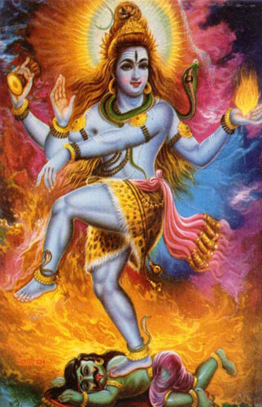

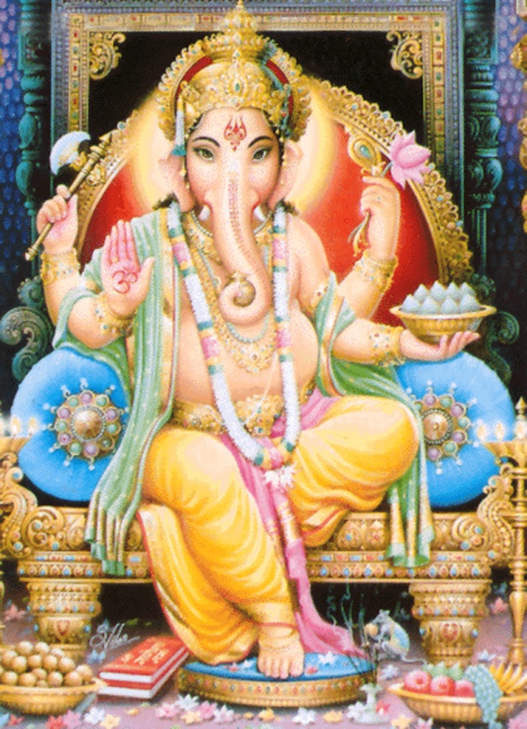
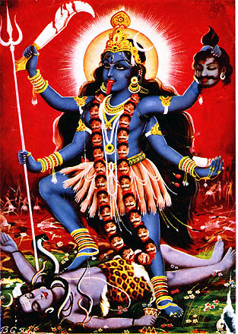

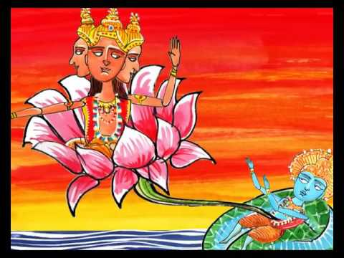

Hindu creation story

