The Emperor and the Langar
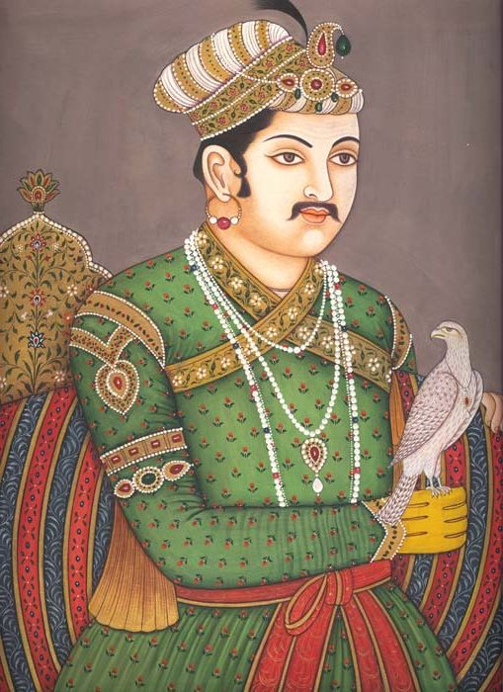 | I know, let’s have a big party or we could have a festival or invite local leaders | 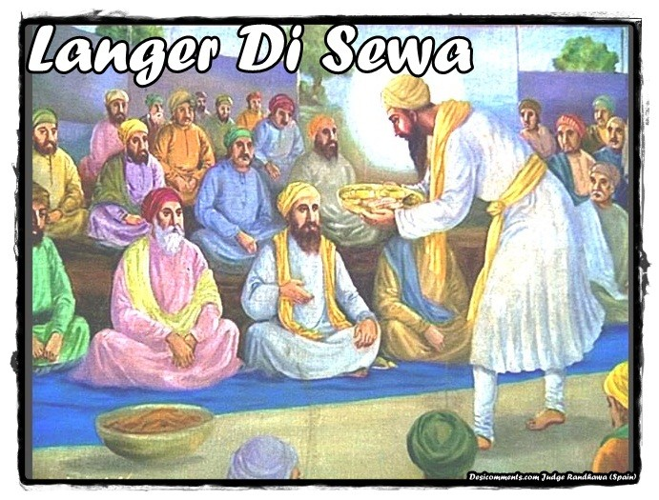
- One day the Muslim Emperor, Akbar, decided he would visit Guru Amar Das and learn about the Sikhs | - Everyone in the village was excited and had lots of ideas about how to welcome the Emperor. The Guru thought about it carefully. | - When Akbar arrived he was taken to the langar and sat on the floor with everyone else to eat bread, rice and lentils
This has been great. Please have this gift of land so that I can provide everything you need for the langar! | 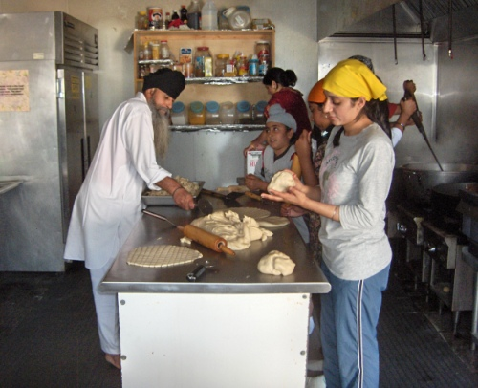 | 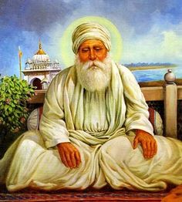
- When the meal was over, Akbar went to speak to the Guru. Akbar offered him a gift of large piece of land to grow crops for the langar. | - The Guru graciously refused the gift and explained that every Sikh has a duty to give to the langar. In that way everyone plays their part. | - Akbar was impressed by the Guru’s words, and gave the Guru’s daughter some land to put to good use.

Guru Amar Das (1479-1574)

Guru Amar Das was the third Sikh Guru. He converted from Hinduism to Sikhism and became a devoted follower of Guru Angad. Even when Guru Angad instructed him to go and live in a village some miles away he still returned to serve the Guru by bringing him water for his daily bath. Amar Das was chosen to be the Guru when he was 73 years old. Even though he was old, he was able to hold the Sikh community together and leave behind him a growing and well-organised faith when he died.

As a man of his time he was very radical, he formalised the langar, where everyone served and sat together to eat a communal meal. This was to demonstrate the equality of all, at a time when the caste system was much more predominant than it is now. It was a practical demonstration of the rejection of the Hindu belief that a person should not eat with someone of a lower caste, women or members of another religion.

Guru Amar Das split the area where Sikhs lived into twenty-two regions. He appointed both male and female preachers, an important step in a Muslim influenced society where women did not usually have contact with men outside of their family. He was also very outspoken against the Hindu practice of sati. The practice of sati meant that women who had been widowed were not allowed to re-marry, but were expected to throw themselves on their burning husband’s funeral pyre. Instead, Guru Amar Das elevated the position of women, he recommended that widows should be allowed to live and re-marry on the death of their husbands; he spoke against the Muslim practice of women being made to cover their faces and spoke against female infanticide.

- In what ways did Guru Amar Das put Guru Nanak’s words ‘There is no Muslim, there is no Sikh’ into practice?
- How did Guru Amar Das elevate the status of women during his lifetime?
- In what ways does the langar demonstrate Guru Amar Das’ belief in equality? (Give at least three ways)
- What inequalities do you think Guru Amar Das would speak out against if he was alive today?

Amar Das fetching water for Guru Angad
