Year group: 1

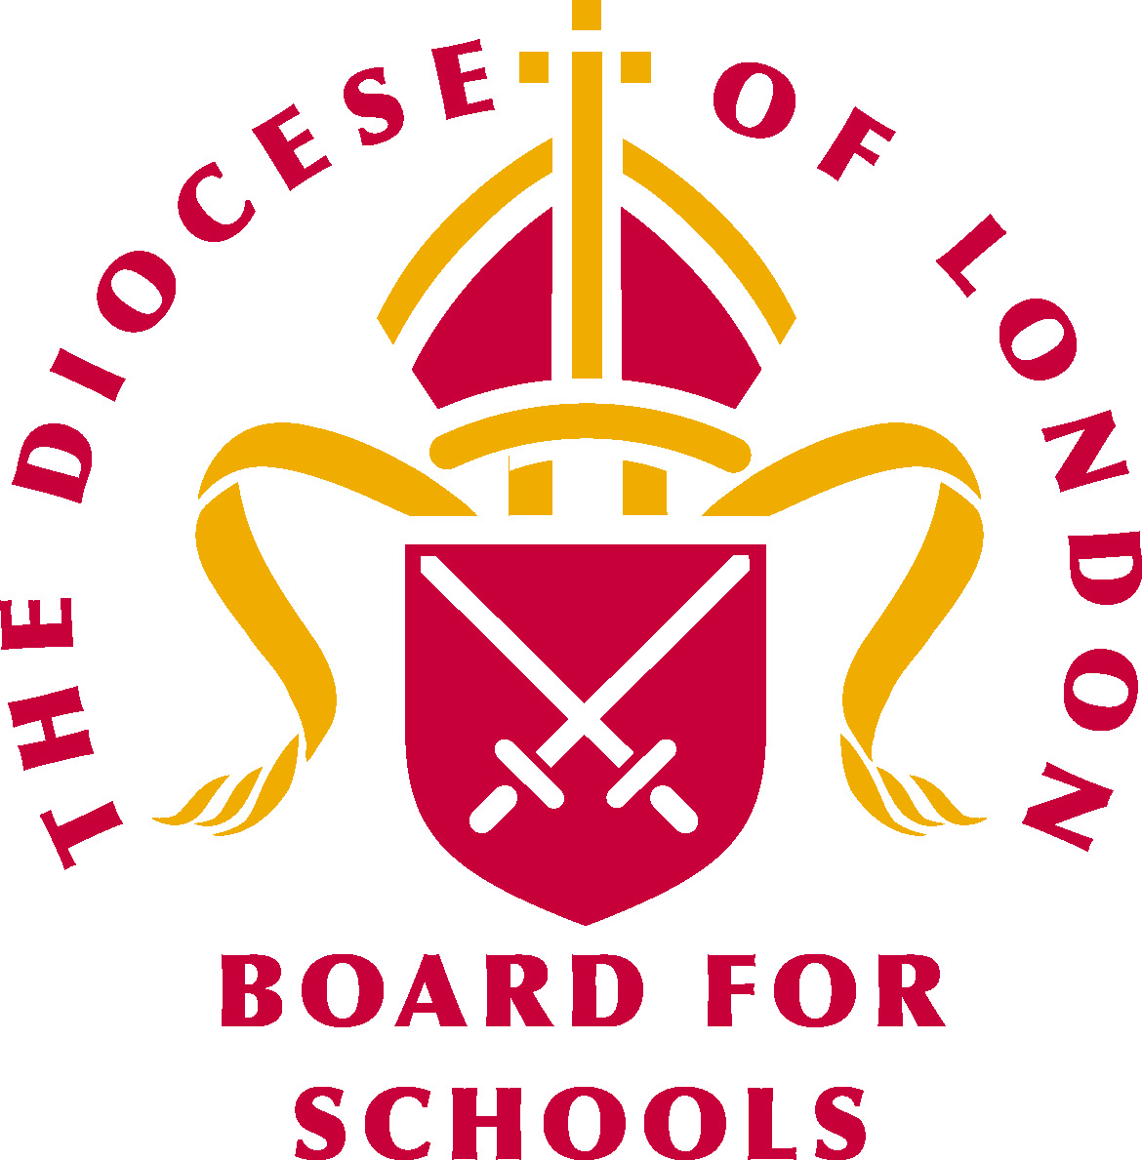Big question: What is it like to live as a Jewish person?
What a child should be able to do: (Assessment)
Ways of expressing meaning:
- I can talk about some of the Jewish symbols ie Star of David. (WT)
- I can recognise the different Jewish symbols and can talk about them. (Exp)
- I can recognise that Jewish symbols, words and actions (worship and the Shabbat meal) have meaning and I am beginning to understand their importance to the Jewish community. (GD)
Questions of identity, diversity and belonging:
- I can talk about the things my family do that are important ie celebrations, rituals, sharing meals together, family gatherings etc (WT)
- I can ask questions about the Jewish faith and other faiths in our school. (Exp)
- I am beginning to understand why faith communities do what they do and respond sensitively to those things. (GD)

Sensitivities:

Be mindful of pupils’ cultural backgrounds and beliefs.

Religious vocabulary:
- Judaism: See background knowledge for teachers
- Jewish people: People who follow the Jewish Faith.
- Star of David: See background knowledge for teachers.
- Menorah: Seven-branched candelabrum which was lit daily in the Temple.
- Torah: Law, teaching. The five books of Moses.
- Yad: Hand-held pointer used in reading the Torah.
- Kippah: Head covering worn during prayers, Torah study, etc. Some followers wear it constantly.
- Tefillin: Small leather boxes containing passages from the Torah, strapped on the forehead and arm for morning prayers on week days.
- Prayer shawl. Four-cornered garment with fringes.
- Shabbat: Day of spiritual renewal and rest commencing at sunset on Friday, terminating at nightfall on Saturday.
- Challah loaf: Enriched bread used particularly on Shabbat and during festivals.
- Synagogue: Jewish place of worship for public prayer, study and assembly.
- Rabbi: An ordained Jewish teacher. Often the religious leader of a Jewish community.

Weekly questions:
Week 1: Why are these objects special?
Week 2: What is the Star of David and the Menorah important to a Jewish person?
Week 3: What is the Torah and how is it used in the Jewish faith?
Week 4: What is the importance of Shabbat within the Jewish faith?
Week 5/6: How do Jewish people worship in the synagogue?

What a child needs to know and remember by the end of the unit:
- To know and remember the meaning of the Star of David, prayer cap, (Kippah) prayer shawl, (Tallit) yad, Torah, Challah loaf and Menorah.
- To know and remember what the Torah is and how it is used by the Jewish people.
- To understand the meaning of Shabbat and what happens during Shabbat including the meal.
- The role the synagogue plays in the life of a Jewish family. (A visit to a synagogue should be encouraged.)
- To understand how the Jewish community worship.

Core concept:
Beliefs and practices

Background knowledge for teachers:

Background to Judaism

Jews believe that God is One and that He is the Creator of the world who cares for all His Creation. They believe their special relationship with God is expressed in the 603 mitzvot (laws). Jews also believe that God’s special relationship with all humanity is expressed through obedience to the seven Noachide laws.

The Torah, which was revealed by God to Moses on Mount Sinai, is the central core foundation of Jewish life. The Torah sets out practical rules and guidance (including the Ten Commandments) for all aspects of daily individual, family and community life. Together with the Oral Law, set out in the Talmud, and described in Halakhah, the Torah remains the basis of belief. The written Torah forms the first five books of the Tenakh (Bible). The New Testament is not part of Jewish religious teaching.

The Jewish people are very family-orientated, and this is reflected both in the celebration of weekly Shabbat, festivals throughout the Jewish year and a proud tradition of caring institutions. Shabbat and festivals are celebrated both in the home and in the synagogue.

Much of Jewish history is connected with the struggle for Israel and identity as a people. The Tenakh describes this early history from the Creation. It contains key events such as the Exodus (the escape from slavery in Egypt under the leadership of Moses), the building of a portable sanctuary in the desert, and the establishment of the Temple in Jerusalem. The Temple was destroyed in 586 BCE, and the Jews were exiled to Babylonia. Re-settlement and the rebuilding of the Temple commenced about 70 years later.

In 70 CE the Romans destroyed the second Temple, and over many centuries the Jews were dispersed throughout the world. Since 1948, the foundation of the State of Israel has provided a beacon of hope for a people nearly destroyed by the Nazis in Hitler’s Germany. The Holocaust and the systematic murder of 6,000,000 Jewish men, women and children is a permanent reminder of the evils of racism.

There is a resurgence of Jewish life and culture in many parts of the world. The future of Judaism will be ensured through the Jewish family, education and Torah study, thus enhancing Jewish continuity.

Meaning of symbol:

- An iconic representation of a specific religion or religious concept.

(Extract taken from BBC.co.uk – religion - Judaism)

Kippah/yarmulke:
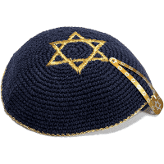
- Clothing worn by Jews usually varies according to which denomination of Judaism they adhere to.
- Orthodox Jewish men always cover their heads by wearing a skullcap known in Hebrew as a kippah or in Yiddish as a yarmulke. Liberal or Reform Jews see the covering of the head as optional.
- Most Jews will cover their heads when praying, attending the synagogue or at a religious event or festival
- Wearing a skullcap is seen as a sign of devoutness.
- Women also cover their heads by wearing a scarf or a hat.
- The most common reason (for covering the head) is a sign of respect and fear of God. It is also felt that this separates God and humans, by wearing a hat you are recognising that God is above all humankind.
- Many Jews feel that by wearing a skullcap they are proudly announcing to the world that they are Jewish. This is classed as an 'outward sign' of their faith.
- It has also become custom to wear kippahs or yarmulkes of certain colours, sizes and materials as a sign of allegiance to a certain group.

Tallith:

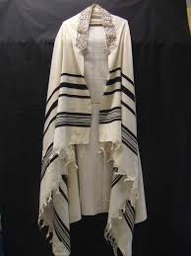

- The tallith, also known as the prayer shawl, is a shawl traditionally worn by Jewish men during morning prayer services, festivals and on the Sabbath.
- Many Reform and Liberal Jewish women now choose to wear a tallith and this is becoming more acceptable in these movements.
- The tallith has 613 fringes known as ‘tzitzits’ which represent the 613 commandments or mitzvot that Jews have to follow.
- After death, the tallith is often wrapped around the body.

Tefillin:
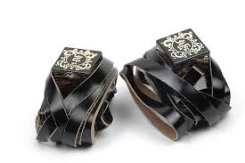

- Tefillin are worn mainly by Orthodox Jewish men during morning prayer.
- Tefillin consist of two leather boxes which contain words from the Shema.
- Jews will tie one of the boxes onto their arm with the leather strap it is attached to, and tie the other box to their head. This signifies that they must serve God with their thoughts and their heart.

Star of David:
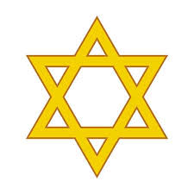
- The star of David, is the symbol most frequently associated with Judaism.
- The Star of David is believed to be a representation of the shield of King David, who was the first king of Jerusalem.
- The Star of David is in the shape of a hexagram made up of two equilateral triangles. It is believed to be a fairly modern symbol, and began to be displayed outside synagogues during the 17th century. It became a popular symbol of Judaism and was adopted as the emblem in 1897.

Menorah:
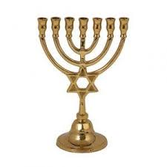
- Seven-branched candelabrum which was lit daily in the Temple and is a feature of every Synagogue.

The Torah:

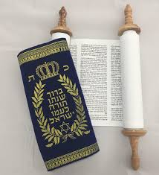

- The Torah is the first part of the Jewish bible. It is the central and most important document of Judaism and has been used by Jews through the ages. Torah refers to the five books of Moses which are known in Hebrew as Chameesha Choomshey Torah. These are: Bresheit (Genesis), Shemot (Exodus), Vayicra (Leviticus), Bamidbar (Numbers), and Devarim (Deuteronomy).
- Jews believe that God dictated the Torah to Moses on Mount Sinai 50 days after their exodus from Egyptian slavery. They believe that the Torah shows how God wants Jews to live. It contains 613 commandments and Jews refer to the ten best known of these as the ten 10 statements.
- The Torah is written in Hebrew, the oldest of Jewish languages. It is also known as Torat Moshe, the Law of Moses. The Torah is the first section or first five books of the Jewish bible. However, Tanach is more commonly used to describe the whole of Jewish scriptures. This is an acronym made up from the first letter of the words Torah, Nevi im (prophets), and Ketuvim (writings).

How is the Torah used?

- The Torah scrolls are taken out from the Ark (Aron ha kodesh) and portions read in the synagogue three times each week. On Mondays and Thursdays small sections are read. The main reading is on the morning of Shabbat (Sabbath).
- Over the course of the year the whole scroll is read in sequence. This begins from the end of Sukkot which is an autumn festival.
- The special portions for the readings are called parshioth and are usually three to five chapters in length. The reader has to be very skilled to read from the scroll because the letters are written without corresponding vowels. They have to know the portion very well to avoid making mistakes. The reading is conducted using an ancient tune and is sung rather than spoken.
- The scrolls are not directly touched when unfurled on the Bimah (raised platform in middle of the synagogue). A pointer or Yad (hand) is used instead. This is in the shape of a hand with an outstretched finger. The reading or chanting is performed by a person who has been trained in this task. However, it may be carried out by the rabbi. It is a very great honour for a congregant to be asked to attend at a reading during a synagogue service. This is called having an Aliyah which is Hebrew for going up.
- The weekly portion or Sedrah is followed by the recitation of part of another of the Jewish holy writings.

How is a Torah scroll constructed?

- The Torah scrolls are entirely handwritten in Hebrew by a sofer (scribe) on parchment from a kosher animal. This is usually a cow. It can take up to 18 months to complete the whole process from the complex preparation of the animal skins to the writing of the final words. Great accuracy is needed when the sofer writes the scroll. If he makes any mistakes it can make the whole scroll pasul (invalid). The completed scroll is known as a Sefer Torah from sefer which is the Hebrew for book.
- A Sefer Torah is so sacred to Jews it is said that if one is accidentally dropped in the synagogue the whole congregation must fast for 40 days. When Jewish communities have suffered persecution, great efforts would be made to preserve these scrolls. This demonstrates just how symbolically and physically important the Torah is to Jews.

Shabbat:

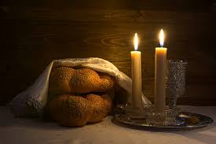

The Sabbath is commanded by God:
- Every week religious Jews observe the Sabbath, the Jewish holy day, and keep its laws and customs.
- The Sabbath begins at nightfall on Friday and lasts until nightfall on Saturday. In practical terms the Sabbath starts a few minutes before sunset on Friday and runs until an hour after sunset on Saturday, so it lasts about 25 hours.
- God commanded the Jewish people to observe the Sabbath and keep it holy as the fourth of the ten commandments.
- The idea of a day of rest comes from the Bible story of the Creation: God rested from creating the universe on the seventh day of that first week, so Jews rest from work on the Sabbath.
- Jews often call the day Shabbat, which is Hebrew for Sabbath, and which comes from the Hebrew word for rest.

A reminder of the covenant:
- The Sabbath is part of the deal between God and the Jewish people, so celebrating it is a reminder of the covenant and an occasion to rejoice in God's kept promises.

A gift from God:

- Most Jewish people look forward to Shabbat all week. They see it as God's gift to his chosen people of a day when they take time out from everyday things to feel special.
- Shabbat is a time with no television, no rushing to the demands of the telephone or a busy work schedule.
- People don't think about work or other stressful things.
- It's an oasis of calm, a time of stillness in life.

Sabbath greetings:

- The traditional Sabbath greetings are Shabbat Shalom (Hebrew), or Gut Shabbos (Yiddish).

A family time:

- Shabbat is very much a time when families come together in the presence of God in their own home.
- Singles, or others with no family around may form a group to celebrate Shabbat together.

Sabbath customs:
- In order to avoid work and to ensure that the Sabbath is special, all chores like shopping, cleaning, and cooking for the Sabbath must be finished before sunset on Friday.
- People dress up for Shabbat and go to considerable trouble to ensure that everything is organised to obey the commandment to make the Sabbath a delight.
- Sabbath candles are lit at sunset on a Friday. The woman of the house usually performs this ritual. It is an integral part of Jewish custom and ceremony.
- The candles are placed in candlesticks. They mark the beginning of each Sabbath and represent the two commandments Zachor (to remember the Sabbath) and Shamor (to observe the Sabbath).
- After the candles are lit, Jewish families will drink wine. Sabbath wine is sweet and is usually drunk from a special goblet known as the Kiddush Cup. The drinking of wine on the Sabbath symbolises joy and celebration.
- It is also traditional to eat challah, a soft rich eggy bread in the shape of a braid. Challah is eaten on the Sabbath and Jewish holidays except for the Passover when leavened bread is not permitted.
- Under Jewish law, every Jew must eat three meals on the Sabbath. One of the meals must include bread. Observant Jews will usually eat challah at the beginning of a Sabbath meal.
- Before the challah is eaten, the following prayer is recited: Baruch atah Adonai, Eloheinu Melech ha'olam, hamotzi lechem min ha'aretz
This means: Blessed are you, Lord our God, King of the universe, who brings forth bread from the earth.
- Other blessings, prayers, songs and readings may also be used.
- It is traditional, too, for parents to bless their children on Shabbat.
The blessing for daughters asks that they become like the four matriarchs, Sarah, Rebecca, Rachel and Leah, while sons are blessed to grow up like Ephraim
and Menasheh, two brothers who lived in harmony.
- Some of the family will have been to synagogue before the Sabbath meal, and it is likely that the whole family will go on Saturday.

Synagogue layout and services:

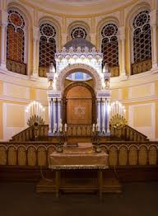

Inside the synagogue:

- The synagogue is the Jewish place of worship, but is also used as a place to study, and often as a community centre as well.
- Orthodox Jews often use the Yiddish word shul (pronounced shool) to refer to their synagogue.

Segregation:
- In Orthodox synagogues men and women sit separately, and everyone (except young girls) has their head covered. In a Reform synagogue men and women can sit together.
The service:

- Synagogue services can be led by a rabbi, a cantor or a member of the congregation.
- Traditional Jewish worship requires a minyan (a quorum of ten adult males) to take place.
- In an Orthodox synagogue the service will be conducted in ancient Hebrew, and the singing will be unaccompanied.
- In a progressive (Reform, Liberal) synagogue the service will be at least partly in English, there may be a choir and instruments, and men and women can sit together.

Hats and prayer shawls:

- Everyone except unmarried women wears a hat in synagogue in order to show reverence to God. (And once unmarried women pass a certain age, they usually wear a hat too.)
- Jewish men always wear hats when they are saying prayers which mention God's name.
- Observant Jewish men wear a hat almost all the time.
- The most common hat for men in the synagogue is a small round cap called a yarmulke (Yiddish) or a kippah (Hebrew), but an ordinary street hat will be accepted.
- Men (i.e. those over the age of 13) often wear a Tallit or prayer shawl for morning prayer. A Tallit has fringes (called tzitzit) on the edges to remind the wearer to observe God's commandments - as commanded by God in the Bible.

The Ark and the Torah:

- Every synagogue contains an Ark, which is a cupboard where the Torah scrolls, which contain the text of the Hebrew Bible, are kept, and a desk from which to read the Torah.
- The Hebrew words of the ten commandments are usually written somewhere above the ark.
- The Ark is named after the wooden chest which held the stone tablets of the covenant that God gave to Moses on Mount Sinai.

The eternal light:

- An eternal light (called Ner Tamid) hangs above the Ark.
- This light is always burning, as a symbol of God's presence.
- It also represents the pillar of fire that guided the Jewish people on their early journey.

Reading from the Torah
- The platform and the desk for Torah readings are called the Bimah (pronounced beemar), and in an Orthodox synagogue are in the centre of the building. (In a Reform synagogue, the Bimah is usually close to the Ark.)
- At the proper moment in the service the Ark is ceremonially opened, and the Torah scroll is carried in procession to the reading desk, unrolled to the reading chosen for the day and laid on the reading desk.
- It is normal for everyone to stand whenever the doors of the ark are open.

Lesson 1: Why are these objects special?

Intentions:  - To give pupils opportunities to: | - Know the name of each object.  - Know why each object is special for a Jewish person.  - Ask and answer questions.  Key religious vocabulary: Star of David, Menorah, Torah, yad, kippah, tefillin, challah loaf.
Implementation:  Outlining how to introduce the religious content in the classroom and create learning opportunities from it. | Introduction:  I wonder what is in this special box?  Pupils to sit in a circle. One by one each object is taken out of the box. A pupil is invited to unwrap it.  Each object is placed on a special cloth as an indication that it is special and must be taken care of.  Key question:  - What do you think the object is?  Once all the objects have been unwrapped see if pupils can identify what they might be learning about in this unit of learning.  Introduce the word artefact and its meaning.  Explain to pupils that they will be learning about Judaism and that all these artefacts are important to the Faith.  Main teaching input: (Investigate and explore)  Introduce the big question for the unit: What is it like to live as a Jewish person?  Introduce this week’s question: Why are these objects special?  Main activity: (Evaluate and communicate)  - Pupils to take three post it notes and write down three things they would like to find out about Judaism. These can then be added to the class RE learning journey.  One artefact to be placed on each table or class to be divided into two groups – one group led by the teacher and one group led by the T.A  Pupils to discuss the following questions:  Recap first what the artefact is from the previous discussion.  Key questions:  - What do you think the artefact is used for?  - Why do you think the artefact is special to a Jewish person?  Plenary: (Reflect and express)  The class regroups and together they explore their questions and answers.  Teacher explains that throughout the unit they will discover what each artefact is used for and why it is important to the Jewish community.
Resources: | - Box of artefacts to include: Star of David, Menorah, Torah, yad, kippah, tefillin, challah loaf.
Sensitivities:
Impact:  What do you notice as a teacher?  What do pupils say? | In this box, note down anything that you heard a pupil say that would provide evidence towards their progress in RE.  Note down anything significant an additional adult has noticed.  Note down anything significant that happened in the lesson that will have an impact on the next lesson.

Lesson 2: Why is the Star of David and the Menorah important to a Jewish person?

(Allow for 1.5 hours for this lesson.)

Intentions:  To give pupils opportunities to: | - Know what a symbol is.  - Know the meaning of the Star of David and the Menorah and why they are important symbols to a Jewish person.  - Explore what is important to them and how they might represent that importance in a symbol.  Key religious vocabulary: Symbol, Star of David, Menorah.
Implementation:  Outlining how to introduce the religious content in the classroom and create learning opportunities from it. | Introduction:  Recap on previous week’s learning.  Key knowledge checking:  - Know what the name of each artefact is.  - Know what each artefact is used for.  - Know the significance of the artefact for the Jewish community.  Pupils share things they have brought in from home that are either symbols of their faith/beliefs or objects/items that hold significant meaning for their family.  Create a special table of important things to our class community.  Explain what a symbol is. Share with pupils a range of symbols that we see in our everyday environment. (Road signs/shop logos/school symbol etc)  Pupils to go on a ‘symbol hunt’ around the classroom/school /local community.  Pupils to take photos of what they see and come back and discuss their findings and what the symbols mean/tell them.  Main teaching input: (Investigate and explore)  Introduce this week’s question: Why is the Star of David and the Menorah important to a Jewish person?  Explain to pupils the meaning of a religious symbol.  Introduce two main symbols for Judaism.  - The Star of David  - The Menorah  Explain the meaning and significance of both symbols for the Jewish person.  Main activity: (Evaluate and communicate)  To note: Pupils need to understand that a symbol is not a picture or something ‘you like’ but is something that represents an idea/concept/relationship. Teachers need to model possibilities for each option. Eg If a pupil wants their life to speak of kindness and friendship – what might the symbol be? If a pupil wants their life to speak of creativity what might the symbol be? If a child wants their life to speak of the importance of family, what might the symbol be?  In terms of option 2 a starting point could be the school vision. How might a symbol represent the vision?  Option 1:  - Pupils to design a symbol for their own life.  Option 2:  - Pupils design a symbol for their school. (A good starting point for this would be the school vision statement – what is the vision speaking of and how could this be represented in the symbol?)  Extension: Pupils write a short paragraph to explain why they have designed what they have designed. What meaning have they given to their symbol and why is it important to me?  Eg: Model: I have drawn two people hugging each other because I want to be someone who is kind and friendly to everyone.  Model: I have drawn a shining light that spreads out around the whole world because our school vision is about being shining lights in our world.  Plenary: (Reflect and express)  Recap the meaning of the Star of David and the Menorah and the significance of both for a Jewish person.  In pairs, pupils share their symbols with each other and are encouraged to explain what they mean and why the symbol is important to them.  Formative assessment opportunity: Do pupils understand what a symbol is? Can they explain the meaning behind their symbol?
Resources: | - Star of David.  - Menorah.
Sensitivities: | - Handle artefacts with care.
Impact:  What do you notice as a teacher?  What do pupils say? | In this box, note down anything that you heard a pupil say that would provide evidence towards their progress in RE.  Note down anything significant an additional adult has noticed.  Note down anything significant that happened in the lesson that will have an impact on the next lesson.

Lesson 3: What is the Torah and how is it used in the Jewish Faith?

Intentions:  To give pupils opportunities to: | - Know what the Torah is.  - Know why the Torah is special.  - Know how the Torah is treated and looked after and the reasons why it is treated in this way.  Key religious vocabulary: Torah, yad, kippah, tallit.
Implementation:  Outlining how to introduce the religious content in the classroom and create learning opportunities from it. | Introduction:  Recap on previous week’s learning.  Key knowledge checking:  - Know and understand what a symbol is.  - Know the meaning and significance of the Star of David and the Menorah for a Jewish person.  Key questions:  - Do you have a favourite book?  - What is it you like about the book?  - Can you remember the name of the special book for Christians? What makes the book special for Christians?  Main teaching input: (Investigate and explore)  Introduce this week’s question: What is the Torah and how is it used in the Jewish Faith?  Introduce the Torah to the pupils and explain why it is important to Jewish people. (Refer to background knowledge for teachers.)  Explain that the first five books of the Bible are also the books found in the Torah.  Key question:  - Can you remember any stories from the Old Testament that we would also read in the Torah?  The pupils watch one of the clips below which give examples of how the Torah is written and looked after.  Show the pupils a replicate of a Torah.  https://www.bbc.co.uk/programmes/p02mxblj - the importance of the Torah explained by a child.  https://www.youtube.com/watch?v=YHhB3XHPA9M – Focus is on the use of the Torah in the synagogue.  https://www.truetube.co.uk/film/holy-books-torah - what the books are about and how it is looked after.  Key things to note:  Main activity: (Evaluate and communicate)  If you had to choose five rules to follow that would help you live and grow well, what do you think they would be? Encourage pupils of other faiths to consider the rules/commandments their faith encourages them to live by.  To note: Model this for pupils. Provide pupils with vocabulary to consider. Refer to the school vision and associated values and how this helps the school live well together.  Pupils to write their rules on a scroll and make a special cover for it.  Differentiation: Pupils to draw their five rules. Pupils to make their fives rules using play dough – eg friendship – make a pair of hands. Caring for the world – make a globe. Sharing – make two people sharing a toy etc.  Plenary: (Reflect and express)  Key question:  - For you, what is the most important rule you think you should live by? Can you explain why?  - How do we care for our special books?  - How would you like people to care for your special book?  - How does it make you feel if people don’t treat your favourite book with care?  - Can you think of one thing we could do in our class to improve the way we take care of our books?
Resources: | - https://www.bbc.co.uk/programmes/p02mxblj - the importance of the Torah explained by a child.  - https://www.youtube.com/watch?v=YHhB3XHPA9M – Focus is on the use of the Torah in the synagogue.  - https://www.truetube.co.uk/film/holy-books-torah - what the books are about and how it is looked after.
Sensitivities: | - Handle artefacts with care.
Impact:  What do you notice as a teacher?  What do pupils say? | In this box, note down anything that you heard a pupil say that would provide evidence towards their progress in RE.  Note down anything significant an additional adult has noticed.  Note down anything significant that happened in the lesson that will have an impact on the next lesson.

Lesson 4: What is the importance of Shabbat within the Jewish faith?

Intentions:  To give pupils opportunities to: | - Know why, when and how Jewish people celebrate Shabbat.  - Experience preparing and participating in a celebration.  - Talk about and respond sensitively to how they felt being part of the celebration and how a Jewish child might feel being part of the Shabbat meal.  Key religious vocabulary: Shabbat, challah loaf.
Implementation:  Outlining how to introduce the religious content in the classroom and create learning opportunities from it. | Introduction:  Recap on previous week’s learning.  Key knowledge checking:  - Know what the Torah is.  - Know why the Torah is special.  - Know how the Torah is treated and looked after and the reasons why it is treated in this way.  Key question:  - Is there a regular and special time in the week when your family get together?  As a class, share experiences. What makes these times special? What things do you do as a family that help to make it a special time?  Main teaching input: (Investigate and explore)  Introduce this week’s question: What is the importance of Shabbat within the Jewish faith?  Explain the meaning of Shabbat. (Refer to background knowledge for teachers.)  Show the pupils the clips below.  https://www.bbc.co.uk/bitesize/clips/zs2hyrd  https://www.bbc.co.uk/bitesize/clips/z3hyr82  https://www.youtube.com/watch?v=JpFw7DqRMEc  Key things to note:  - Fourth commandment is to keep the sabbath day holy.  - The creation story talks about the seventh day being the day God rested and made it holy – Shabbat for the Jewish community is their day of rest.  - Shabbat begins at sunset on Friday and ends at sunset on Sunday.  - Shabbat begins with a blessing over the candles, wine and challah loaf and worship. This then leads into a family meal.  - For an orthodox Jew, no work must take place on Shabbat.  - Shabbat brings the family and faith community together each week. It reminds them of the importance of their Faith and their relationship with God in their everyday life.  Main activity: (Evaluate and communicate)  Class create their own special celebration to have together.  The celebration to include the following:  - Special food to share – this may include a group making a challah loaf or pupils decorating biscuits/cupcakes.  - Writing of an opening prayer that could be said before the celebration begins. This prayer could include giving thanks to God for all the thigs that He gives us each day.  - Pupils consider including a ‘ritual’ they could all participate in before they begin the celebration. Eg – shaking hands with each other, smiling at each other, saying welcome to each other.  - Pupils choose songs they wish to sing as part of their celebration.  - Pupils decide how they wish to set the table – what will make it special? Could they make a table decoration? Could someone bring in a special table cloth from home? Do they want to light candles?  - Who would the class like to invite as their special guest? Shabbat is about keeping the day holy, resting and bringing the family together.  Plenary: (Reflect and express)  Key questions: (Pupils responses to be recorded on the RE learning journey. This is an opportunity for AFL to take place.)  - How did you feel taking part in the special celebration?  - What part of the celebration did you enjoy most and why?  - How do you think a Jewish child might feel when they take part in the Shabbat meal?  - What part of the Shabbat meal do you think a Jewish child would like best? Can you say why?
Resources: | - https://www.bbc.co.uk/bitesize/clips/zs2hyrd  - https://www.bbc.co.uk/bitesize/clips/z3hyr82  - https://www.youtube.com/watch?v=JpFw7DqRMEc
Sensitivities:
Impact:  What do you notice as a teacher?  What do pupils say? | In this box, note down anything that you heard a pupil say that would provide evidence towards their progress in RE.  Note down anything significant an additional adult has noticed.  Note down anything significant that happened in the lesson that will have an impact on the next lesson.

Lessons 5 and 6: How do Jewish people worship in a synagogue?

Intentions:  To give pupils opportunities to: | - Know what a synagogue is.  - Know what happens inside a synagogue  - Know what happens during worship.  - Know and understand how the synagogue is laid out.  - Know how the Torah is kept in the synagogue.  - Ask and answer questions.  - Talk about celebrations artefacts/objects that are important to them and say why,  Key religious vocabulary: Synagogue.
Implementation:  Outlining how to introduce the religious content in the classroom and create learning opportunities from it. | Introduction:  Key questions:  Recap on previous week’s learning.  Key knowledge checking:  - Know the meaning of Shabbat and why Jewish people observe it.  - Know how Jewish people celebrate Shabbat in the home.  Lesson 5:  Main teaching input: (Investigate and explore)  Introduce this week’s question: How do Jewish people worship in a synagogue?  During this session pupils should visit a local synagogue to explore its role in worship within the Jewish faith.  Pupils to prepare questions before the go.  Pupils to take photos of their visit if allowed by the place of worship.  Things to focus on:  - The use of the Torah in worship  - What people wear when they go to the synagogue and reasons for the dress.  - Where people sit in worship. (Remember in orthodox synagogue men and women sit separately. In liberal or reformed synagogues men and women sit together  - What happens during worship.  If a visit can not take place possible alternatives:  - Invite a Jewish person into school to talk to the pupils about the importance of the synagogue to the Jewish community.  - Use a video clip: Pupils as a class, create questions first before watching and then see if the clip gives them the answer to their question.  https://www.bbc.co.uk/bitesize/clips/zcfgkqt - child’s perspective  https://www.truetube.co.uk/film/holy-cribs-synagogue - explanation of all the parts of the synagogue and what happens during worship  Lesson 6:  Key question:  - What can you remember from our visit to the synagogue (either virtually or in person)?  Recap key learning points about worship in a synagogue. (Refer to background knowledge for teachers.)  Use photographs from the visit to aid discussion and stimulate memory.  Return to the main question of the unit: What is it like to live as a Jewish person?  Main activity: (Evaluate and communicate)  Pupils to complete task. (See appendix lesson 6.)  Plenary: (Reflect and express)  What can we remember?  Circle time:  Return to the artefact box from lesson 1:  Take out one item at a time:  Key question:  - What can you tell me about this artefact?  - Turn to your partner: Tell your partner one celebration that is important to your family and say why and one object/artefact that is important to your family and say why.  Finish by showing this final clip which shows how Shabbat ends in the family home.  https://www.bbc.co.uk/bitesize/clips/zkcd2hv
Resources: | - https://www.bbc.co.uk/bitesize/clips/zcfgkqt - child’s perspective.  - https://www.truetube.co.uk/film/holy-cribs-synagogue - explanation of all the parts of the synagogue and what happens during worship.  - https://www.bbc.co.uk/bitesize/clips/zkcd2hv - the closing of Shabbat.  - Box of artefacts to include: Star of David, Menorah, Torah, yad, kippah, tefillin, challah loaf.
Sensitivities: | - Handle artefacts with care.
Impact:  What do you notice as a teacher?  What do pupils say? | In this box, note down anything that you heard a pupil say that would provide evidence towards their progress in RE.  Note down anything significant an additional adult has noticed.  Note down anything significant that happened in the lesson that will have an impact on the next lesson.

