Lesson 6:
Using talking tubs
Talking tubs:

A talking tub is a collection of materials that are designed to stimulate talking and thinking about a concept. They can also be used to:
- assess prior knowledge and understanding;
- assess pupil knowledge and understanding part way through a teaching sequence or at the end of a unit of learning.

Possible content of a talking tub to explore the question: What does it mean to be Jewish?

- Picture of Abraham
- Picture of Moses
- Picture of Mount Sania
- Mezuzah
- Copy of the Shema
- Pictures of the ten plagues
- Sedar plate
- Seder food – real or pictures of each item.
- Tablets of stone with the ten commandments on them

How to use the talking tub:

The activity works best when the photos/objects are presents in a box to create the element of mystery and exploration.

Step 1:
- Pupils are given the opportunity to talk about each object/photo in the box. What can they remember from the unit of learning? Children are encouraged throughout to use religious vocabulary in their talk and conversation.

Step 2:
- On strips of paper, pupils write down what they believe the key knowledge is for each item, using appropriate religious vocabulary.

Step 3:
- On a different coloured strip of paper, pupils write down any links/connections they can make/see between the items. Eg: What is the link between a shrine at home and the mandir. What is the link between the puja set and the aum, what is the link between pilgrimage and God, what is the link between a Hindu priest and the mandir? etc

Step 4:
- On speech bubbles, pupils write down any questions they still have related to the big question?

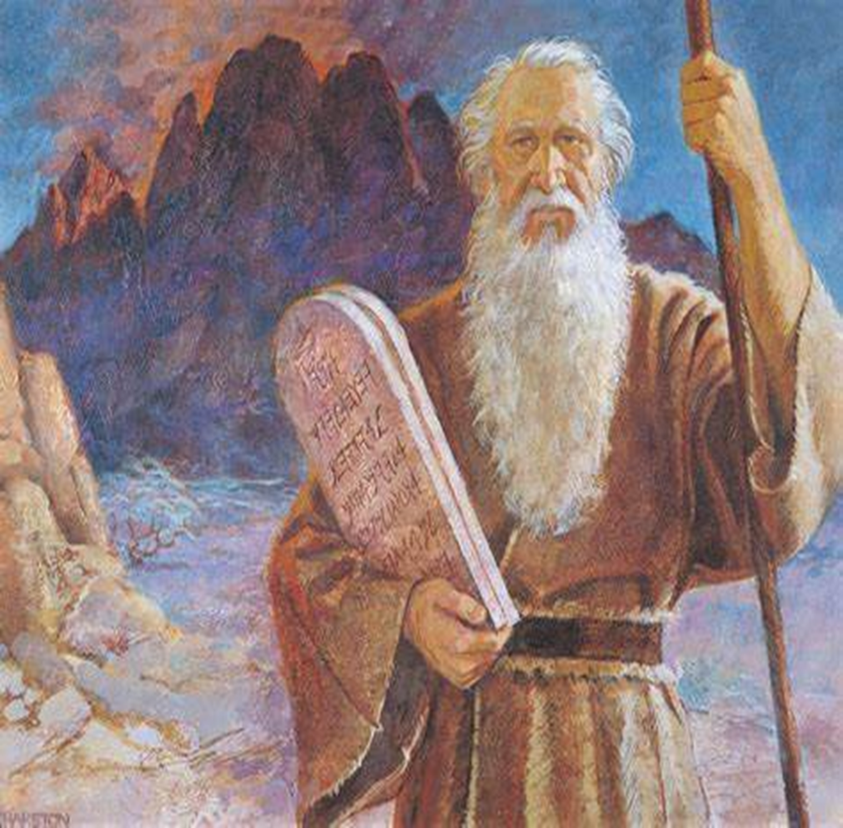

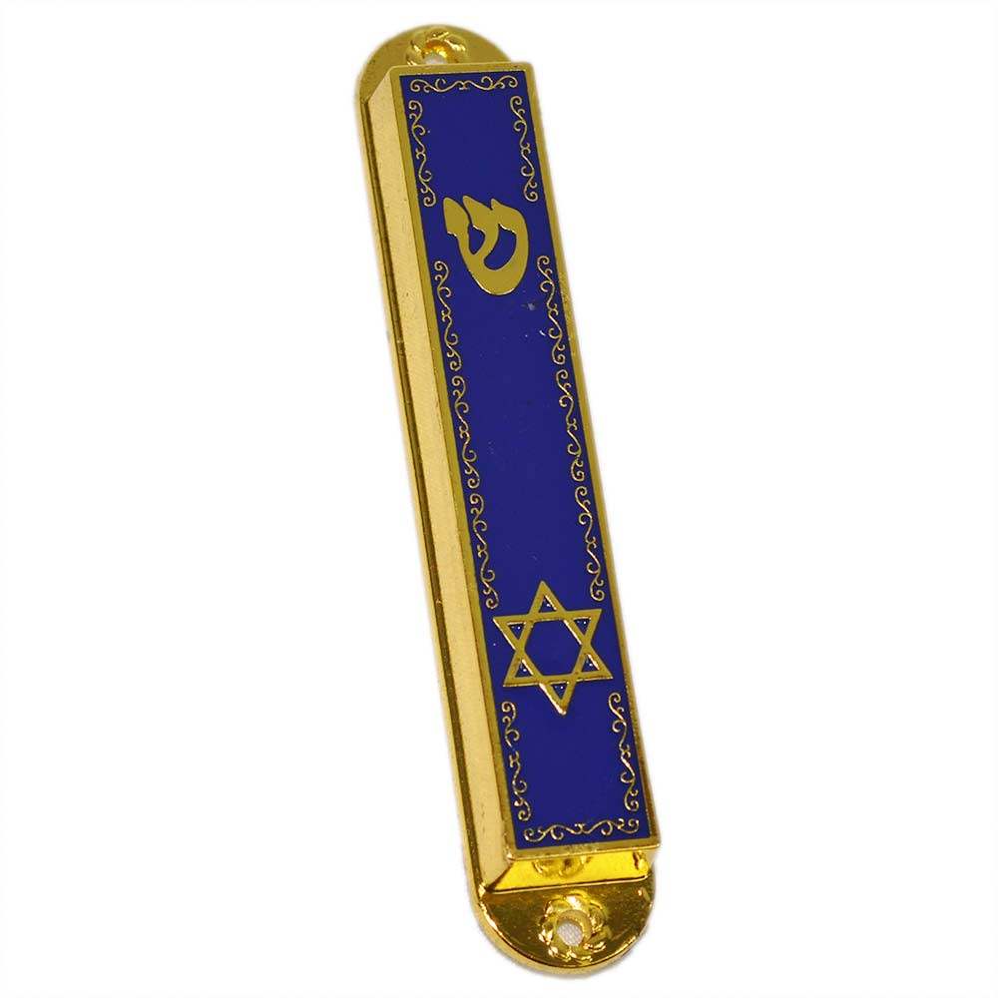

The Shema
The Daily Declaration of Faith
Shema Yisrael (שְׁמַע יִשְׂרָאֵל) (“Hear, O Israel”) are the first two words of a section of the Torah that is the centre-piece of the morning and evening prayer services.
“Hear, O Israel: G-d is our L-rd, G-d is one.”

