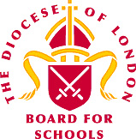

Anti-racism Statement

The London Diocesan Board for Schools (LDBS) is committed to being actively anti-racist.
The schools we support are rich in their diversity and we believe that this diversity brings strength and opportunity. Racism and other forms of discrimination are wholly incompatible with Jesus’ promise of “life in all its fullness” and our vision of human flourishing.
We expect that staff working for the LDBS and the schools we support, will reflect the diversity of their communities. As an organization we have a zero-tolerance towards discrimination of any kind and we are committed to challenging and removing structural racism and discrimination within the Diocese. We celebrate the current diversity of our staff and are seeking to expand this to reflect our schools and their communities.
February 2021

