St. Peter’s Eaton Square
Church of England Primary School

Together, we will realise the potential God has given us

HEADTEACHER
APPOINTMENT PACK

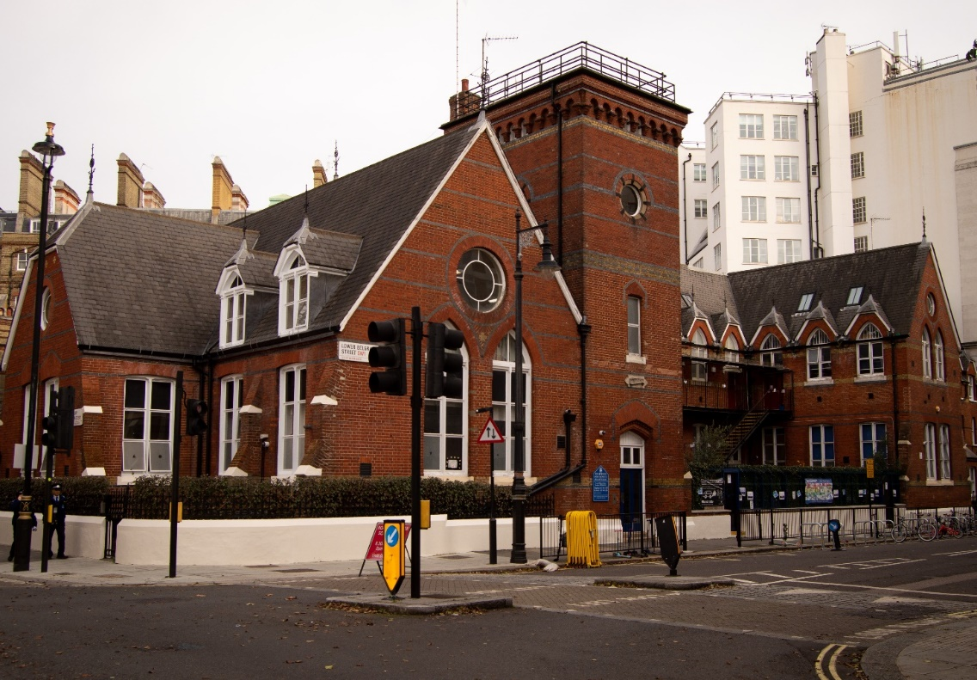

St. Peter’s Eaton Square Church of England VA Primary School, Lower Belgrave Street, London SW1W ONZ

Telephone - 020 7504 0537 ✧ Email - office@stpeaton.org.uk ✧ Chair of Governors - vicar@stpetereatonsquare.co.uk ✧ www.stpeaton.org.uk

St. Peter’s Eaton Square

Church of England Primary School

Lower Belgrave Street

London SW1W ONZ

10 February 2021

Dear Applicant,
Thank you for your interest in the position of Headteacher at St Peter’s, Eaton Square.
We are looking for an outstanding candidate to lead our happy and successful school from September 2021, following a period of change for the school and the retirement of our previous Head in August 2020. You will find all the necessary information in the enclosed application pack but please also look at our website: www.stpeaton.org.uk
Situated in the historic heart of London, close to Victoria Station, St. Peter’s is a two-form entry Church of England Primary School with a strong Christian ethos, in an exciting and vibrant location. It serves a very diverse community drawn from a wide area, and with over half our pupils having English as a second language it is inclusive and generous in its approach to life and learning.
The coronavirus pandemic has posed an unprecedented challenge for all schools and St Peter’s is no exception. Last year it prevented us from recruiting a substantive Head to start in September 2020 as the Governing Body had a strong preference to meet candidates in person and for them to visit the school safely and while operational. It is now a priority for the school to recruit a substantive Head to begin in September 2021. The potential in the school is enormous, and the right candidate will draw on the strengths of the school’s community, diversity, Christian values, talent and location to take it forward as we emerge from the pandemic.
An outstanding SIAMS inspection of the school in 2018 said, “The distinctiveness and effectiveness of St Peter’s as a Church of England school is outstanding.” The Ofsted subject inspection in October 2019 said, “The Latin curriculum is ambitious and exceeds the requirements of the national curriculum for languages at key stage 2.” Our last full Ofsted inspection was in 2006 (rating: Outstanding), so the person appointed will need to lead the school through a new Ofsted, unless it is before September. We currently evaluate the school as Good, recognising the recent changes in the Ofsted framework and within the school.
St Peter’s has a strong staff team, committed governors and supportive parents, and is now in need of the stability which a strong, permanent Head provides. We are a happy and successful school with strong links to St Peter’s Church and excellent results in all year groups. This is reflected in the large number of applications for places in lower years, and our success in maintaining numbers despite falling rolls across London. Although our school site is small, it has been sensitively and creatively enriched and we currently have an extremely exciting prospect of extending our playground into Lower Belgrave Street, with the support of Grosvenor Estate and Westminster Council, which will greatly improve our facilities. This follows the establishment during the pandemic of a “school street” closed to traffic during drop off and pick up times in term-time, to assist with social distancing.
We have strong links with the wider community not just in Westminster, but also with other schools, in the UK and overseas. With parents who work for local embassies, the Guards Barracks or Buckingham Palace, and with families from a wide range of international backgrounds, the school community reflects the vibrant life of London, and the Governors are keen to see the children’s learning enriched through the exciting opportunities which are uniquely available here.
We are looking for an energetic, dynamic, creative, financially astute and committed leader to take our school forward. The successful candidate will need a deep knowledge of how children learn, a sound understanding of education policy and innovation, and commitment to the important role of a church school within its community.
I hope that you will apply for the post.
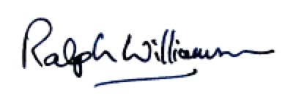
Yours sincerely
Ralph Williamson - Chair of Governors
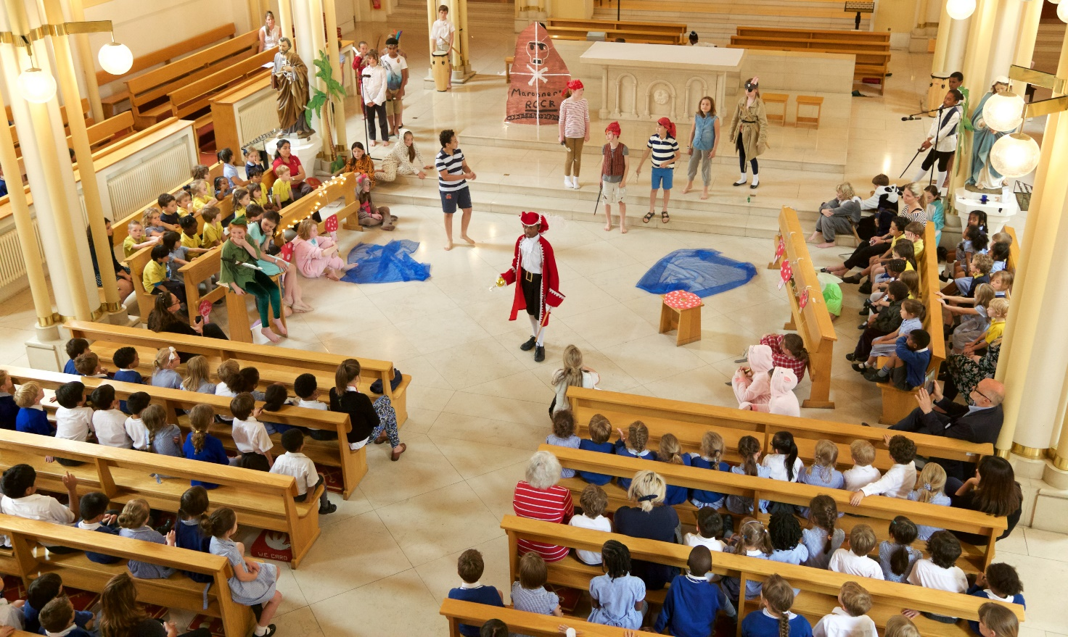

St Peter’s Eaton Square CE School

Headteacher Appointment Pack

Contents

Cover page | Page 1
Letter from the Chair of Governors | Page 2
Contents | Page 4
Copy of Advertisement | Page 5
School Information | Page 7
Ethos | Page 8
Academic Information and Achievement | Page 10
Quotes about the School | Page 11
Enrichment and Extra-curricular activity | Page 12
Resources, Premises and Governance | Page 14
Person Specification | Page 16
Job Description | Page 18
How to Apply | Page 24

Advertisement
Headteacher, Westminster
St Peter’s Eaton Square Primary School

Dates: ​​Job starting September 2021 (or earlier if appropriate)
Salary: £67,556-77,011 (L15-L21) Group 2 (with potential for salary review as and when school grows to become Group 3)
Location: ​Victoria, London (very close to public transport links)

“Members of staff work as a tightly knit team and morale is high”. SIAMS Report 2018

Built in 1872 and with 293 pupils (including 9 in Nursery), St Peter's is a distinctive, happy and outstanding Church of England primary school. It has the potential to grow to Group 3 in size in the medium term, and the school provides a modern and flexible learning space for the two-form entry intake.

Characterised by a rich curriculum, strong staff team and close community of parents, St Peter's is shaped by Christian values which are reflected in the positive behaviour of children, as recognised in the 2018 SIAMS Inspection. It has a close and rewarding relationship with the church, and staff make exceptional and creative use of the opportunities provided by the fantastic central London location to provide a rich and fulfilling curriculum for all children. St Peter's makes the very best of opportunities for outdoor exploration and exercise provided by the supportive local community.

The past year has of course forced all schools to adapt in new ways to offer remote learning on digital platforms alongside on-site provision for vulnerable children and children of critical workers. The Governors of St Peter’s recognise the enormity of this challenge for the schools and its staff, and the consequences of so much missed “normal” school for the wellbeing and learning of its pupils. We therefore propose to provide a fund to be allocated to enrichment and extra-curricular activities, to compensate in some way for so many cancelled trips and projects over the last year. As we anticipate the end of the pandemic, the successful applicant will need to navigate the school through remaining restrictions and help the school to emerge strong and resilient; eager to regroup after time apart, make up lost ground and step forward with huge optimism into the future.

Because Governors felt strongly that we wanted to meet any new substantive Head before appointing them, and to allow them to visit the school, the pandemic prevented this recruitment in 2020. We therefore appointed an Interim Head and now have an Acting Head and Acting Deputy Head, supported by an experienced Consultant Head from a local school. Having put appropriate measures in place to ensure the safety of applicants and those in school during visits, the governors are now looking for an outstanding leader and experienced manager at a senior level as Headteacher in our happy and thriving school.

The successful candidate will
- display the vision and creativity to harness local opportunities, to embrace a rich curriculum and innovative approaches to learning, and to lead the school out of the shadow of coronavirus
- be an exceptional practitioner with the ability to get the very best out of a highly committed and able staff team who have had to adapt constantly through 2020/2021
- have strong personal commitment to the Christian values of the school
- have excellent communication and interpersonal skills, and demonstrable experience of working collaboratively to achieve a school's vision
- possess a proven track record of always putting the needs of children and their learning first, as well as experience in leadership during the pandemic.

We welcome visits and the opportunity to show you around our school (which will be handled in a Covid-secure manner) in either the week beginning 22nd February 2021 or 1st March 2021. Visits can be arranged by contacting the Chair of Governors, Revd Ralph Williamson, on 020 7235 4242 or by e-mail at vicar@stpetereatonsquare.co.uk and will be treated as part of the interview process. We would also direct candidates to the virtual tour of the school site available on our website homepage.

We are committed to safeguarding and promoting the welfare of children and young people. We are also passionate about promoting Equality and Diversity in the school. We expect all staff and volunteers to share these commitments. The successful applicant will be subject to an enhanced DBS check.

Closing date: 9am on Monday 8th March 2021
Shortlisting: week beginning 8th March 2021
Interview dates: Thursday 18th / Friday 19th March 2021

Interviews will combine elements of in-person assessment and online video interviews. The process will be outlined to those shortlisted.

To discuss the role further please contact the Clerk to the Governors, Sue Jacobs, at clerkstpeters@yahoo.co.uk.

Contact us:
St Peter’s Eaton Square CE VA Primary School, Lower Belgrave Street, London SW1W 0NL
Telephone: 020 7504 0537
Email: office@stpeaton.org.uk
Website: www.stpeaton.org.uk

School Information

St Peter’s school meets the challenge of fulfilling its vision outstandingly well
as an effective church school.
SIAMS Inspection 2018

School Characteristics

Age Range 3-11
Number on roll 293 (including Nursery children)
Nursery number 10
Location Westminster LA, near Victoria mainline and underground stations
Attendance
- Attendance autumn term 2019 96.1%
Ofsted rating Outstanding - October 2006
SIAMS rating Outstanding - March 2018
Ofsted Subject Inspection - Foreign Language A very positive inspection, which did not alter the school’s Outstanding status - December 2019

Pupils
- Pupil Premium 13%
- English as an additional language 56%
- Pupils from minority ethnic groups 60%
- Students with SEN - EHC plans 2%
- Residency – in borough/out of borough 62%/38% (Pupils generally live locally but some come into school with working parents)

Ethos

Mission Statement: Together, we will realise the potential God has given us

As a Church of England school our purpose is to provide a broad curriculum which strives to achieve excellence within a Christian context. Through Religious Education and a daily act of worship, we also aim to develop an understanding and knowledge of Christianity whilst being aware of and respecting other faiths.

Pupils love coming to school and this is reflected in the above national average attendance figures. Behaviour is exceptionally good because pupils try to help everyone and are kind and polite. As a result of positive relationships between all groups everyone is welcomed and a strong community is built. One very young child said ‘everyone shows respect’. A parent from another world faith said ‘there is no discrimination here – the family of church and school are firmly integrated’. SIAMS Report 2018

St Peter's Way - Our School Code of Conduct
We help everyone. We are kind. We are polite. We are safe.

Educational Aims for St Peter’s School
At St Peter’s we strive to achieve excellence within a Christian environment. We aim to create a happy school with equal opportunities for all which will stimulate and nurture a sense of curiosity and thus enable children to reach their full learning potential. Each child should be encouraged to develop a sense of independence whilst promoting mutual support.
The Latin curriculum is ambitious and exceeds the requirements of the national curriculum for languages at key stage 2.
Ofsted subject inspection December 2019

Intellectual:
- To foster and stimulate a spirit of enquiry.
- To enhance pupils’ developments intellectually, aesthetically, spiritually and physically.
- To enable pupils to discover and develop their talents and to use their knowledge and abilities positively.

Social:
- To promote understanding and respect for others, to develop a sense of justice and compassion and to recognise and oppose all forms of prejudice where it exists.
- To foster a sense of responsibility and the realisation that each individual has a role to play in society.
- To encourage each pupil to care for and respect the environment.
Personal:
- To develop a healthy self-esteem.
- To enable each pupil to make informed, independent decisions and choices.
- To develop commitment and self-discipline.
- To help children achieve realistic goals in life.
- To prepare children for a future world of work, leisure and technology.
- To encourage an enjoyment of and enthusiasm for learning.

Community
St Peter's attracts a diverse range of families and pupils who all contribute different things to the school community. Parents engage with the school in many ways through workshops, volunteering, class reps, home learning, social events and PTA activities and have always been tremendously supportive of the school. The pandemic has seen the partnership with parents take on additional significance as remote learning has become part of life.
The school also has strong relationships with the wider community - Church, Belgravia Neighbourhood Forum, the Grosvenor Estate, Eaton Square Gardens as well as other local heads, nearby independent and secondary schools, the London Diocesan Board for Schools and so on. Close ties with teaching colleges in London and abroad enables the school to offer a wide range of teaching experiences for PGCE students and international trainee teachers.
The clergy of St Peter's Church play an active part in the life of the school as well as conducting the weekly act of worship on Friday. Class assemblies, concerts and other events are held in church and there are regular joint events between school and parish.

Academic Information and Achievement
Key Priorities for Development 2019-20
Quality of Education:
- To improve the delivery of an ambitious, well planned, relevant and creative curriculum, encouraging independent, self-motivated and active learners.
- To maintain and improve outcomes for all pupil groups in reading, writing, maths and science.

Academic Achievement
For full results data, please refer to the St Peter’s website, here:
https://www.stpeaton.org.uk/page/?title=School+Performance&pid=136
In summary, attainment over time at Key Stage 2 has been above in both standards when compared to national and Local Authority figures. Progress in reading and maths has been well above the national average over time. Writing progress is average and continues to be a whole school focus.
At Key Stage 1, Phonics outcomes are well above the national average.
In the Early Years Foundation Stage, our GLD is generally in line with the National figures. The majority of children join the Reception (50 places), from starting points which are usually below or in line with what is typical for their age,

Quotes about the School

Children’s answers to “What makes St Peter’s special?”
“It’s a lovely caring environment. We all take care of each other.”
“I love Latin – that’s my favourite subject!”
“I like St Peter’s because I am happy to go every day to somewhere I am cared for, where teachers treat us equally and I feel that everyone gets taught very well.”
“We love the playground, the activities and eating lunch!”
“St Peter’s is a really welcoming school.”

Recent parent comments:
“I love the nurturing yet challenging culture at St Peter's.”
“My daughter has made excellent progress throughout the years and I’m confident about the future. I give the credit to the School.”
“Thank you for the experience you offer the children. St Peter's is clearly a cohesive, happy school, and I'm pleased my child is a pupil. The teachers seem very committed to the children and the school. My child loves reading and maths. It is great to have the turbo tables and daily reading.”
"I love that my son is very happy there and looks forward to school. As being happy at school is the basis on which everything else happens, my mind is at peace"

Recent staff comments:
“We are a very caring, close-knit family at St Peter’s. The staff are honoured to serve our community and feel very lucky to have such wonderful children.”
“Our school is diverse and inclusive. We have curious, independent pupils, an involved parent community and an amazing staff! The St. Peter's Way is at the heart of all we do.”
“The St. Peter's Way and Christian values are at the core of our school. They influence the way we teach, build relationships with parents and the way the staff treat each other.”
“Our school is often described as the village school in the middle of the city. We have the incredible benefit of our location and this, paired with the community feel and supportive nature, make us unique. St. Peter's is at the heart of a diverse and vibrant community.”

Enrichment and Extra Curricular activity

Recognising that access to enrichment and extra-curricular activities has been necessarily but sadly hampered by the pandemic, the Governors intend to allocate a fund to promote safe access to enrichment and extra-curricular opportunities as schools reopen.

Enrichment
Our enrichment programme at St Peter’s has long been one of the strengths of the school.
We have a long-standing relationship with the Primary Shakespeare company and were the winners of their Annie Williams award in 2018, given to the school which integrates drama and that year’s chosen play most successfully across their curriculum. Our pupils won £600 towards a theatre trip and collected their trophy at the House of Lords! Both our Year 5 and Year 2 pupils take part in this project annually with the final performance this year being held at the Royal Academy of Dramatic Art.

Pupils regularly visit the National Gallery and our Year 3 pupils took part in the Steve McQueen exhibition at the Tate Gallery recently.
We have visited Cadogan Hall for Classical Roadshow interactive performances and have been part of the Royal Albert Hall/cirque du soleil stage design project with Rolls Royce engineers visiting the school.
We have links with the Grosvenor Estate who deliver nature and science workshops in their beautiful gardens nearby.
The Latin programme offers pupils the opportunity to deepen their history knowledge through their Londinium project and the chance to visit Cambridge University.

Extra-curricular
Extra-curricular activities range from the sporty to the creative: attendance at a range of sports events is organised through the Westminster Sports Hub; participation in the Year 3 ‘I can be’ project raises girls’ aspirations through visits to female leaders and professionals in their workplace; a Pupil Parliament was form in 2020 with delegates to address a range of current challenges facing the school and the world; and there are a range of lunchtime and after school activities which include two French clubs, Football club (run by parents) and Choir.

Resources, Premises and Governance
Resources
Like other schools we have had to make economies in recent years in response to the tight public finance situation. We have reduced the number of staff and at the same time worked hard to maintain pupil numbers at a time of falling rolls elsewhere. We have been successful in raising funds from other sources including some paid nursery places, and we continue to look for ways to expand that part of our income stream.

Premises
The school was the subject of a major rebuilding in 2012/13 which gave us additional teaching space, including a purpose-designed reception and early years’ space, improved circulation and also provided us with a secure new entrance. An earlier building project enabled us to refurbish the school kitchen; we are very proud of the freshly-cooked, nutritious meals cooked on site daily for the children, which are also offered to staff and visitors.

We have recently installed a library and are in the process of reviewing our science provision. Our next exciting project is to extend the playground which would completely transform the outside space available. We are in discussion with the local authority and local stakeholders about using part of the street for play space; a process which may have been accelerated by the introduction of a “school street” at drop off and pick up times in termtime during the pandemic to allow for social distancing.
Air quality in central London is an issue and we have been trialling various ways of addressing this problem, with support from parents, children and outside organisations. In collaboration with Westminster City Council and with generous charitable donations the school has improved the playground and perimeter in a recent greening project as part of an air quality improvement scheme.

Governance
The Governing Body of St Peter’s is keen to ensure that we recruit an exceptional Headteacher. We are an active team with strong committees, a highly skilled Clerk and a good relationship with both the LDBS (London Diocesan Board for Schools) and the Local Authority. We will support our new Headteacher through a mentoring programme and CPD opportunities.

Person Specification
Headteacher of St Peter’s School

Please address the aspects under the headings below in your supporting statement of no more than three A4 pages (Arial or Helvetica 12pt). Criteria will be assessed at one or more stages of application, references and interview.
If you have not been in a classroom for a period of time we ask you to address your proven skills in the leadership of teaching and learning.

QUALIFICATIONS | Essential | Desirable
Qualified Teacher Status
Evidence of continuing and relevant professional development in school leadership and management
KEY SKILLS AND EXPERIENCE
Proven successful experience as a Headteacher or Deputy Headteacher in a primary school
Proven successful leadership of a core subject and/or phase
A highly effective teacher with proven consistent good/outstanding teaching in the primary classroom
Experience of teaching in more than one school across the whole primary age
Experience of teaching in a Voluntary Aided school
Experience of leading in a school which serves a challenging urban environment
Experience of leading change and innovation effectively
QUALITIES AND KNOWLEDGE
Evidence of an ability to build, communicate and implement a coherent vision for the school in consultation with all stakeholders
Able to demonstrate personal behaviour that leads by example, forges positive relationships, attitudes and communication towards and between pupils and staff, and with parents, PTA, governors and members of the local community
Proven ability to lead by example and create a shared commitment and responsibility to the school through teamwork, collaborative working, distributed leadership and professional reflection
Evidence of clear values and moral purpose which place pupils at the heart of all decisions
A strong intellect, able to exercise creativity and emotional intelligence in leadership
Evidence of a drive to encourage and pursue excellence in all aspects of school life and a clear sense of what strategies might be effective for achieving this
Evidence of a commitment to CPD to sustain up-to-date knowledge and understanding of education
Knowledge of legal requirements affecting schools
Proven record of being transparent and accountable to staff, parents, governors, relevant external bodies and the local community
Commitment to promoting Equality and Diversity in the school, with a no tolerance approach to racism or other forms of discrimination
SYSTEMS AND PROCESSES & RESOURCES
Excellent organisational skills which maintain the smooth running of the school whilst maintaining a focus on the long-term vision
Knowledge and experience of a range of mechanisms for working productively with the governing body and an understanding of its statutory duties
Proven experience of managing people, including staff performance reviews, and acting on any associated issues and valuing excellent practice
Proven experience of prioritising, setting and managing a range of processes to contribute to school improvement (data, finance, communications)
LEADING & MANAGING PUPILS AND STAFF
Experience of setting and achieving challenging goals and targets for staff and pupils so as to impact positively on pupil outcomes
A proven track record of maintaining and raising the quality of teaching and learning across a school
Experience of analysing pupil performance information to identify trends which in turn has informed and improved teaching and learning outcomes
Experience of developing a consistently high quality of teaching through rigorous assessment, monitoring, evaluation and feedback
Experience in challenging underperformance in teaching and supporting improvement in performance
Proven commitment to a curriculum that is creative and relevant to the interests and needs of all pupils, including their well-being
Ability to encourage parents to play their part in their child’s learning (both in and out of school)
SAFEGUARDING & PROMOTING THE WELFARE OF PUPILS
Absolute commitment to ensuring the safety and well-being of pupils
Proven ability to build a culture where children feel confident that their concerns will be listened to and acted upon
Experience as a DSL or Deputy DSL (or without this a willingness to be trained and be at least a DDSL)
A DISTINCTIVE CHURCH SCHOOL
Commitment to the distinctive ethos of Voluntary Aided CE school
Member of a Christian Church
LEADING SCHOOL SELF-IMPROVEMENT
Proven experience of building mutually beneficial and supportive relationships with other schools, agencies and groups to enhance opportunities for staff and pupils so as to secure excellent pupil outcomes
A willingness to accept and act upon support offered by others including colleagues, governors, Local Authority and Diocese
Proven ability to adapt to change, able to assess new ideas and technology and embrace them if they improve children’s learning
Evidence of a current knowledge and understanding of local, national and global education and a proven commitment to high quality training and ongoing professional development for all staff

Job Description
St Peter’s Eaton Square CE VA Primary School

Title of Post: Headteacher

Salary range: £67,556-77,011 (L15-L21) Group 2 (with potential for salary review as and when school becomes Group 3)

Job Purpose: To provide effective leadership for St Peter’s Eaton Square CE School, ensuring high quality education for all pupils and the highest standards of learning and achievement in accordance with statutory requirements. As St Peter’s school is a Church of England school, the Headteacher will be required to uphold and embed our Christian ethos and values within day-to-day working practices.

Responsible to: The Governing Body of St Peter’s Eaton Square CE School

The duties outlined here are linked to
- Those covered by the National Standards of Excellence for Headteachers (DfE 2020) and are outlined under the Excellence As Standards domains
- Those covered by the latest STPC document which should be read in conjunction with this document

Other duties include:

- Achieving any performance criteria, objectives and targets agreed with, or set by, the school’s Governing Body.

Accountability:

The Headteacher is legally and contractually accountable to the Governing Body of St Peter’s Eaton Square CE School

The Headteacher will
- Work closely with and provide information, advice and support to the Chair of Governors and Governing Body to enable it to meet its’ responsibilities
- Ensure that parents and pupils are well informed about curriculum attainment and progress and are able to understand targets for improvement
- Ensure individual staff accountabilities are clearly defined, understood and agreed and are subject to rigorous review and evaluation through performance management
- Develop and present an accurate account of the school’s performance to a range of audiences including governors, parents and carers, Children’s Services, the Local Authority, London Diocesan Board for Schools, SIAMS and Ofsted, to enable them to play their part effectively
- Ensure all legal requirements for health and safety, maintenance and financial management are fulfilled.

Key Priorities:

- Reinforce the school vision “Together, we will realise the potential God has given us” with the whole staff team so they work cohesively together to ensure the best academic and personal outcomes for pupils.
- Set and maintain high standards and expectations of teaching, learning and behaviour or all staff through good quality coaching, mentoring and modelling of high-quality teaching and behaviour for every pupil at all times
- Secure a good Ofsted outcome, by ensuring that the Quality of Education, behaviour and attitudes, personal development, EYFS and leadership and management are all at least good.
- Maintain the Christian ethos of the school, valuing each individual child and enabling them to reach their full potential within a stable, committed school community
- Inspire and promote a broad, balanced curriculum which takes account of pupils’ interests and boosts their achievement, their engagement with learning and their well-being. This includes adapting to innovative techniques and technology.
- Promote proactive involvement of the whole school in the safeguarding of pupils.
- Work closely with the Governing Body to ensure that the school maintains an annual balanced budget so as to secure the school’s future viability in a time of declining numbers in Westminster.

Qualities and Knowledge:

The Headteacher will:
- Hold and articulate clear values and moral purpose, focused on providing a world-class education for the pupils they serve
- Communicate a shared vision so that the school moves forward to the benefit of its pupils and the wider community
- Promote the school’s ethos, ensuring that this is a shared set of values formed by consultation with all stakeholders
- Lead by example and create a shared commitment and responsibility to the school through collaborative working, distributed leadership and professional reflection
- Establish and implement a strategic plan that inspires and motivates all stakeholders, which ensures pupils achieve high standards and develop in all aspects of their education and reflects the needs of both the school and its community
- Work with political and financial astuteness, within a clear set of principles centred on the school’s vision
- In a time of change, be able to translate local and national policy into the school’s context to ensure that the school is able to respond to, and benefit from, this change
- Demonstrate political awareness; anticipate local, national and global trends in education and embrace future opportunities
- Pursue continuous professional development so as to sustain wide, current knowledge and understanding of education and school systems locally, nationally and globally
- Demonstrate personal behaviour that leads by example, and forges positive relationships and attitudes towards and between pupils and staff, and with parents, governors, the school's PTA and members of the local community
- Motivate and inspire stakeholders to create a strong culture of learning within an inclusive environment.

Leading and Managing Pupils and Staff:

The Headteacher will:
- Demand ambitious standards for all pupils, overcoming disadvantage and advancing equality, instilling a strong sense of accountability in staff for the impact of their work on pupils’ outcomes
- Secure excellent teaching through an analytical understanding of how pupils learn and of the core features of successful classroom practice and curriculum design, leading to rich curriculum opportunities and pupils’ well-being
- Maintain the school’s focus on pupils’ achievement, using assessment information and benchmarks to monitor progress in every child’s learning
- Establish creative, effective approaches to learning and teaching, responsive to the needs of the pupil community
- Establish a culture that supports and facilitates pupil engagement in, and ownership of, their own learning
- Monitor and evaluate the effectiveness of the curriculum to ensure it is providing the best opportunity for pupils to enjoy and achieve their potential, whilst providing financial value
- Implement strategies to secure high standards of behaviour and attendance
- Establish an educational culture of ‘open classrooms’ as a basis for sharing best practice within and between schools, drawing on and conducting relevant research and robust data analysis
- Create an ethos within which all staff are motivated and supported to develop their own skills and subject knowledge, and to support each other
- Identify emerging talents, coaching current and aspiring leaders in a climate where excellence is the standard, leading to clear succession planning
- Hold all staff to account for their professional conduct and practice and seek advice from Human Resources where appropriate, including communicating with unions.

Systems, Processes and Resources

The Headteacher will:
- Assist the governing body and ensure that the school’s systems, organisation and processes are well considered, efficient and fit for purpose, upholding the principles of transparency, integrity and probity;
- Welcome strong governance and actively support the governing body to understand its role and deliver its functions effectively- in particular its functions to set school strategy and enable the governors to hold the Headteacher to account for pupil, staff and financial performance
- In partnership with the governing body, set appropriate priorities for expenditure within a balanced budget and ensure efficient financial and administrative controls are maintained through regular monitoring Exercise strategic, curriculum-led financial planning to ensure the equitable deployment of budgets and resources, in the best interests of pupils’ achievements and the school’s sustainability
- Develop and maintain rigorous, transparent systems for the induction, professional development and performance review for all staff, addressing any under-performance, supporting staff to improve and valuing excellent practice
- Distribute leadership throughout the organisation, forging teams of colleagues who have distinct roles and responsibilities and hold each other to account for their decision making
- Regularly evaluate the allocation of roles, responsibilities, finance, school site and resources to ensure these underpin the best possible learning environment
- Provide a safe, calm and well-ordered learning environment for pupils and staff, focused on safeguarding pupils and developing exemplary behaviour in school and in wider society.

Leading School Self-Improvement

The Headteacher will:
- Create an outward-facing school, developing the partnership work with other schools and organisations to champion best practice and secure excellent achievements for all pupils
- Develop effective relationships, and actively engage with fellow professionals and colleagues in other public services, including the Local Authority and London Diocesan Board for Schools and, where required, Teachers’ Unions, to improve academic and social outcomes for all pupils
- Shape the current and future quality of the teaching profession through high quality training and sustained professional development for all staff
- Model entrepreneurial and innovative approaches to school improvement, leadership and governance
- Inspire and influence others - within and beyond the school - to believe in the fundamental importance and value of education in young people’s lives and, in the best interest of achieving excellence, challenge educational orthodoxies, harnessing the findings of well evidenced research to self-regulate school improvement
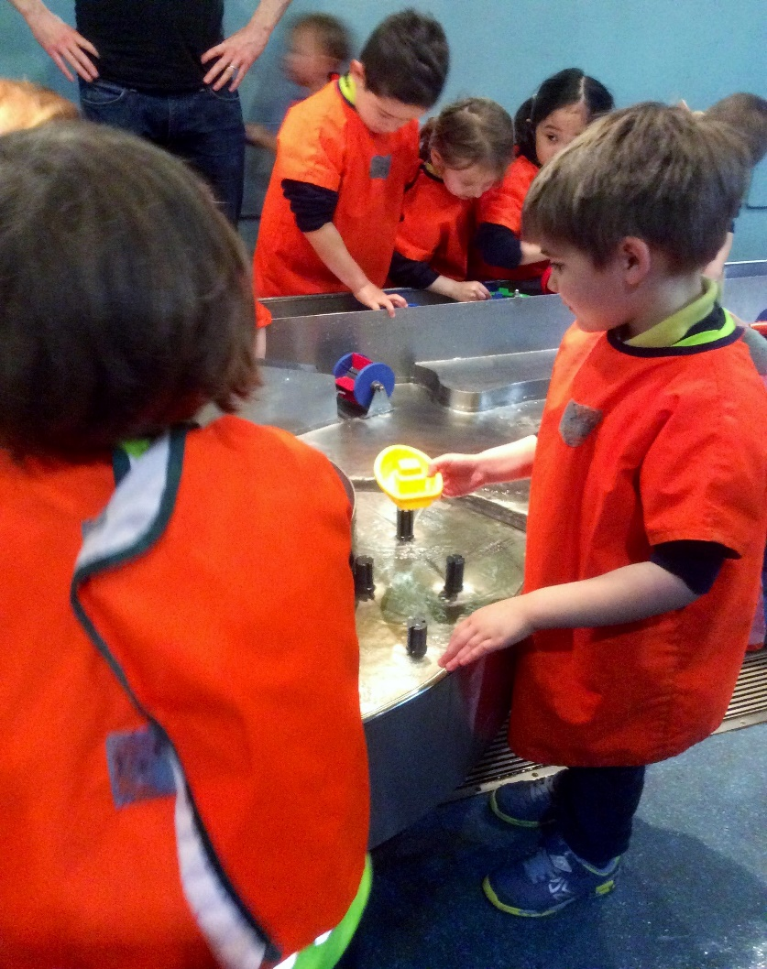
- Promote positive strategies for challenging prejudice and building community cohesion.

Safeguarding and Promoting the Welfare of Pupils

There is an expectation that the Headteacher will be the Designated Safeguarding Leader and will undergo training to enable this.

The Headteacher will ensure that all statutory and advisory duties regarding safeguarding are in place and robustly monitored and will:

- Work with governors and senior colleagues to recruit, induct and develop high-quality staff within safer recruitment guidelines
- Ensure safeguarding policies and procedures are implemented rigorously and reviewed at regular intervals
- Ensure that all teaching, NQTs, support staff and volunteers are fully inducted in school safeguarding procedures
- Utilise to the full the potential of the CPOMS system to support effective safeguarding recording, monitoring and actions
- Ensure that the Designated Safeguarding Leader has the appropriate resources to carry out the duties of the role effectively in line with the statutory guidance ‘Keeping Children Safe in Education”.

How to Apply

Visits
We very much welcome visits and the opportunity to show you around our school. This will be done in a Covid-secure manner to ensure the safety of applicants and those already in school.
Visits will be possible during the week beginning 22nd February and the week beginning 1st March. We look forward to showing you around.
Visits can be arranged by contacting the Chair of Governors, Revd Ralph Williamson, on 020 7235 4242 or by e-mail at vicar@stpetereatonsquare.co.uk and will be treated as part of the interview process.
We also encourage applicants to view the virtual school tour available on our homepage.

Deadline
The deadline for applications is 9am on Monday 8th March 2021.
Completed application forms should be emailed to the Clerk to the Governors, Sue Jacobs, at clerkstpeters@yahoo.co.uk

Applications
The application must include:
- Completed LDBS (London Diocesan board for Schools) application form
- A supporting statement against the Person Specification. Please attach as a separate Word document entitled Supporting Statement + your name. (No more than 3 pages Arial or Helvetica 12pt)
- A separate statement of no more than 500 words outlining your own philosophy and approach to Education. Please attach as a separate Word document entitled “Personal Statement + Your Name”.

Shortlisted Candidates
Shortlisted candidates will be contacted by email on the afternoon or evening of
Friday 12th March, and information regarding the content of the interview process and any necessary preparation will be circulated to all shortlisted candidates as soon as possible. References will be taken up for shortlisted candidates before the interviews.
If you are shortlisted, arrangements will be made (with the permission of your Headteacher) for two governors to visit you in your school between 15th – 17th March, Covid-restrictions permitting. Please note that this will be part of the interview process.
We will acknowledge all unsuccessful applicants by email but regret that we will be unable to provide feedback at this stage.
The interview process will be conducted on Thursday 18th / Friday 19th March 2021.

Job Offer
The successful candidate will be contacted on or before Monday 22nd March 2021 and an offer will be made, subject to references, contract, and an enhanced DBS check.

Start Date
The position is available from September 2021.

Contact us:
St Peter’s Eaton Square CE VA Primary School,
Lower Belgrave Street, London SW1W 0NZ
Telephone: 020 7504 0537
e-mail: office@stpeaton.org.uk
Website: www.stpeaton.org.uk

February 2021

