**Applicant’s pack**

Dear Applicant

A very warm welcome from St George the Martyr CE Primary School and thank you for your interest in applying for the position of Deputy Headteacher.

St George the Martyr is a vibrant one-form entry school caring for children from nursery to Y6. A short walk from the Charles Dickens Museum, the British Museum, Leather Lane Market and a host of other historical and cultural landmarks, it serves a socio-economically mixed and culturally diverse local community. Rated ‘outstanding’ by Ofsted in 2013, our pupils make good progress and the school is popular with children, parents and carers. We take pride in being warm, welcoming and friendly.

We are now looking for a new Deputy Headteacher to build on the strong foundations and take the school to the next level, “to really make it sing”. There are fabulous and committed members of staff, a loyal parent body and a very supportive group of governors wanting to empower a new Deputy Headteacher to work in partnership with the Headteacher.

Children at St George the Martyr perform well in comparison with those nationally and there is a strong emphasis on the love of reading. The school is committed to maintaining a broad curriculum and, notwithstanding the financial pressures, has managed to retain its array of exciting extra-curricular provision.

We are tremendously proud of the school but there is always room for improvement and we are looking for a dynamic new Deputy Headteacher to make St George the Martyr a beacon for learning – outward facing, confident and in the heart in the community.

Please find enclosed in this pack some ‘what you need to know’ insights, a Job Description and a Person Specification. We encourage you to visit the school and look forward to your application.

Yours faithfully

Rev. Guy Pope

Chair of Governors

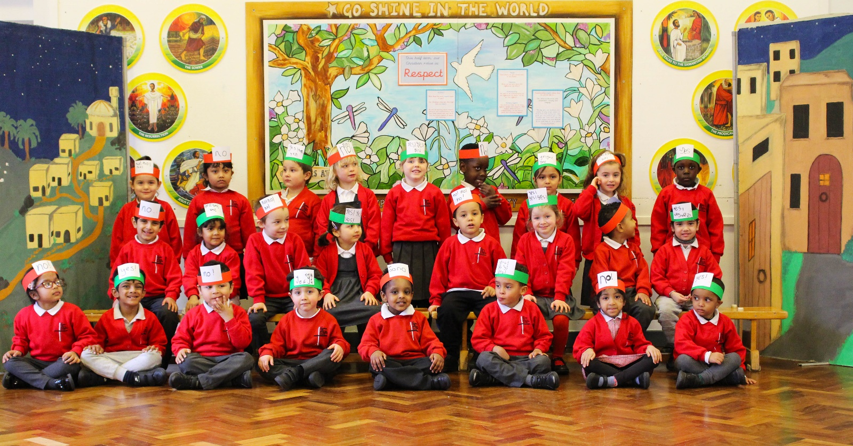

**About us: What you need to know**

Established St George the Martyr characteristics

* Highly valued Christian foundation, which permeates all our activities
* Broad curriculum
* Emphasis on high academic attainment and pupil wellbeing
* Inclusion and an emphasis on high expectations for all
* Seeking to address the attainment gap between Pupil Premium children and not
* High standards for all, including school uniform
* Warm and inviting

Our School Vision Statement

**Go, shine in the world and live as Jesus lived, with compassion, honesty and integrity.**

**Our School motto is based upon Philippians 2:12-16**

Vision and Values

Our school offers a distinctly Christian education in an inclusive environment, welcoming children and staff of all faiths and none.

As a community, we have identified **nine core values that stem from our Vision** andare woven in to the very fabric of the school. We expect all members of the school community-pupils, staff, governors, clergy - to model these. These are also closely linked to the **four foundations** of our **curriculum design.**

1. Educating for Wisdom, Knowledge and Skills (value link - excellence)
2. Educating for Hope and Aspiration (value link - determination and inspiration)
3. Educating for Community and Living Well Together (value link - compassion, integrity, friendship)
4. Educating for Dignity and Respect (value link - honesty, integrity, respect)

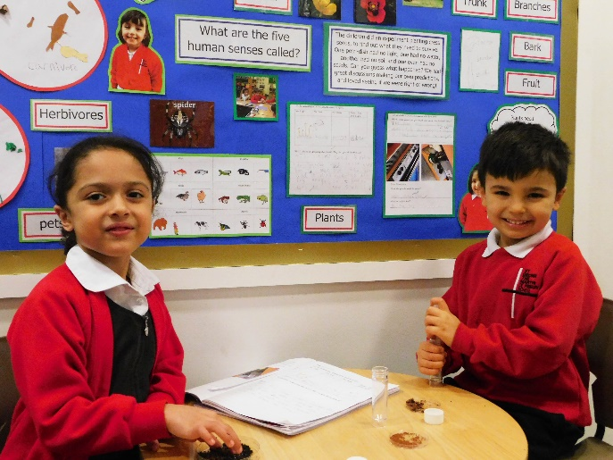

**Determination**

**Respect**

**Friendship**

**Inspiration**

**Excellence**

**Community**

**Compassion**

**Honesty**

**Integrity**

What we are looking for

An inspirational Deputy Headteacher who will enjoy working in close collaboration with the Headteacher, stimulating ongoing professional dialogue.

Someone who:

* Has clarity of purpose
* Has strong achievement drive
* Has courage, conviction and dynamism
* Is outward looking
* Has a clear understanding of how to foster an inclusive environment
* Is a clear and effective communicator with children, staff, parents and carers

The school knows that our staff being happy and successful is critical to our vision. We take the wellbeing of our staff extremely seriously as we do their professional development. They have access to high quality training through the LDBS and Camden Learning. The school is now looking to strengthen its CPD provision and for inspirational pedagogy to be further developed to make a positive difference to children’s outcomes.

St George the Martyr prides itself on being friendly and welcoming with an inclusive ethos that underpins its welcoming nature.

The school enjoys strong links to the wider community and is fortunate to be able to draw on the expertise of a culturally rich borough. However, the school is looking to strengthen further its connections with all areas of the diverse community we serve.

The school continues to develop a contextually appropriate and balanced curriculum, meeting the requirements of the national curriculum. One of our current school improvement priorities is to review and refine our reading approach, thereby enabling our children to access all areas of a broad and rich curriculum. It is our firm belief that we should resist any temptation and pressures to narrow the curriculum and instead strive for a rich, challenging and fascinating one.

We are excited to be at this point in the school’s development and to be able to offer such a fantastic opportunity. St George the Martyr is built on solid foundations and operates happily and successfully. But there is room for growth and we are looking for our new Deputy Headteacher to make this popular Church of England school “really sing”.



School information

|  |  |
| --- | --- |
| Leadership Structure | Headteacher  Deputy Headteacher  Assistant Headteacher / Senco |
| Teaching Staff | 8 Class Teachers  1 Trainee Teacher |
| Support Staff include | 2 HLTAs  3 Cleaners (contract)  3 Caterers (contract) |
| Number of children | 214 |
| % of children on FSM | 34.1% |
| % of children in receipt of PPG | 36.5% |
| % of children with SEN | SEN support 13.1% EHCP 1.9% |
| % of children with EAL | 56% |



  



**St George the Martyr CE Primary School**

**JOB DESCRIPTION**

This job description sets out the main tasks and responsibilities of the Deputy Headteacher, however it is not exhaustive and new responsibilities may need to be added or altered from time to time according to the needs of St George the Martyr School.

**Job title: Deputy Headteacher**

**Full time, permanent contract**

**Start date: September 2021**

**Salary: L8 to L12 (£58,132 to £63,319)**

**Purpose and Aims of the Role**

In order to take St George the Martyr to the next level, working in partnership with the Headteacher, the Deputy Headteacher will:

* review and develop the school’s vision and values and implement these with clarity and purpose
* provide inspirational pedagogical leadership and embed a culture of purposeful professional development
* actively engage with other schools and institutions to develop St George the Martyr as a beacon for learning
* with high aspirations, ensure exceptional provision for all pupils
* ensure a broad and contextually appropriate curriculum
* strengthen the school’s connections with its diverse community
* manage the resources of the school effectively to ensure a sustainable budget

**Responsibilities**

The *Headteachers’ Standards 2020* are set out in four domains. Within each domain there are characteristics expected of a Deputy Headteacher. These contain the key responsibilities of the role.

**Domain One**The main duties, under the direction of the Headteacher, are responsibilities for:

**Culture and ethos**

* school culture
* behaviour
* professional development

**Curriculum and teaching**

* teaching
* curriculum and assessment
* additional and special educational needs

**Organisational effectiveness**

* organisational management
* school improvement
* working in partnership

Ethics and Professional Conduct

The Deputy Headteacher will be expected to demonstrate high standards of principle and professional conduct at all times. Those principles are the same as those expected of the Headteacher and include integrity, objectivity, accountability, openness, honesty and leadership. Both inside and outside school the Deputy Headteacher will build relationships based on mutual respect, observe professional boundaries, show tolerance and respect cultural diversity while upholding fundamental British values.

**Culture and Ethos**

School Culture

The Deputy Headteacher will help to sustain the school's ethos and strategic direction, working closely with the Headteacher and governors to do this. She/he will help foster a positive experience for pupils while upholding high educational standards for pupils from all backgrounds, with a clear eye on the next phase of their education and life. The Deputy Headteacher should also ensure a high standard of professionalism among staff and respectful relationships across the school. In partnership with the Headteacher, she/he will hold all staff to account for their professional conduct and practice

Behaviour

The Deputy Headteacher will:

* establish and sustain high expectations of behaviour for all pupils, built upon relationships, rules and routines, which are understood clearly by all staff and pupils
* ensure high standards of pupil behaviour and courteous conduct in accordance with the school’s behaviour policy
* implement consistent, fair and respectful approaches to managing behaviour
* lead the playtime and lunchtime behaviour programme
* ensure that adults within the school model and teach the behaviour of a good citizen

Professional development

The Deputy Headteacher will:

* ensure staff have access to high-quality, sustained professional development opportunities, aligned to balance the priorities of whole-school improvement, team and individual needs
* prioritise the professional development of staff, ensuring effective planning, delivery and evaluation which is consistent with the approaches laid out in the *Teachers’ Standards*

**Curriculum and Teaching**

Teaching

The Deputy Headteacher will:

* demand ambitious standards for all pupils, overcoming disadvantage and advancing equality, instilling a strong sense of accountability in staff for the impact of their work on pupils’ outcomes
* secure excellent teaching through an analytical understanding of how pupils learn and of the core features of successful classroom practice and curriculum design, leading to rich curriculum opportunities and pupils’ well-being
* establish an educational culture of ‘open classrooms’ as a basis for sharing best practice within and between schools, drawing on and conducting relevant research and robust data analysis
* create an ethos within which all staff are motivated and supported to develop their own skills and subject knowledge, and to support each other
* demonstrate excellent practice as a teacher and coach, providing an excellent role model of practice for others
* establish and sustain high-quality, expert teaching across all subjects and phases, built on an evidence-informed understanding of effective teaching and how pupils learn
* ensure teaching is underpinned by high levels of subject expertise and approaches which respect the distinct nature of subject disciplines or specialist domains
* identify emerging talents, coaching current and aspiring leaders in a climate where excellence is the standard, leading to clear succession planning

Curriculum and Assessment

The Deputy Headteacher will:

* co-ordinate areas of the curriculum depending on the school’s needs
* in partnership with the Headteacher, co-ordinate and monitor assessment throughout the school, liaising with all staff including curriculum leaders and class teachers
* ensure a broad, structured and coherent curriculum which sets out the knowledge, skills and values that will be taught
* establish effective curricular leadership, developing subject leaders with high levels of relevant expertise
* ensure that all pupils are taught to read through the provision of evidence-informed approaches to reading, particularly the use of systematic synthetic phonics in schools that teach early reading
* ensure valid, reliable and proportionate approaches are used when assessing pupils’ knowledge and understanding of the curriculum
* ensure effective use is made of formative assessment

Additional and special educational needs and disabilities

The Deputy Headteacher will:

* in partnership with the Headteacher, ensure the school holds ambitious expectations for all pupils with additional and special educational needs and disabilities
* in partnership with the Headteacher, establish and sustain culture and practices that enable pupils to access the curriculum and learn effectively
* in partnership with the Headteacher, ensure that effective, appropriate moral and pastoral support is available to both pupils and staff and play a positive part in promoting and maintaining the school’s Inclusion and Equal Opportunities Policies

**Organisational Effectiveness**

Organisational management

The Deputy Headteacher will:

* in partnership with the Headteacher, ensure the protection and safety of pupils and staff through effective approaches to safeguarding, as part of the duty of care as a designated safeguarding lead
* in partnership with the Headteacher, provide a safe, calm and well ordered environment for all pupils and staff, focused on safeguarding pupils and developing their exemplary behaviour in school and in the wider society
* in partnership with the Headteacher, ensure staff are deployed and managed well with due attention paid to workload
* in partnership with the Headteacher, ensure that all school activities are adequately staffed and appropriate space allocated on a day to day basis
* ensure timetabling meets the current curriculum needs of the school
* in consultation with the Headteacher, ensure that staff absence is appropriately covered using the resources available within the school’s capacity and where necessary arrange agency staff through the school’s agreed methods
* in partnership with the Headteacher, maintain rigorous, fair and transparent systems and measures for managing the performance of all staff, addressing any under-performance, supporting staff to improve and valuing excellent practice
* participate in the recruitment procedures for teaching and non-teaching personnel
* induct and mentor new members of staff, e.g. new teachers, NQTs, trainee teachers and teaching assistants, ensuring the school’s policies are understood and maintained and any relevant records or reports completed
* co-ordinate the school’s voluntary partners, including inducting new volunteers, keeping them informed of school issues and dates, ensuring that pupils and staff are aware of arrangements and that volunteers contributions are valued and acknowledged
* in partnership with the Headteacher, monitor and ensure school environment and resources are maintained to a high standard, kept tidy and in order
* maintain rigorous approaches to identifying, managing and mitigating risk

Continuous school improvement

The Deputy Headteacher will:

* champion best practice and secure excellent achievements for all pupils
* hold and articulate clear values and moral purpose, focused on providing a world - class education for the pupils they serve
* communicate compellingly the school’s vision and drive the strategic leadership, empowering all pupils and staff to excel
* demonstrate optimistic personal behaviour, positive relationships and attitudes towards their pupils and staff, and towards parents, governors and members of the local community
* lead by example – with integrity, creativity, resilience, and clarity – drawing on their own scholarship, expertise and skills, and that of those around them
* positively support the Christian ethos of the school including taking an active part in Religious Education and leading Daily Collective Worship and assemblies (this is also shared with other staff)
* contribute to creating an ethos, educational vision and direction which secures effective teaching, successful learning and achievement by pupils and prepares them for the next phase of their education
* sustain wide, current knowledge and understanding of education and school systems locally, nationally and globally, and pursue continuous professional development
* make use of effective and proportional processes of evaluation to identify and analyse complex or persistent problems and barriers which limit school effectiveness, and identify priority areas for improvement
* in partnership with the Headteacher, develop appropriate evidence-informed strategies for improvement as part of well-targeted plans which are realistic, timely, appropriately sequenced and suited to the school’s context
* ensure careful and effective implementation of improvement strategies, which lead to sustained school improvement over time
* in partnership with the Headteacher, help to create and implement a school improvement strategic plan, underpinned by sound financial planning which identifies priorities and targets for ensuring that pupils achieve high standards and make progress, increasing the teachers’ effectiveness and securing school improvement
* assist in monitoring, evaluating, writing the self evaluation form (SEF) and reviewing the effects of policies, priorities and targets of the school in practice and take action if and when necessary

Working in partnership

The Deputy Headteacher will:

* develop effective relationships with fellow professionals and colleagues to improve academic and social outcomes for all pupils
* maintain and develop an effective partnership with parents and assist them in supporting their child’s learning – this may be through meetings, training workshops, homework etc)
* commit to work successfully with other schools and organisations in a climate of mutual challenge and support to improve academic and social outcomes for all pupils
* establish an excellent relationship with the Governing body, contributing to Governors’ meetings or other committees when appropriate
* maintain and develop effective links with the community to extend the curriculum and enhance teaching and learning (e.g. museums, theatres, local businesses, artists, community groups etc)
* play a full part in the life of the school community, attending social and school events and working with parents and the School Council amongst others, offering professional guidance and support
* in consultation with the Headteacher, co-ordinate the school’s support of the wider community in terms of providing work experience and training opportunities for parents, students and young people

Safeguarding

The Deputy Headteacher will:

* In consultation with the Headteacher, ensure that all statutory and advisory duties regarding safeguarding are in place and robustly monitored
* Work with the Headteacher and governors to recruit, induct and develop high quality staff within safer recruitment guidelines
* In consultation with the Headteacher, ensure safeguarding policies and procedures are implemented rigorously and reviewed at regular intervals
* In consultation with the Headteacher, ensure that all teaching, support staff and volunteers are fully inducted in school safeguarding procedures
* Co-operate and work with relevant agencies to ensure the safety and wellbeing of children

Lead by example, providing inspiration and motivation undertaking any professional duty which may be delegated by the Headteacher.

The Deputy Headteacher should be prepared to take responsibility for any major aspect of the school development or organisation in the light of changing circumstances, as the need arises or in response to Government directives or initiatives.

It is not anticipated that the Deputy Headteacher will have full class responsibility in their first year at the school but it is expected that they will have some regular weekly teaching commitment. The duties of the Deputy Headteacher’s teaching commitment in any one year will also be reviewed according to school needs (duties may change within the year according to the school’s needs).

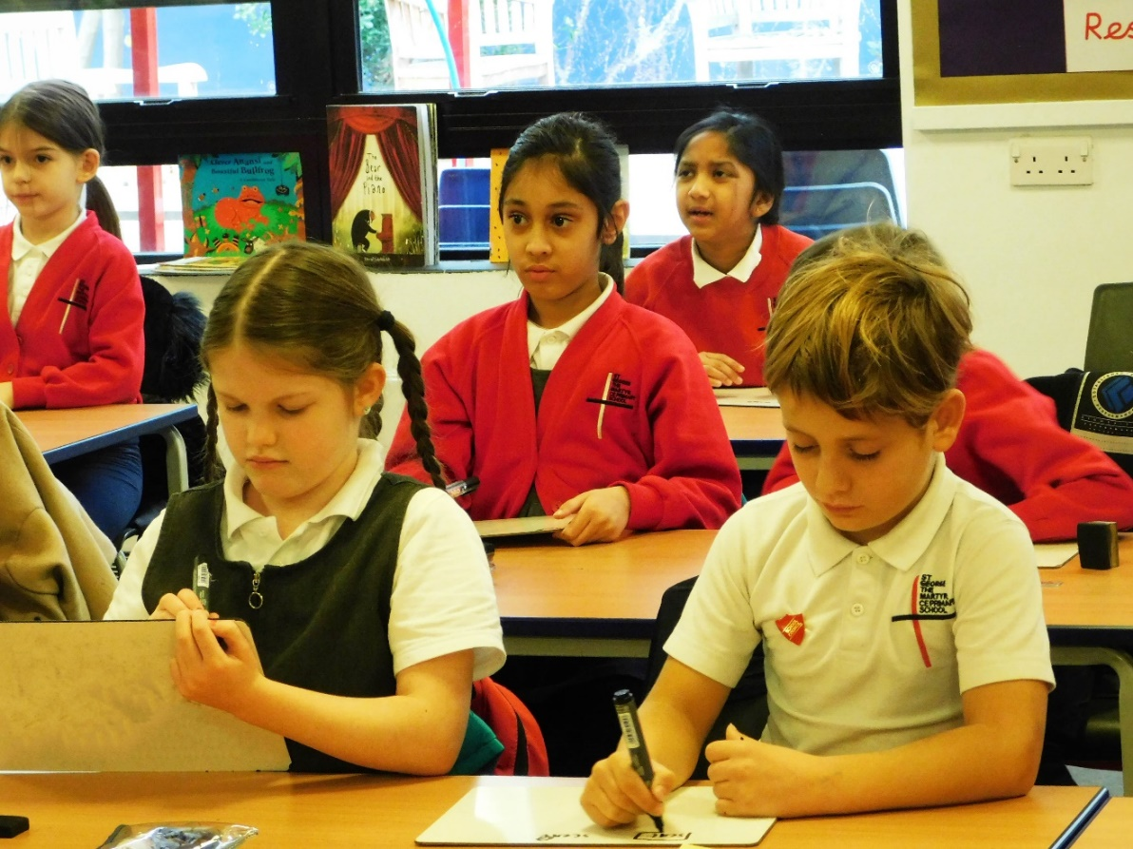

**St George the Martyr CE Primary School**

**PERSON SPECIFICATION**

**Qualifications / Training**

* Graduate level qualification or equivalent, at 2.1 Honours Level or equivalent
* Qualified Teacher Status
* Appropriate safeguarding training
* Appropriate Leadership and Management training

**Work Experience**

* Substantial leadership experience in urban primary schools – this could be Phase Leader or Assistant Headteacher
* Curriculum development responsibility in a core subject area
* Whole school responsibilities, with positive impact upon pupil wellbeing and outcomes
* Experience of leading and improving teaching and learning
* Evidence of contributing to whole school development
* Experience of working in a challenging diverse, multicultural community
* Experience of working with children with SEND

**Desirable:**

* Teaching experience in Foundation Stage, KS1 and KS2
* Experience of teaching in more than one school

**Distinctive Christian Ethos of the School**

* A commitment to work in partnership with the Headteacher to ensure the distinctive Christian vision and values are lived out in school life
* Secure understanding of the distinctive nature of a Church of England school
* Experience in leading Acts of Worship

**Desirable:**

* Evidence of participation in faith activities beyond the school

**Knowledge Requirements**

* Knowledge of child development
* National and global trends and research in education
* Safeguarding and child protection legislation, procedures and issues
* Knowledge of the needs and issues of disadvantaged / minority groups including for example SEND, Pupil Premium, BAME, Looked after Children

**Professional Skills**

* Excellent teaching skills
* Strategic thinking and clarity of purpose
* Analytic ability
* Initiative
* IT literacy
* Staff management and ability to build and maintain good relationships
* Understanding of and commitment to promoting and safeguarding the welfare of pupils

**Personal Capabilities**

* Achievement orientation – drive to improve
* External orientation – outward looking
* Ability to work in partnership within and outside of the school
* Ability to lead and inspire others
* Ability to coach, mentor and develop others
* Empathy
* Resilience – the ability to sustain energy, optimism and motivation
* Strategic influence
* Emotional self-control
* Consistency and accountability with high standards for oneself and the organisation, and the capacity to hold others to account for high standards of performance
* Ability to organise work, prioritise tasks, make decisions and manage time effectively
* Confidence and a sense of own authority

**Motivation**

* Urgent and compelling motivation to improve opportunities for children in terms of their progress and overall development
* Strong commitment to the school’s distinctive Christian vision and ethos
* Desire to understand and engage with the community
* Motivated by inclusion, fairness and equality

**Strategic Leadership**

* Ability to articulate and share a vision of primary education within the context of the school’s distinctive Christian vision
* Ability to inspire and motivate staff, pupils, parents and governors to achieve the aims the school’s vision
* Ability to implement the school’s curriculum intent and implementation statement, leading to positive impact and outcomes for pupils
* Evidence of successful strategies for planning, implementing, monitoring and evaluating school improvement
* Ability to effectively analyse data, develop strategic plans, set targets and monitor/evaluate progress towards these
* Knowledge of what constitutes quality in educational provision, the characteristics of effective schools and strategies for raising standards and the achievement of all pupils

**Teaching and Learning**

* Secure knowledge of statutory requirements relating to the national curriculum and assessment
* Knowledge and experience of a range of successful research based teaching and learning strategies to meet the needs of all pupils
* A secure understanding of assessment strategies and the use of assessment to inform the next stages of learning
* Experience of effective coaching, monitoring and evaluation of teaching and learning
* Understanding of the characteristics of an effective learning environment and the key elements of successful behaviour

**Leading and Managing Staff**

* Experience of working in and successfully leading staff teams to successful outcomes for children
* Ability to delegate work and support colleagues in undertaking responsibilities
* Leading successful staff induction
* Experience of appraisal and supporting the continuing professional development of colleagues

**Accountability**

* Ability to communicate effectively, orally and in writing to a range of audiences, e.g. staff, pupils, parents, governors
* Experience of whole school self-evaluation and improvement strategies
* Ability to provide clear information and advice to staff and governors
* Secure understanding of strategies for appraisal
* Experience of offering challenge and support to improve performance
* Experience of presenting reports to governors
* Leading sessions to support parents with children’s learning and development

**How to apply**

This is an outstanding opportunity to lead a vibrant school in a prime London location and inspire the next generation of pupils. If you believe you have the right set of skills and aptitude, we warmly invite you to apply for the post of Deputy Headteacher.

An application form is provided online or can be obtained from our School Business Manager, Carol Jamieson on:

Tel: 0207 405 5640

[carol.jamieson@stgeorge.camden.sch.uk](mailto:p.boreland@brookfield.camden.sch.uk)

* Completed applications to be emailed to Carol Jamieson and received by 12.00pm Monday 19th April 2021
* Shortlisted candidates will be notified by 5.00pm on Wednesday 21st April 2021
* Interviews will take place at St George the Martyr CE Primary school on Wednesday 28th April 2021

*Our school is committed to safeguarding and protecting the welfare of children. Appointment is subject to an enhanced DBS check.*

**

